What is a Declared Mine Rehabilitation Plan?

A Declared Mine Rehabilitation Plan (DMRP) outlines the measures and actions that declared mine licensees will take to rehabilitate land impacted by mining within the mine license, to create safe, stable and sustainable landforms which support the next land use.

The DMRP is a live document prepared by the mine licensee. It is reviewed and updated as the licensee’s knowledge of the site grows. The DMRP is designed to be iterative, in-line with international best practice guidance, such as those published by the International Council on Mining and Metals (ICMM), due to its ability to adapt to the changing regulatory and physical environment, and the growing knowledge base over time (see Figure 1).
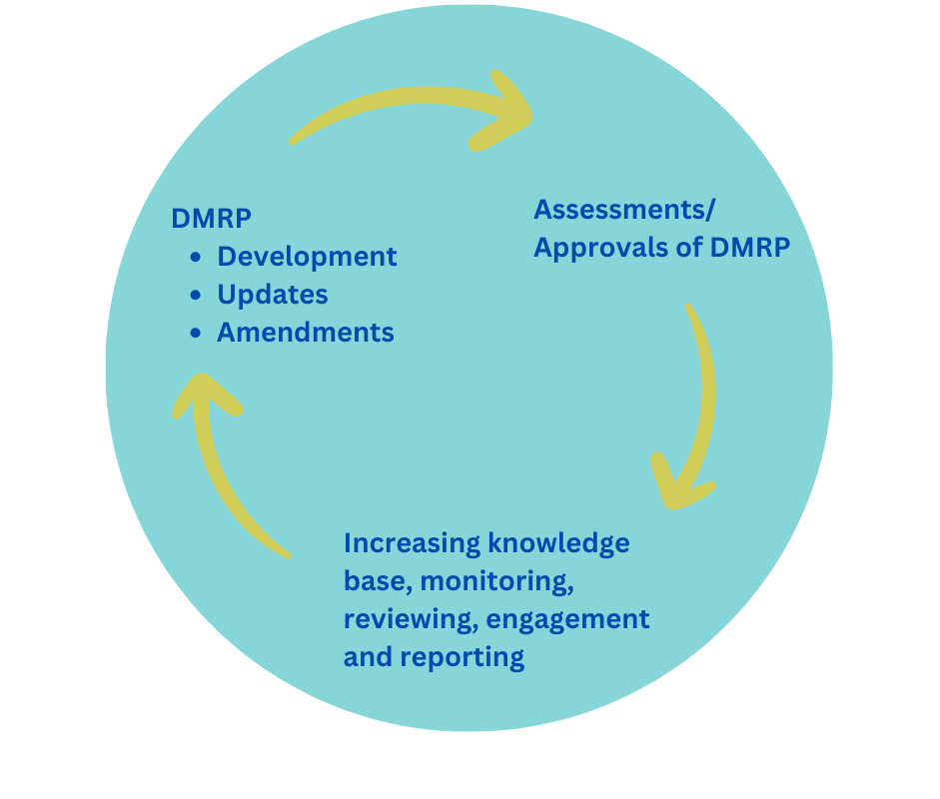
Figure.1: DMRP Review process
The DMRP is reviewed and approved by government and provides government and stakeholders with comprehensive information of the licensees’ planned rehabilitation activities. This in turn will enable the government to make informed decisions relating to the acceptability of risks and liabilities that may remain subsequent to the relinquishment of mine land, and ultimately determinations on mine license relinquishment.
To enable license relinquishment, the declared mine licensees need to achieve their closure criteria as set out in their DMRP and pay into the Declared Mine Fund.
It is also a requirement that the licensees have to consult with the community throughout the creation of a DMRP.
The DMRP for the Latrobe Valley Declared Mines, which includes Hazelwood, Loy Yang and Yallourn, is developed over the remaining life of mine – in the operational and closure implementation phase (see Figure 2). Any new declared mines would be expected to have a DMRP prior to mine operations commencing.
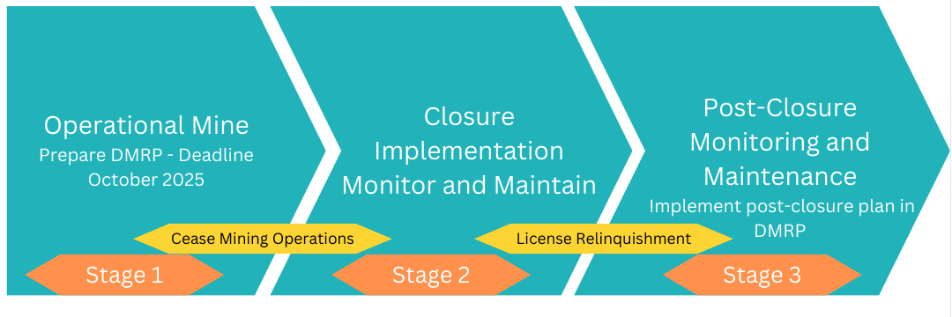Figure.2: Closure Phases

Why do licensees need a DMRP?
The requirement for declared mine licensees to develop and implement a DMRP by October 2025, was introduced in the recent amendment in 2022 to Victorian mining legislation.
Mines and quarries in Victoria are regulated under the Mineral Resources (Sustainable Development) Act of 1990 (MRSDA) and associated Regulations. The Act and Regulations have been amended in recent years in response to the Hazelwood Mine Fire Inquiry (HMFI).

What needs to be included in a DMRP?
The Regulations outline the matters which must be included in a DMRP. Some of these include:
• Post-mining land use – proposed outcomes for land use, for after mining and rehabilitation
• Knowledge base – repository of information, data and reports used to inform, monitor and evaluate rehabilitation planning activities. The DMRP outlines the ongoing research that will be undertaken to grow the knowledge base, to target and resolve any data gaps
• Closure objectives – outlines the goals for what rehabilitation aims to achieve
• Closure criteria – provide a metric to measure the success of rehabilitation
• Closure and rehabilitation milestones – the milestones the licensee must meet as rehabilitation progresses to ensure that the works are ‘on-track’ to achieving the outlined closure objectives / criteria. This includes milestones relating to ongoing engagement, obtaining legal approvals, and other rehabilitation activities.
• Post-closure plan – sets out the monitoring and maintenance to be carried out following rehabilitation and license relinquishment
• Post-closure costs – the costs associated with the management of the declared mine land subsequent to rehabilitation and relinquishment. The DMRP and post-closure plan inform this cost.
• Stakeholder engagement plan
• Risk assessment – identifies and assesses rehabilitation related risks, and an associated risk management plan that specifies the actions that will be taken to mitigate these risks
• An overview of roles and responsibilities of licensees’ employees

Who are the stakeholders involved?
• Declared Mine Licensees – Responsible for developing and implementing a DMRP.
• Earth Resources Regulator (ERR) – Responsible for assessing any DMRP.
• Mine Land Rehabilitation Authority (among other government bodies) listed as a referral authority as part of the approval process.
The declared mine licensees must engage with the community and other stakeholder groups, in accordance with their stakeholder engagement plan as part of the development of their DMRP. These consultations can provide the community with an opportunity to provide input on the rehabilitation and end land-uses proposed for each mine.

What is the status for the DMRPs for the three declared mines?
All licensees are currently developing their DMRPs for submission to ERR by October 2025.
The Victorian Government is preparing guidelines to assist the licensees with development of their DMRPs.
Due to the scale and complexity of the Latrobe Valley coal mines, a complicated regulatory framework currently exists.
One example is whether an Environmental Effects Statement (EES) is undertaken before a DMRP.
The Victorian Government is currently working to improve the overall legislative process for declared mine rehabilitation.

For more information about declared mine rehabilitation contact us on 1800 571 966 or www.mineland.vic.gov.au or contactus@mineland.vic.gov.au

@MLRAuthority Facebook.com/MLRAVictoria MLRAuthority

