What is a Declared Mine Rehabilitation Plan?

A Declared Mine Rehabilitation Plan (DMRP) outlines the steps that a declared mine licensee will take to rehabilitate land impacted by mining. The plan outlines how land within a declared mine license will be rehabilitated and made safe, stable and sustainable, to support proposed end land uses after mining.

The DMRP is prepared by the licensee and is reviewed and updated as the licensee’s knowledge of their site develops. DMRPs are designed to be iterated (updated) over time, to allow them to be adapted to the physical environment, and the growing knowledge base and provides the opportunity to ensure advances in technology and regulatory approaches can be incorporated (see Figure 1). This is in-line with international best practice, such as guidance published by the International Council on Mining and Metals (ICMM), a peak body in the mining industry.

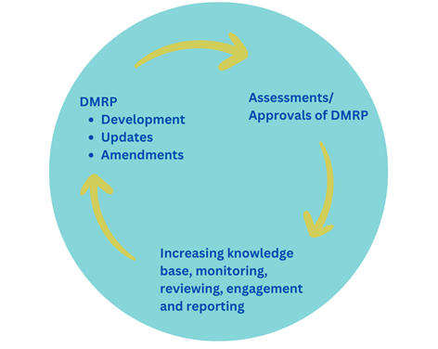

*Figure 1 The DMRP development and review process is iterative, with knowledge increasing over time*

The DMRP is assessed and approved or declined by government and provides government and stakeholders with comprehensive details of a licensee’s planned rehabilitation activities. This enables the government to make informed decisions relating to the acceptability of risks and ongoing liabilities that may remain past the end of the closure process. The closure process is ended with the return of the mining license to the Government along with a payment into the Declared Mine Fund when the licensees have demonstrated the successful achievement of rehabilitation through the determination of Closure Criteria (set out in the DMRP).

Declared mine licensees are required to consult with the community throughout the development of the DMRP.

DMRPs are being developed for the Latrobe Valley’s three declared mines – Hazelwood, Loy Yang and Yallourn – which are in various stages of their operational and closure implementation stages (see Figure 2). Any new declared mines are now expected to have a DMRP prior to the commencement of their operational stage.

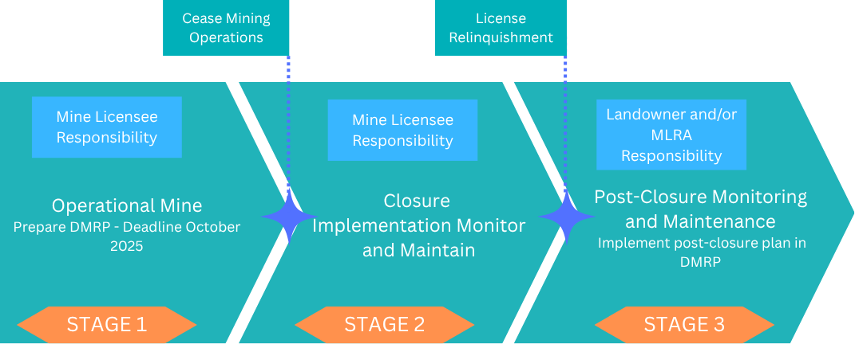

*Figure 2 Stages of declared mine life are 1) operational (mining), 2) closure implementation and 3) post-closure*

Why do licensees need a DMRP?

Mines and quarries in Victoria are regulated under the *Mineral Resources (Sustainable Development) Act of 1990 (MRSDA)* and associated Regulations. The Act and Regulations have been amended in response to the Hazelwood Mine Fire Inquiry (HMFI), conducted in 2015. The requirement for declared mine licensees to develop a DMRP was introduced in 2022 in further amendments to this legislation.

Declared mine status and the requirement for a DMRP were added to the legislation to ensure that the rehabilitation of these sites is carefully managed and ensure that risks associated with these mines are well understood.

What needs to be included in a DMRP?

The MRSD Regulations outline the matters which must be included in a DMRP. Some of these are:

• **Post-mining land use outcomes** – proposed land uses outcomes after mining and following rehabilitation and relinquishment

• **Knowledge base** – repository of information (e.g., data, reports) used to develop rehabilitation landform designs, develop & implement appropriate monitoring, develop closure criteria, understand gaps in understanding and evaluate rehabilitation. The DMRP must also outline research that will be undertaken to develop the knowledge base and resolve any knowledge gaps

• **Rehabilitation objectives** – the measurable, site specific goals that rehabilitation aims to achieve

• **Closure criteria** – are measurable demonstration of the success of the closure objectives and therefore the rehabilitation of the site

• **Closure and rehabilitation milestones** – interim targets the licensee must meet as rehabilitation progresses, to ensure that the works are ‘on-track’ to rehabilitate the site. These might relate to ongoing engagement, updating the DMRP, completion of technical studies, the development of criteria, obtaining legal approvals, or other various rehabilitation activities.

• **Post-closure plan** – sets out the monitoring and maintenance to be carried out following successful rehabilitation and license relinquishment

• **Post-closure fund** – the ongoing costs associated with the managing the declared mine land following successful rehabilitation and license relinquishment. The DMRP and post-closure plan inform this cost.

• **Stakeholder engagement plan** – how the licensee intends to engage during DMRP development and implementation

• **Closure** **risk assessments** – identifies and assesses risks related to rehabilitation and post closure (after the license is relinquished). Associated risk management plans that specifies any actions that will be taken to mitigate these risks

Who are the stakeholders involved?

• Minister for Resources – Responsible for final approval of a DMRP

• Declared Mine Licensees – Responsible for developing and implementing a DMRP

• Earth Resources Regulator (ERR) – Responsible for assessing a DMRP

• Mine Land Rehabilitation Authority (among other government bodies) listed as a referral authority as part of the DMRP assessment process

The declared mine licensees must engage with the community and other stakeholder groups as part of the development of their DMRP, in accordance with their stakeholder engagement plan. These consultations provide the community with an opportunity to provide input on the DMRPs.

What is the status of DMRPs for the three declared mines?

All declared mine licensees are required under the legislation to submit a DMRP for assessment to ERR by October 2025. The licensees can apply for an extension to the submission date of up to 2 years.

The Victorian Government is preparing guidelines to assist the licensees with development of their DMRPs.

MLRA Content Disclaimer:

This content provides the MLRA's high-level overview of aspects of mine rehabilitation in the Latrobe Valley. It does not reflect the opinions, pre-empt decisions or policies of Resources Victoria, mine licensees or any other government department. The information was accurate to the best of the MLRA's knowledge at the time of publication and is intended to inform the community, stakeholders and Traditional Owners.

Contact the MLRA for more information on 1800 571 966 or [contactus@mineland.vic.gov.au](mailto:contactus@mineland.vic.gov.au)

 @MLRAuthority  Facebook.com/MLRAVictoria  MLRAuthority