What are rehabilitation Closure Criteria?
At the end of mine closure activities, before a declared mine licence can be surrendered, declared mine licensees are required to meet approved closure criteria. The MLRA defines these as ‘site specific measures or metrics developed during mine rehabilitation planning against which successful mine closure is determined’.

Why do we need them?
Evaluation against criteria is employed internationally by governments and the mining industry, to ensure accountability and demonstrate successful mine rehabilitation.
Developing and refining criteria allows for licensees to undertake detailed planning with a targeted goal in mind and helps provide consistency for rehabilitation over timeframes that are expected to last several decades.
Mine licensees can only apply to surrender their mining licence once criteria have been met. This helps make sure the site is safe, stable and ready for future land uses.

How does it all fit together?
Closure criteria form a vital part of closure planning and are a detailed element of the planning framework that starts with the closure vision (Figure 1). From there, principles and objectives add more detail. This process helps create clear, site-specific targets. Closure criteria are the final step. They are the exact measures used to show that the targets have been met and that the closure vision has been achieved. The ICMM Integrated Mine Closure, Good Practice Guideline 2nd Edition gives more information about this planning framework.
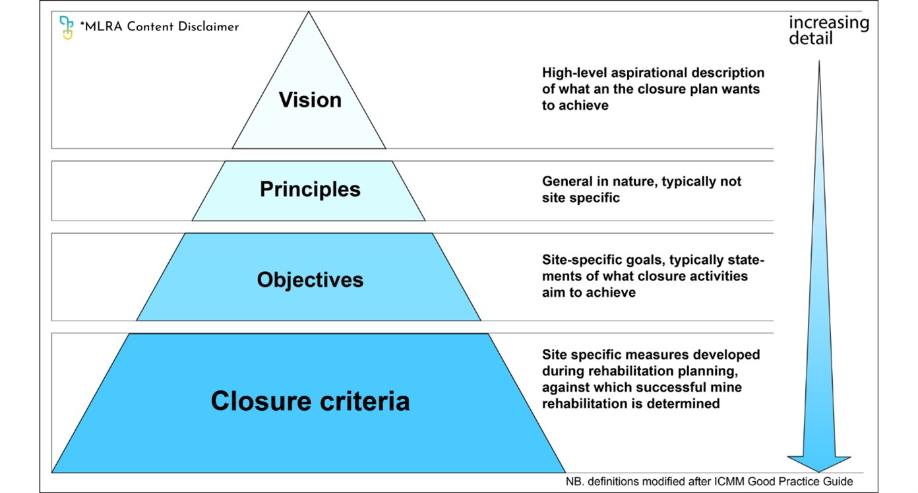

Figure 1 The closure criteria articulate the vision for the site and are site specific
In Victoria, declared mine licensees are required to develop closure criteria as part of their DMRP. The law allows this to be updated over time as new information becomes available.

Closure Criteria in Detail
Closure criteria in Victoria must be S.M.A.R.T. (Specific, Measurable, Achievable, Relevant, Time-bound). Legislation allows for these criteria to be matured over time, as planning advances and site knowledge develops.
The final, approved criteria should demonstrate that the rehabilitated landform is safe, stable and sustainable, and that it can support the proposed end land uses. Criteria are developed by focusing on the measurement of controls for key risks demonstrating the successful long-term mitigation, the construction and performance of designs, and other relevant aspects to, thereby demonstrating the successful rehabilitation.
Criteria are likely to be developed to demonstrate that the following examples of objectives have been achieved:
- mine batters are stable
- vegetation is self-sustaining and resilient
- water quality is suitable for proposed end land uses

Who is responsible?
In Victoria, legislation requires declared mine licensees to develop closure criteria that ensure the site is left ‘safe, stable and sustainable’.
Closure criteria are assessed by Resources Victoria as part of the Declared Mine Rehabilitation Plan (DMRP) assessment process.
The DMRP must be referred to relevant agencies and to the Ministers responsible for Crown Land, Environmental Protection, Forests, Land, National Parks, Planning and Environment, Water and Wildlife.
The licensees are responsible for all rehabilitation works to make the site safe, stable and sustainable as detailed in the DMRP. This includes monitoring to demonstrate the achievement of the closure criteria and thereby successful rehabilitation.
Licensees will apply to the Minister for Resources, who will determine if the criteria are met and if the licence can be surrendered. Relevant agencies will be consulted by the Minister on this determination.
MLRA Content Disclaimer:
This content provides the MLRA's high-level overview of aspects of mine rehabilitation in the Latrobe Valley. It does not reflect the opinions, pre-empt decisions or policies of Resources Victoria, mine licensees or any other government department. The information was accurate to the best of the MLRA's knowledge at the time of publication and is intended to inform the community, stakeholders and Traditional Owners.
Contact the MLRA for more information on 1800 571 966 or contactus@mineland.vic.gov.au

 @MLRAuthority  Facebook.com/MLRAVictoria  MLRAuthority

