# Key hazards series: Block Sliding

# The Latrobe Valley declared mines must be rehabilitated to a state which is safe, stable, sustainable and suitable for proposed post-mining land uses. Mitigating hazards, both during operations and rehabilitation, is a key responsibility of mine licensees.

# A hazard is any source of potential harm, damage, or adverse health effects on individuals, assets, or the environment.

# This fact sheet is part of the Key Hazards series which addresses hazards such as block sliding, floor heave, climate change and fire. Key terminology is defined in the MLRA Vocabulary on our website.

# Block sliding

## Ground movement in the Latrobe Valley declared mines can occur for various reasons, with block sliding being a significant risk to the stability of mine batters and land near the void edges. Under certain conditions, large coal blocks can slide into the void, compromising stability.

## How can blocks slide?

In the Latrobe Valley, clay and silt layers, known as interseams, lie between coal layers and create surfaces along which coal blocks can slide. Water buildup behind the batters in coal joints and cracks, caused by heavy rainfall or water from nearby watercourses, applies sideways pressure (Figure 1.) If unmanaged, this pressure can force the blocks to slide along the interseam into the void, causing the batter to slump into the pit (Figure 2.)

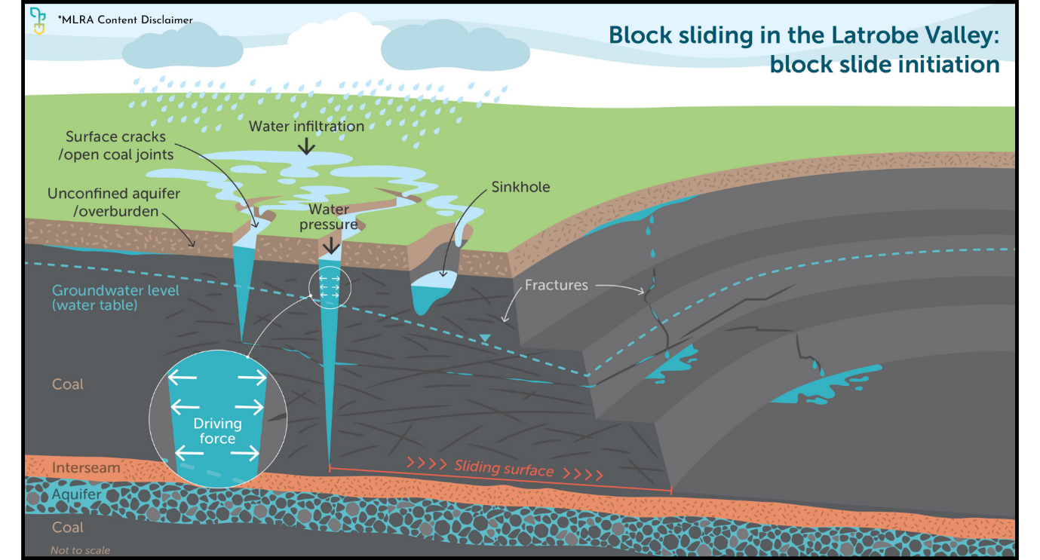

Figure

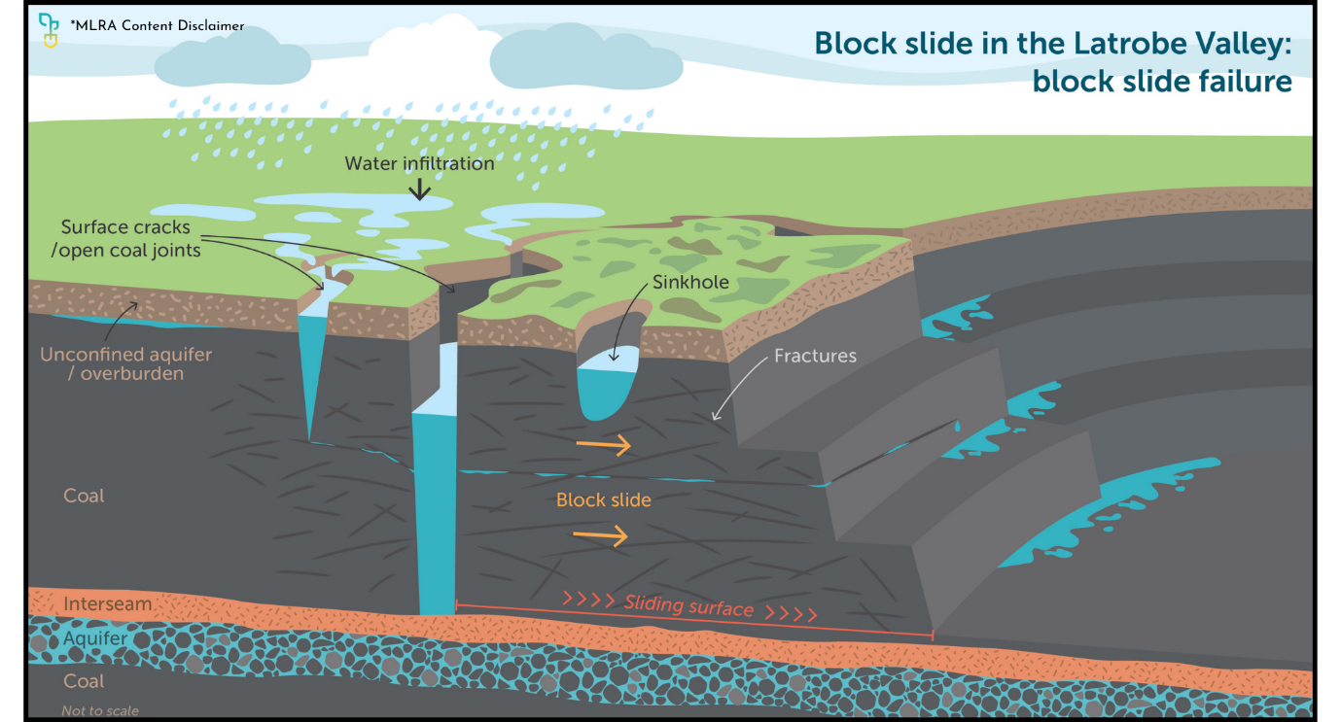

Figure

## How can slides be prevented?

Common operational measures aimed at reducing the water from behind the batters (Figure 3) include but are not limited to:

• Horizontal Drains: Boring horizontal drains into batters to release water and prevent buildup behind coal batters.

• Surface Water Diversion: Installing drains and culverts to redirect surface water away from cracks and joints.

Rehabilitating coal mines offers an opportunity to minimise the potential for block sliding. Rehabilitation options aim for passive mitigation of block slides focussing on applying counter-pressures to stabilise batters. For further information see the MLRA Rehabilitation Concepts fact sheet series.

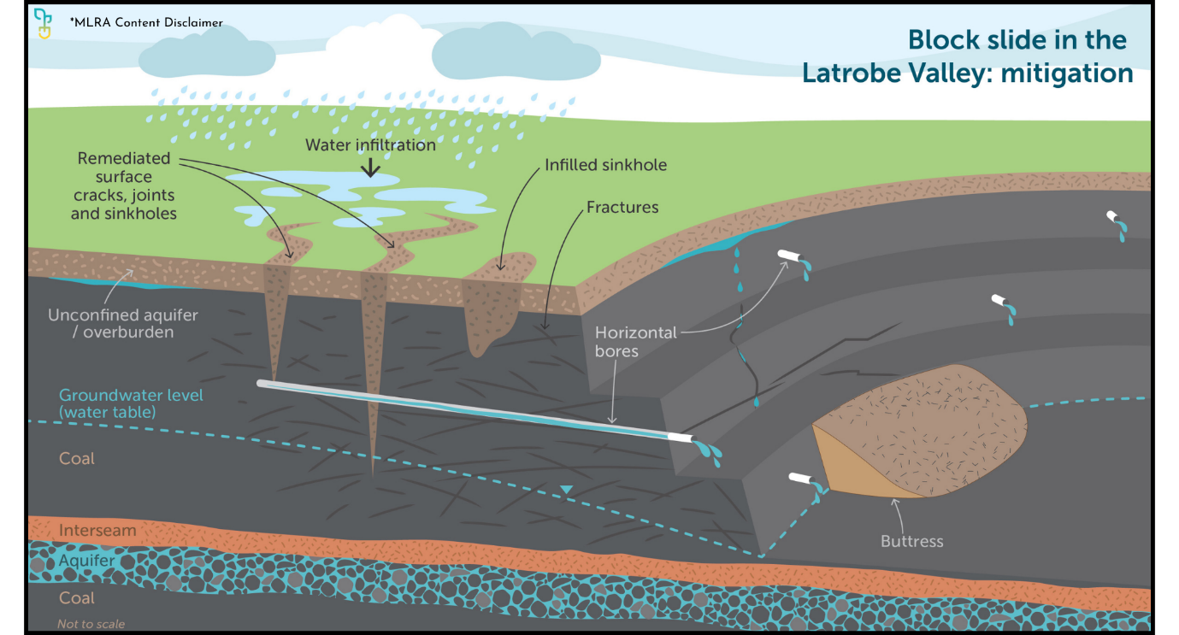

Figure

If you’re reading a printed copy, you can find all hyperlinks by visiting www.mineland.vic.gov.au and searching for the relevant topic.

## Disclaimer:

This content provides the MLRA's high-level overview of aspects of mine rehabilitation in the Latrobe Valley. It does not reflect the opinions, pre-empt decisions or policies of Resources Victoria, mine licensees or any other government department.  The information was accurate to the best of the MLRA's knowledge at the time of publication and is intended to inform the community, stakeholders and Traditional Owners.

 @MLRAuthority  Facebook.com/MLRAVictoria  MLRAuthority