# Key hazards series: Floor Heave

# The Latrobe Valley declared mines must be rehabilitated to a state which is safe, stable, sustainable and suitable for proposed post-mining land uses. Mitigating hazards, both during operations and rehabilitation, is a key responsibility of mine licensees.

# A hazard is any source of potential harm, damage, or adverse health effects on individuals, assets, or the environment.

# This fact sheet is part of the Key Hazards series which addresses hazards such as block sliding, floor heave, climate change and fire. Key terminology is defined in the MLRA Vocabulary on our website.

# Floor Heave

## Floor heave refers to the upward movement of a mine’s floor caused by pressure from underlying aquifers. This ground movement can destabilise mine batters and surrounding areas, potentially triggering block slides, batter collapses, and increased fire risks in rehabilitated batters. Additionally, floor heave may cause groundwater aquifers to break through into the mine void, leading to water inflow and potential aquifer contamination.

## How can floor heave occur?

When coal and overburden are removed during mining, the resulting void disrupts the balance of forces in the ground. With the weight of the removed material no longer counteracting the pressure from underlying aquifers, an upward force is exerted on the pit floor, causing it to rise. This process is illustrated in Figures 1 to 4.

Floor heave requires proactive management during both mining operations and rehabilitation to minimise risks to the stability of the mine and surrounding environment.

A diagram of a ground layer



Figure 1

A diagram of a mine


Figure 2

A diagram of a mine void



Figure 3

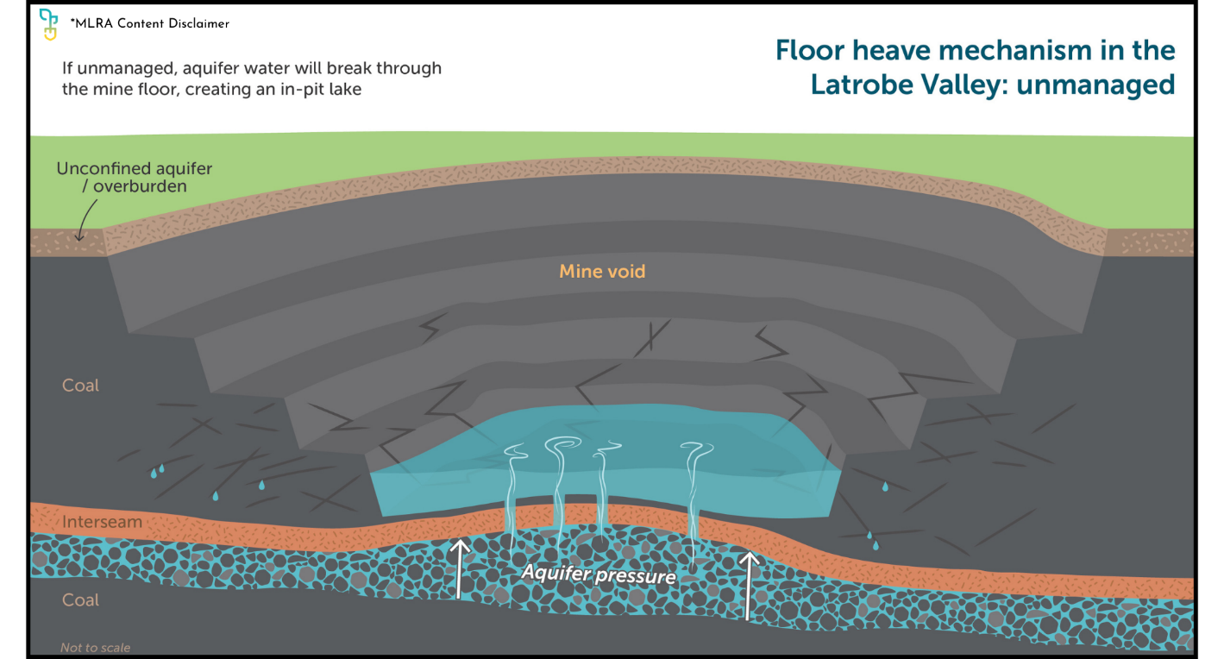

Figure 4

How can floor heave be prevented?

Common operational measures aimed at achieving weight balance include but are not limited to:

* Aquifer Depressurisation: Pumping water from aquifers to reduce upward pressure.
* Strategic Overburden Placement: Adding overburden in the mine void to counteract aquifer pressures (surcharges) and buttress the mine batters.

Rehabilitating coal mines offers an opportunity to minimise the potential for floor heave. Rehabilitation options aim for passive mitigation of floor heave, focussing on providing counterweights against aquifer pressures. For further information see the MLRA Rehabilitation Concepts fact sheet series.

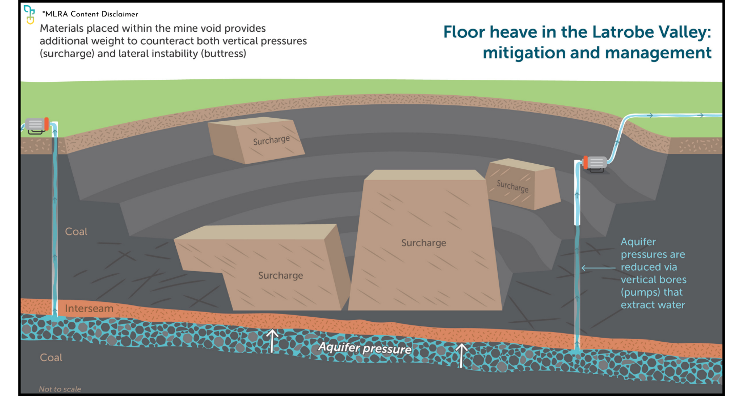

*Figure 5*

If you’re reading a printed copy, you can find all hyperlinks by visiting www.mineland.vic.gov.au and searching for the relevant topic.

## Disclaimer:

This content provides the MLRA's high-level overview of aspects of mine rehabilitation in the Latrobe Valley. It does not reflect the opinions, pre-empt decisions or policies of Resources Victoria, mine licensees or any other government department. The information was accurate to the best of the MLRA's knowledge at the time of publication and is intended to inform the community, stakeholders and Traditional Owners.

 @MLRAuthority  Facebook.com/MLRAVictoria  MLRAuthority