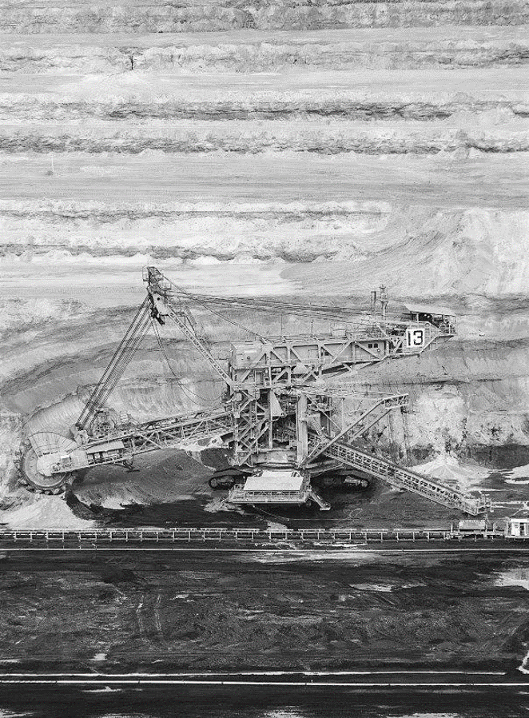
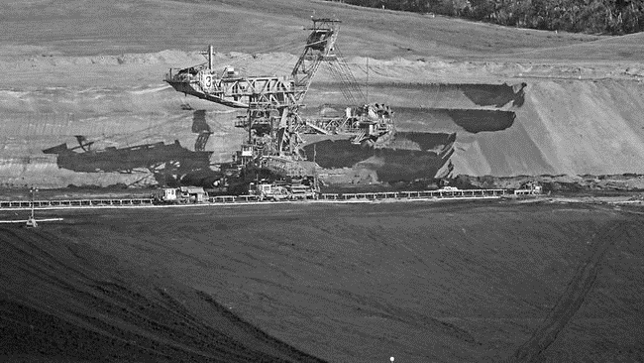
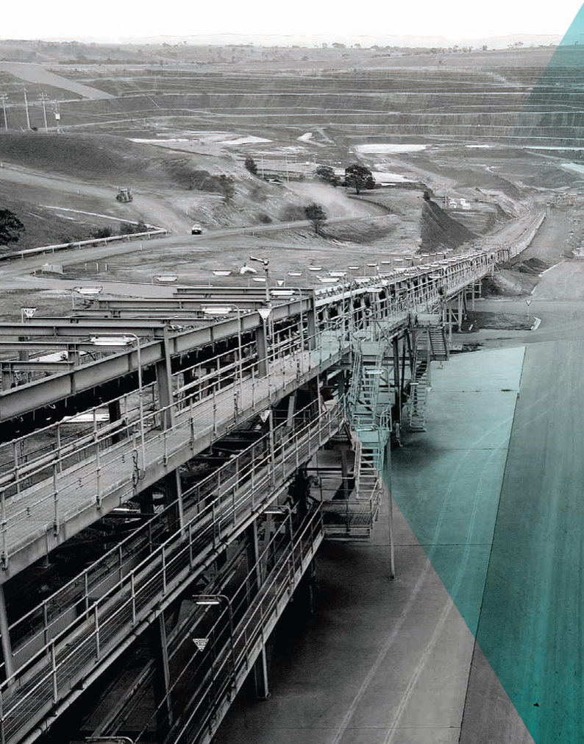
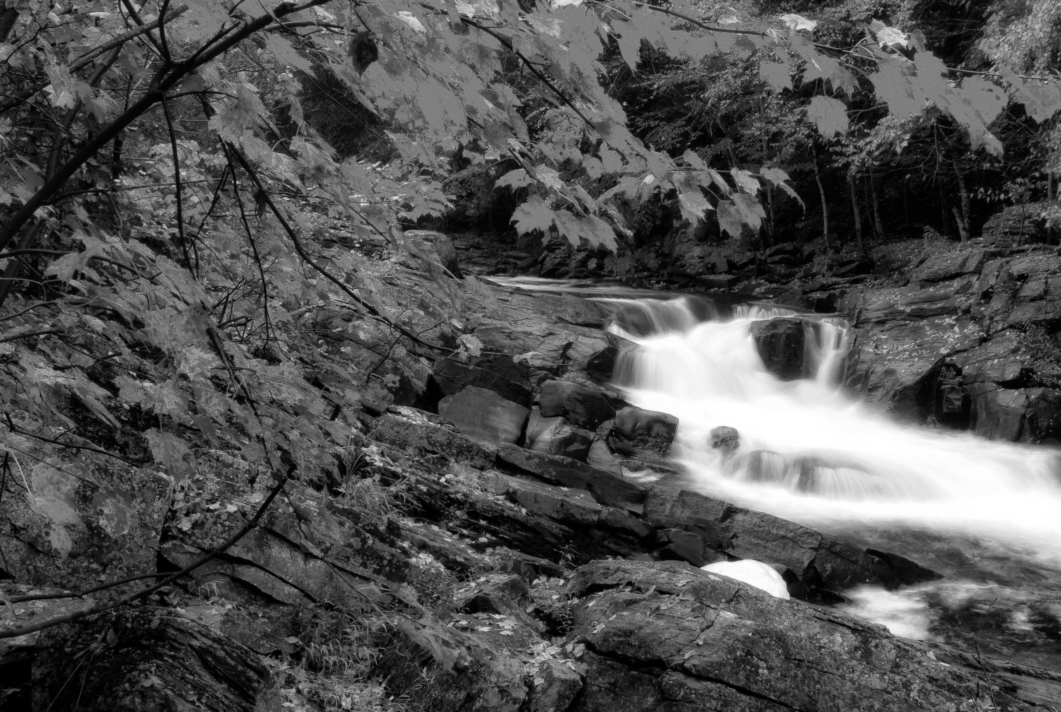
3

MINE LAND
REHABILITATION
AUTHORITY

History of Mining in the Latrobe Valley
Book 3
Background information and useful reference regarding the History of Mining in the Latrobe Valley

OFFICIAL
The Mine Land Rehabilitation Authority
September 2024


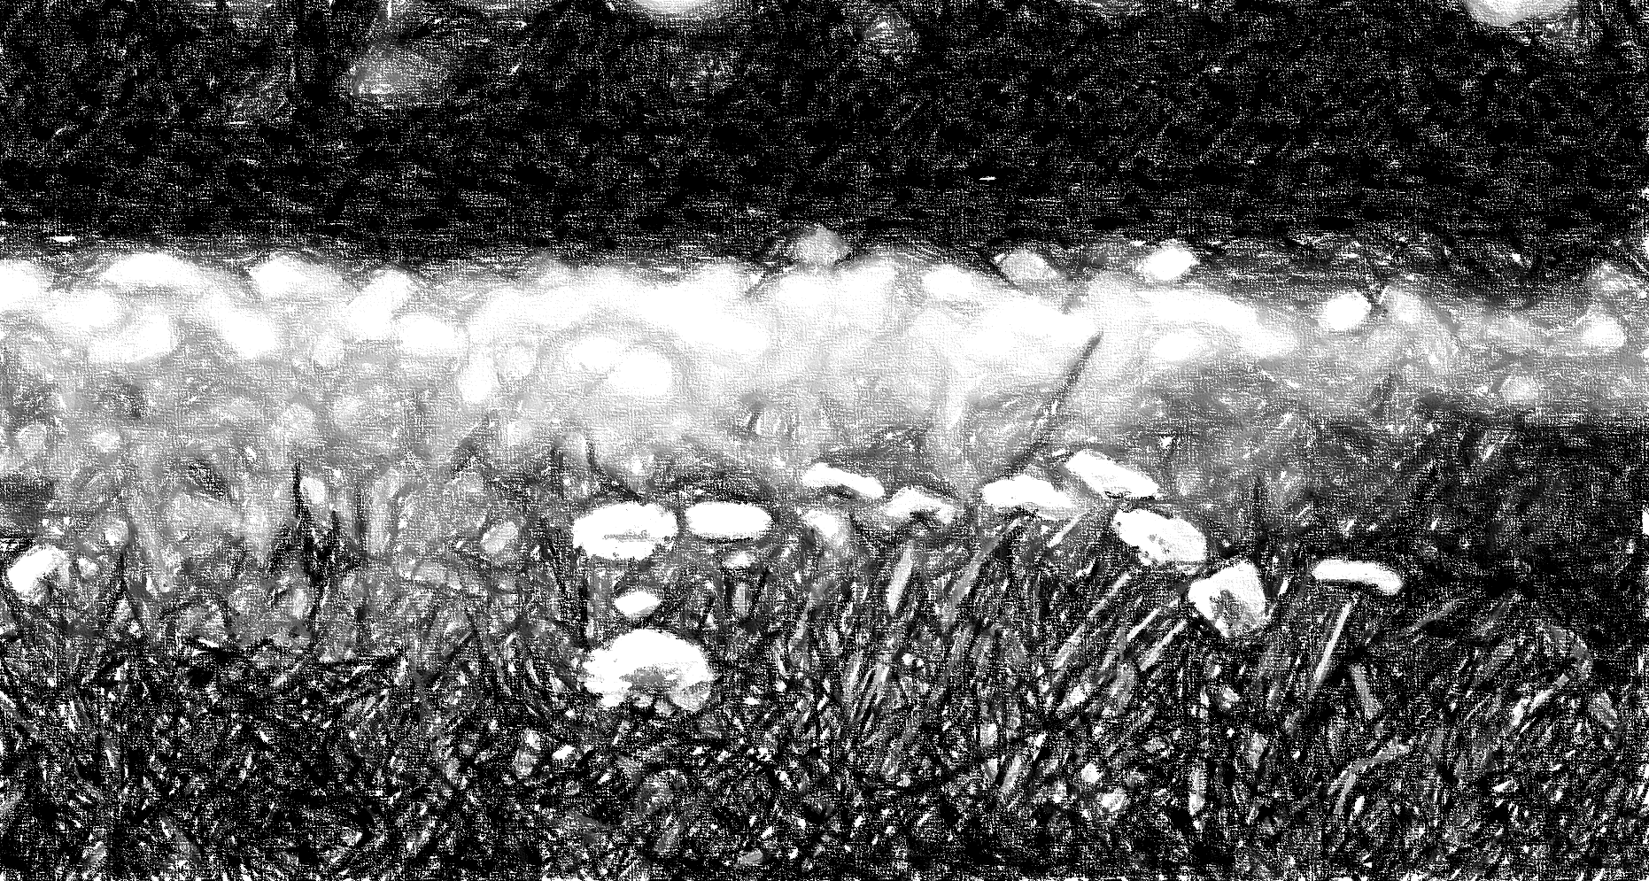
The Mine Land Rehabilitation Authority acknowledges Aboriginal and Torres Strait Islander people as the Traditional Custodians of the land and acknowledges and pays respect to their Elders, past, present, and emerging.

Approval for Use
Doc Title / Version |  | History of Mining in the Latrobe Valley V.01.docx
Classification |  | For Publication
Version | Date |  | Prepared By | Reviewed By | Approved For Use
1.0 | 10 September 2024 |  | Nathan Gardiner  Technical Officer | Antonia Scrase Technical Director | Jenny Brereton  Chief Executive Officer

Contents
1. Introduction 5
1.1. Purpose 5
2. Definitions 6
3. Geology of the Gippsland Basin 8
4. History of Mining and Brown Coal in Latrobe Valley 5
4.1. Yallourn 6
4.2. Hazelwood 13
4.3. Loy Yang 17
5. Rivers of the Latrobe Valley – TBC – option ??? Error! Bookmark not defined.
Appendix A - Reference 20

Introduction
The Latrobe Valley is an inland geographical district and urban area of the Gippsland region in the state of Victoria, Australia. The district is located approximately 2 hours’ drive (150 km) east of Melbourne nestled between the Strzelecki Ranges to the south and the Baw Baw Ranges (part of the Great Dividing Range), to the north.
The area has three major centres, from west to east, Moe, Morwell and Traralgon, with minor centres including Churchill, Yinnar, Glengarry, and Tyers. Currently (2024), the population of the Latrobe Valley is approximately 125,000.
The Latrobe Valley has been the powerhouse of Victoria’s economy for decades with its brown coal resource used to produce reliable, affordable electricity distributed across the state. The sector has employed thousands of people both directly and indirectly for several generations.
Mining has played a significant role in shaping the history and identity of the Latrobe Valley. Many towns and communities in the region were established to support mining operations, and the industry has been a cornerstone of the local economy for generations.
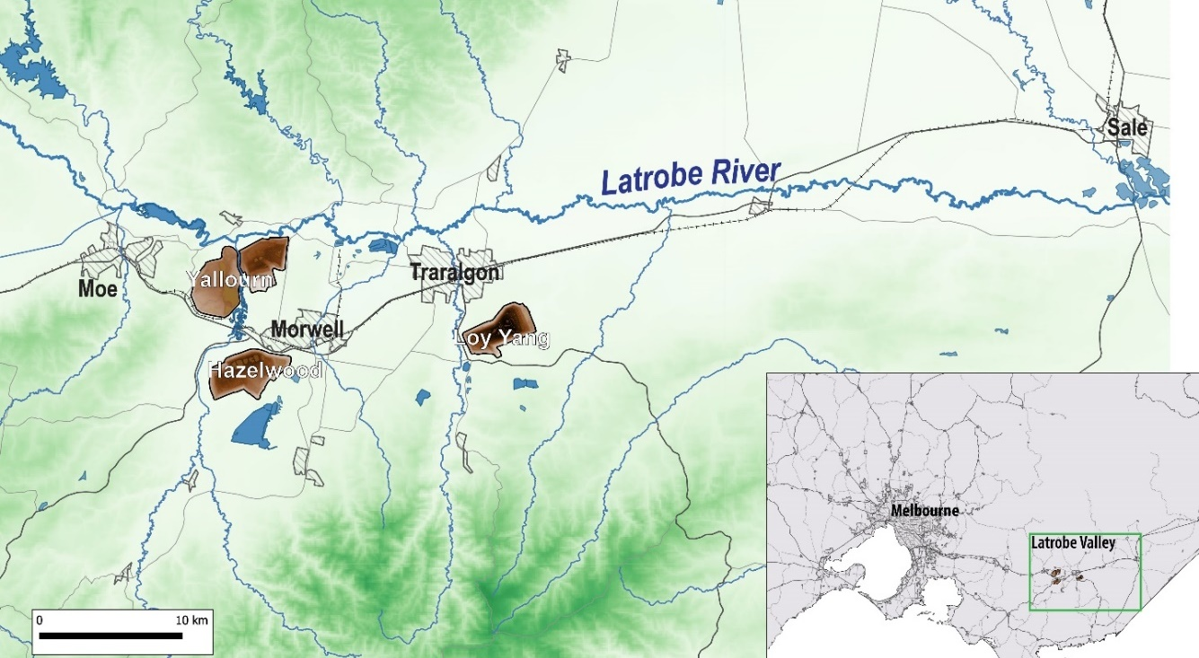
Moe
Morwell
Traralgon
Figure 1 The Latrobe River valley and location of the three brown coal mines around Morwell and Traralgon, ~150 km east of Melbourne

Purpose
The purpose of this document is to provide background information for the Victorian community and other interested parties to appreciate the history of coal mining in the Latrobe Valley and introduce its declared mines.

Acknowledgements
MLRA would like to thank the following, for their assistance with this document:
- Engie Hazelwood
- EnergyAustralia Yallourn
- AGL Loy Yang
- Yallourn North & District Historical Society, Old Brown Coal Museum

Limitations
This report was prepared based on available public information at the time, sourced from multiple locations. The MLRA fact checked as far as reasonably practical, to ensure the information is factual, however the MLRA holds no responsibility for information contained within this document.

Definitions & Acronyms
Definitions considered useful for the improved creation, use and understanding of this document have been identified.
Reference | Definition
The Australian Height Datum (AHD) | The Australian Height Datum 1971 (AHD71) is the official elevation datum for Australia. The datum approximates mean sea-level (MSL) between 1966-68, as measured around Australia.
Relative Level (RL) | A reduced, or relative level, is an elevation measured relative to a known datum. RLs are commonly referenced to MSL, but in elevated regions may instead reference a local datum for convenience.
Declared Mine | A mine that has geotechnical, hydrogeological, water quality or hydrological factors that may be deemed to pose significant risk of harm to the community, environment, and infrastructure.
Overburden | Near surface materials lying above the ore body that are removed for the mining process
SECV | State Electricity Commission Victoria
CFA | Victorian Country Fire Authority
HMFI | Hazelwood Mine Fire Inquiry
Refer to the MLRA Vocabulary for all other definitions and reference.

Geology of the Gippsland Basin
Formation of the Gippsland Basin began with the rifting and breakup of Australia and Antarctica around 100 million years (Ma) ago, in the mid-Cretaceous. Extension and stretching of the crust developed graben and half-graben structures – elongated, steep sided basins – that progressively filled with sediments as the Tasman Sea opened in the (present day) east. These sediments are collectively named the Strzelecki Group and outcrop in West Gippsland, where black coals were mined at Wonthaggi, Kilcunda and elsewhere (Figure 2).
As the Tasman Sea continued to open, the Cretaceous Strzelecki Group sediments were uplifted and eroded. The first deposition of brown coal in the Latrobe Valley occurred around 25 Ma ago on the eroded surface of the Strzelecki Group. Over the next 16 million years enormous amounts of organic matter accumulated, as trees and plants growing in vast swamps across the region died as the underlying basin slowly subsided. This organic matter formed peats that were isolated and protected behind the Seaspray Formation – an extensive coastal barrier system of marine limestones and marls (muddy limestones) that are the same age as the coal. The peats were progressively buried and compressed, forming brown coal.
Brown coal in the Latrobe Valley is divided into 5 major seams spanning the Traralgon, Morwell, and Yallourn formations, some of which are up to 100m thick. Falling sea-levels around 3 Ma driven by glaciation produced deposition of the riverine Boisdale and Haunted Hills formations. These formations form a veneer (cover) up to 200m thick of clastic sediments – cobbles, gravels, sands and silts – deposited by high energy braided rivers that, in places, erode the underlying coal seams.
The riverine deposits of the Boisdale and Haunted Hills formations are around 6 Ma years younger than the underlying coals. This timeframe records an important period during which the region was uplifted, ending the deposition of coal, and eroded by rivers and streams.
Global warming and rises in sea-level in recent geologic time have resulted in decreases in sediment volumes, as rivers such as the Latrobe River (Durt’Yowan) reverted to lower energy meandering forms. Evidence for this can be seen in the broad alluvial plains of the present day Latrobe Valley, which are punctuated with abundant billabongs and marshes that mark long abandoned meander bends where the Latrobe River previously flowed. The Haunted Hills Formation mirrors this current day Latrobe River system, indicating that the Latrobe Valley has experienced only modest geologic evolution over the last tens of millions of years.
Refer to Appendix A for reference documents.

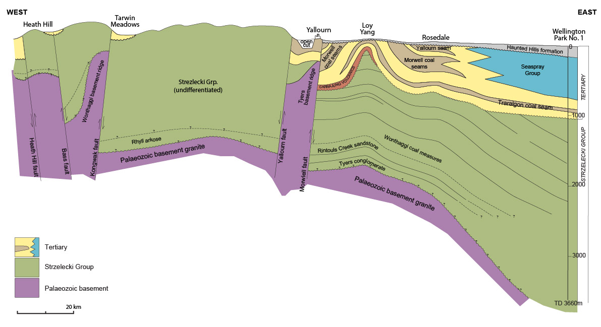
Figure 2 Geologic cross-section showing the coal-bearing Strzelecki Group (Cretaceous) and Latrobe Group (Tertiary) overlying Palaeozoic continental crust (basement). Figure modified after Phillips G. N. et al. (2003)

History of Mining and Brown Coal in Latrobe Valley
The Latrobe Valley contains a quarter of the world’s known brown coal reserves, an estimated 65 billion tonnes. Geologically older, more energy dense black coal had been discovered and commercially mined in the Latrobe Valley from 1873 but proved uneconomic. The first reported brown coal discoveries date from 1867 at Yarragon, west of Morwell. The Great Morwell Brown Coal Mine was formed in 1888, mining brown coal on the north banks of the Latrobe River close to the subsequent Yallourn North Open Cut mine.
From 1882 the state government undertook drilling to establish the extent of the younger, less energy dense brown coal reserves. A Royal Commission in 1889 outlined aims to exploit brown coal deposits across Victoria for a range of uses, including electricity generation. This followed the declining reliability of black coal supplies from interstate, and a dramatic increase in demand for electricity for things such as rail and tram networks, street lighting, local gasworks and factories. By 1916, drilling had concentrated on the ‘Morwell Coal Field’ on the south bank of the Latrobe River, the present-day site of the Yallourn mine
Following the First World War, in 1918 the Victorian Government established the Electricity commission (later renamed the State Electricity Commission Victoria, or SECV, in 1921) to assure reliable coal supply and power for Victoria. Sir John Monash was appointed Chairman of the Commission in 1920, and immediately sought expert advice from Germany on how best to manage the high-water content of the brown coal to convert it into electricity.
The Latrobe Valley coal is currently being extracted at the following declared mines:
- Yallourn (currently operated by Energy Australia) – 1921 – to present (Heritage Vic, Coal-mining-heritage-study-in-Victoria-Vines-2008.pdf).
- Loy Yang (currently operated by AGL) – 1984 – to present.
- Hazelwood (currently in rehabilitation phase, operated by Engie) between 1948 and 2017.
All three coal mines and their associated power stations were previously owned and operated by the SECV and privatised in the 1990s. The Loy Yang mine supplies coal to two power stations – Loy Yang A and B – owned and operated by AGL and Alinta Energy, respectively.
At its peak, the Latrobe Valley power stations and mines supplied over ninety percent of Victoria’s electrical power needs from brown coal combustion (almost 54,000 GWh) and continues to supply over 60% of the States power from the three remaining power stations – Yallourn, and Loy Yang A and B. This has resulted in three very large, deep pits (200m deep at Loy Yang) following extraction of more than 2.5 billion tonnes of brown coal (to date) which is only a small fraction of the total reserves in the region.

Yallourn
Located to the east of Moe and at the intersection of the Morwell and Latrobe Rivers, the Yallourn mine is the oldest of the three open cut coal mines. It is also the shallowest, but still with an average mining depth around 90m and exceeding 120m in places. Yallourn mine has produced over 1 billion tonnes of brown coal since the 1920s. Up until the 1950’s the mine was the single largest employer in the region and at its peak extracted over 22 million tonnes of coal (1981-82).
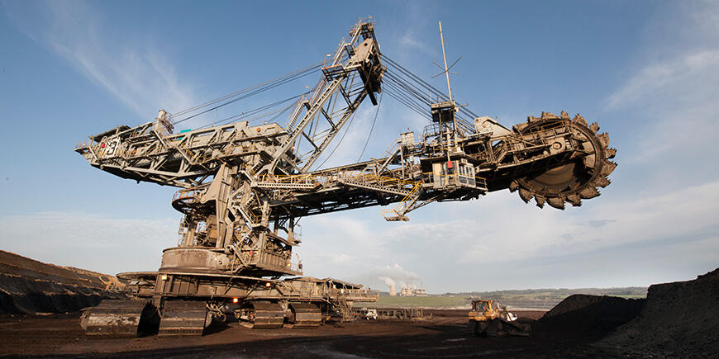
Figure 3 The bucket wheel excavator (dredger) at Yallourn (picture by Energy Australia).
As of 2024 Yallourn provides up to 22 per cent of Victoria’s energy supply or eight per cent of the National Electricity Market. Yallourn was announced as a Declared Mine under the Mineral Resources (Sustainable Development) Act 1990 (MRSDA) by the Minister on 30th Jun 2005.

The History of Yallourn
Coal in the Latrobe Valley was first recorded by settlers in 1873, with coal extraction by the Great Morwell Coal Mining Co. commencing in 1888 on the banks of the Latrobe River, north of the present-day Yallourn mine. A royal commission in 1906 determined that a state-run coal mine should be established in the Latrobe Valley, but it was not until 1916 that the state began testing coal deposits and planning for development.
This period saw the evolution of the Latrobe Valley from a predominantly agricultural region to one dominated by power generation. In 1922, John Monash estimated that power could be transmitted at 132KV along 90 miles of lines at a cost of £600,000. Coal mined at the Yallourn open cut was initially pressed into briquettes for combustion, then from 1924 fed directly into a power station constructed adjacent to the mine. Power generated at Yallourn first reached Melbourne in 1924, providing cheap energy for manufacturing and households, and from the 1930s to 1950s it began supplying towns across the state. Some key events in Yallourn Mines’ history are described below.

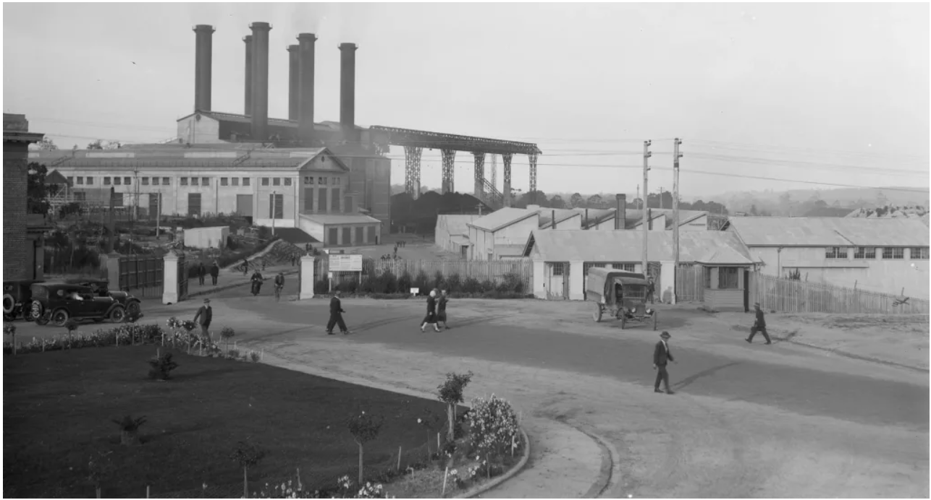
Figure 4 – J.P. Campbell (ca.1920-ca 1940). Yallourn Power Station H2009.18/989. Pictures Collection, State Library Victoria.

Relocation of the Yallourn Township
Yallourn Township was originally established by the SECV as a company town to support the nearby Yallourn coal mine and power station. With the construction of the new Yallourn W power station, the decision was taken in 1970 to move the Yallourn township to access the higher quality coal lying underneath. The SECV initiated the gradual relocation of both houses and residents from Yallourn, which continued into the early 1980’s.
The relocation of Yallourn resulted in the displacement of residents and the disruption of established communities, moving houses, infrastructure, and facilities to new locations further away from the active mining areas. The process involved complex planning and demonstrated the challenges involved in managing urban development in resource-rich regions. These challenges include balancing the physical development on land impacted by mining activities, but also protecting natural resources while meeting energy production needs.
The relocation of Yallourn is part of the region's historical legacy and is part of the lived experience of many residents in the area, shaping the cultural identity and memory of its community. It serves as a reminder of the region's industrial heritage and the challenges faced by communities living in resource-dependent area.

The Latrobe River Floods
The present-day Yallourn mine sits within the flood plains of the Morwell and Latrobe rivers. Extreme high flows in either of these waterways highlight the particular vulnerability of the Yallourn mine to flooding and emphasize the importance of effective flood management measures in the region.
1934 Flood
Over three days from 29th November between 250 and 500 mm of rain fell in the Latrobe Valley, producing the largest floods on record. Despite efforts to manage the rising river levels, flood waters entered the mine void, inundating the mine to a depth of 62 m.
Over a period of twenty weeks after the floods, water was pumped from the mine and damaged machinery reconditioned and returned to mining operations. Infrastructure, including roads, railways, pumping stations and levee banks, were washed away or buried under mud that remained in the bottom of the pit up to 9 months later.

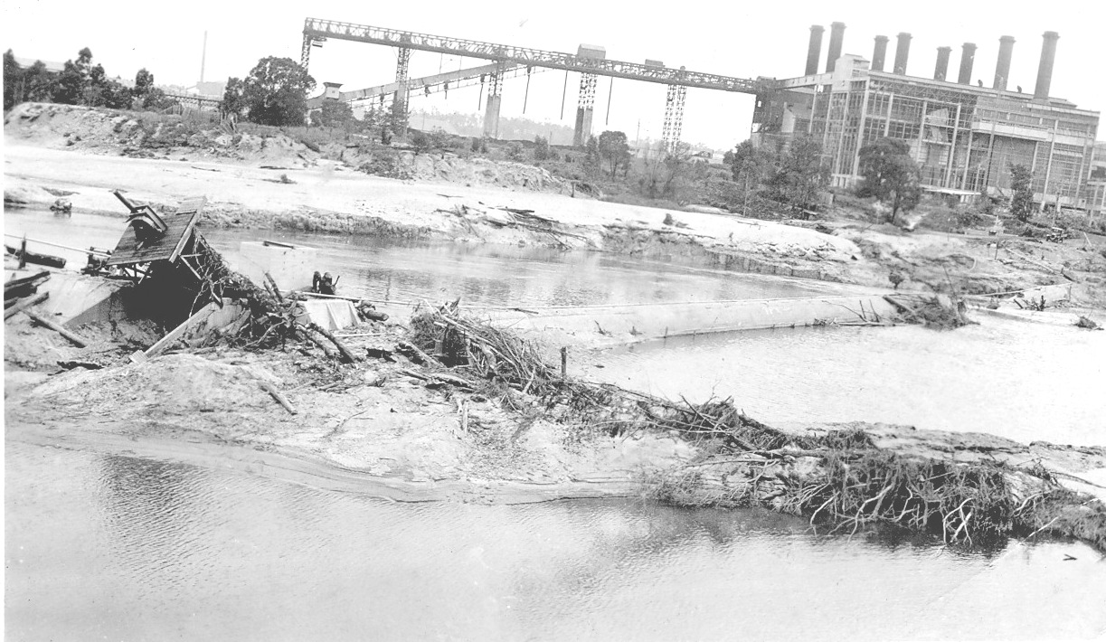
Figure 5a – Extensive flooding damage caused by flooding of the Latrobe River, 1934. Photo courtesy of Virtual Yallourn

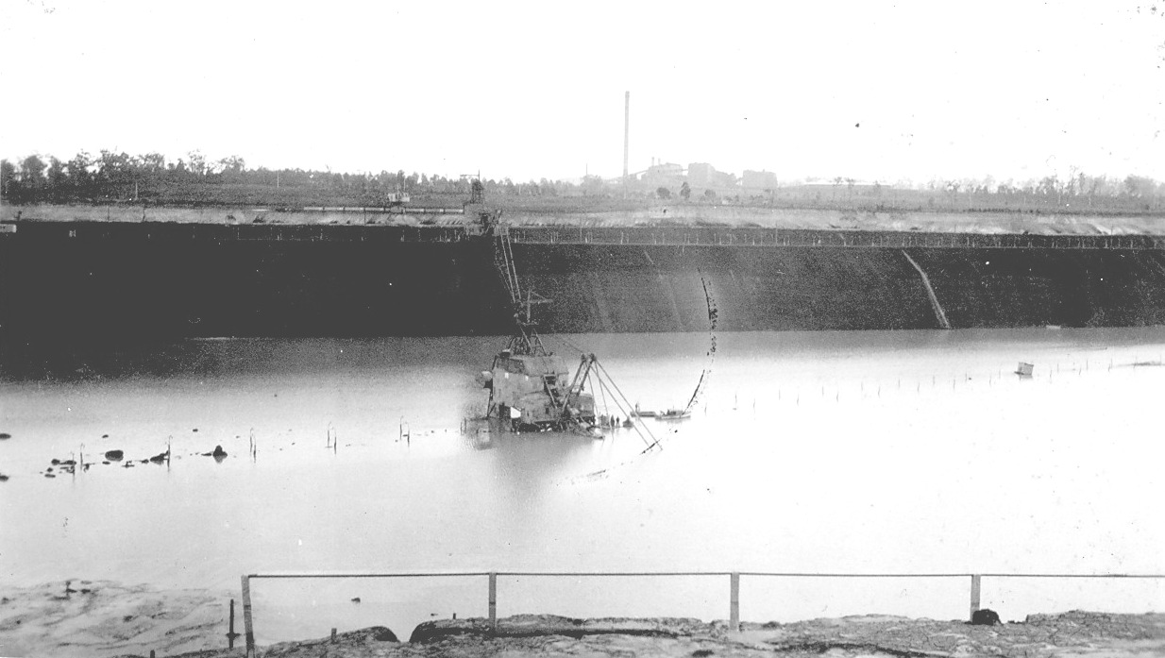
Figure 5b – Mining equipment impacted by floodwaters, 1934. Photo courtesy of Virtual Yallourn

Morwell River Diversions (Yallourn)
The Morwell River was first diverted in the 1980s by the SECV. By 1987 the construction of a 3.8km long buried “low flow” pipeline at Yallourn was completed, diverting baseflows to the south and east of the East Field.
Between 2001 and 2005 the Morwell River was diverted again, to allow mining to continue. This time the river diversion was constructed through the middle of the mine, dividing the mine into the East and Maryvale fields in the east, and Township field in the west. The present day Morwell River Diversion (MRD) is an earthen embankment constructed on a remaining coal causeway with overburden placed around it and on top.

Latrobe River Enters Yallourn Mine 2007
In 2007, a batter collapse occurred along the northeast section of the mine. The collapse was estimated to be approximately 6,000,000 m³ in size, extended back to the nearby Latrobe River and resulted in the entire river flow entering the mine. This temporarily reduced the downstream flows within the Latrobe River likely leading to some negative environmental effects. Outcomes of the batter failure led to the damage of mine infrastructure, disruptions to coal production and supply to the power station.
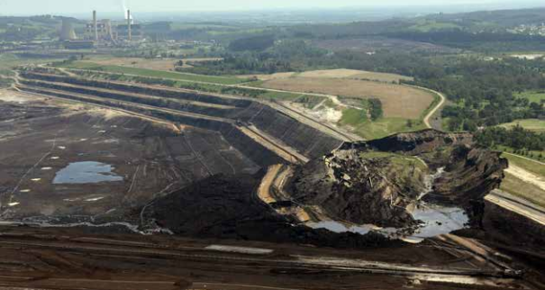
Figure 6 Yallourn Mine after Latrobe River enters, picture HMFI Report. 2015-2016

Morwell River Enters Yallourn Mine 2012
Heavy rainfall during June 2012 resulted in the MRD being close to capacity. On June 6th a section of the diversion embankment failed, allowing water to flood into the inactive (western) Township Field. When excessive floodwaters could not be pumped out of the mine, coal supply from the East Field was disrupted, leading to a reduction in power generation to a quarter of its usual capacity.
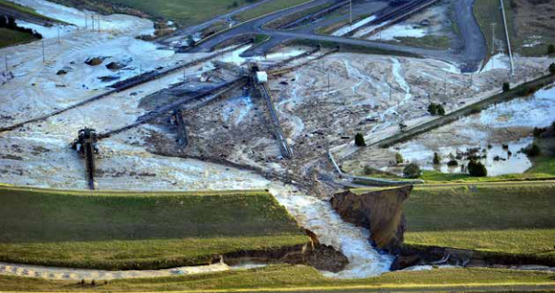
Figure 7 Yallourn Mine after Morwell River enters, picture HMFI Report 2015-2016
Emergency response measures, including pumping water from the mine, repair and reconstruction efforts, were swiftly initiated to mitigate the impacts of the flood. It was not until October of 2013, however, that all water had been evacuated from the mine, repair works completed, and river flows returned to the MRD.
The 2012 Morwell River Diversion collapse highlights the vulnerability of mining operations and associated infrastructure to natural events, particularly flooding, and underlines the importance of effective risk management and preparedness in the mining industry.

Morwell River Diversion Event 2021
From the 9th to the 10th of June 2021 very heavy rain fell on the Strzelecki Ranges – over 200 mm was recorded overnight in some locations. The rainfalls resulted in a one in 75-year event on the Traralgon Creek, and severe flooding on the Morwell River that caused damage to the southern end of the MRD at the Yallourn mine.
The flooding resulted in cracking in one part of the MRD structure. Failure of the MRD would have resulted in the Morwell River inundating Yallourn mine, which would have impacted power production at Yallourn power station as well as having environmental consequences.
In July 2021 the state government gave permission to the mine’s owner, Energy Australia, to direct river flows around the MRD and into the nearby Latrobe River. The temporary diversions were required to reduce the Morwell River flows, so that a detailed assessment of the MRD could occur, followed by any repair works. The diversions included a range of on-site and off-site options. Except for flood waters, all Morwell River flows were transferred directly to the Latrobe River along large high-density polyethylene piping laid in parallel to the MRD.
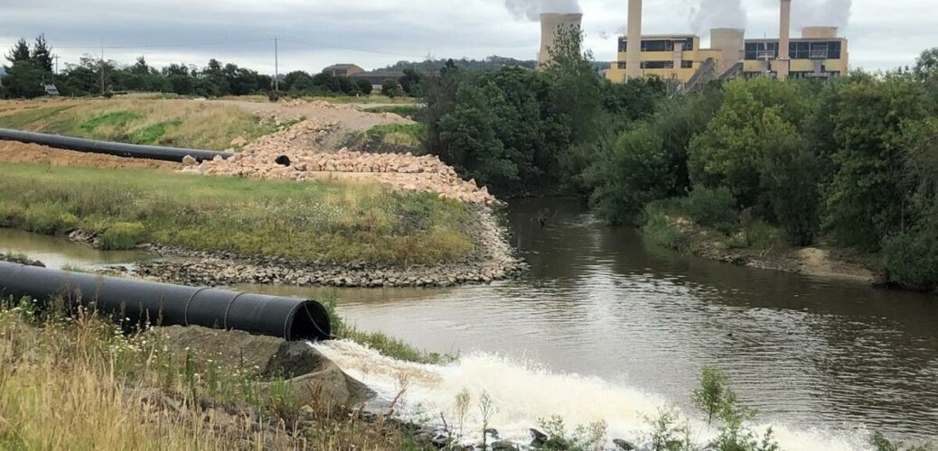
Figure 7 - 2021 A temporary river diversion (via a polyethylene pipes) was employed to support the repair of the Morwell River Diversion, picture EA website
Upstream of the MRD at the Hazelwood mine an engineered weir was subsequently constructed to provide the option to divert floodwaters into the Hazelwood mine void. This facility was employed over the 2022 winter period to attenuate flows from high rainfall events in the Morwell River, helping to reduce the risk to the MRD while repair works were carried out.

Cease Mining and Rehabilitation
In March 2021 the operator of Yallourn, EnergyAustralia, announced that it will cease mining operations at Yallourn in June 2028 and enter its Closure Implementation phase, 4 years ahead of schedule. Closure is the term used to describe all planning, decommissioning and rehabilitation of a site in order to relinquish the mining license (see Vocabulary | Mine Land Rehabilitation Authority).
EnergyAustralia is currently undertaking closure planning for their preferred rehabilitation option of a pit lake level of +37 mAHD and preparing to submit regulatory documents in 2025. The company will continue to manage the risks at the site until rehabilitation is complete, at which point the site is deemed to be safe, stable, and sustainable. This point is determined by assessment against prescribed closure criteria (see Fig. 8), which form a key part of the mine’s Declared Mine Rehabilitation Plan (DMRP).

Hazelwood
Located to the south of Morwell, the open cut mine ceased operations in March 2017 with the closure of Hazelwood power station by its owner, ENGIE. Planning for final rehabilitation of the 120-metre-deep mine is underway with significant “no regrets” earthworks focused on the safe, stable, and sustainable rehabilitation of the site. Demolition of the former Hazelwood Power Station and mine infrastructure, which cover an area of approximately 4000 hectares, was largely finalised in 2022.
At its peak Hazelwood mine produced up to 18m tonnes of coal per year.
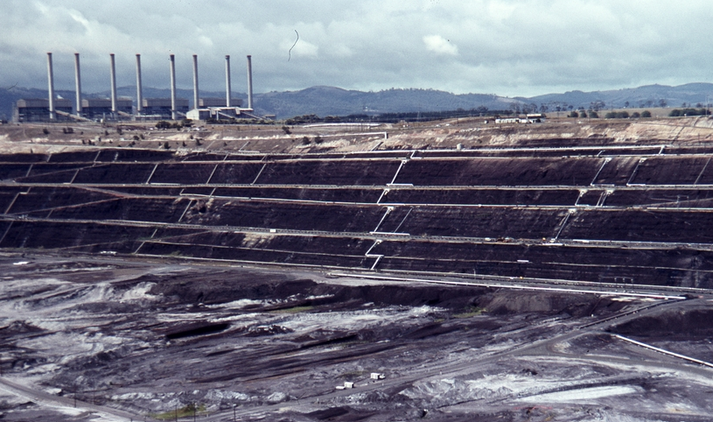
Figure 9 - Morwell Open cut brown coal mine, (400469.jpg) Jan 1983 courtesy of Weston Langford Photography (licence free).
Hazelwood was announced as a Declared Mine under the Mineral Resources (Sustainable Development) Act 1990 (MRSDA) by the Minister on 30 Jun 2005.

The History of Hazelwood
Mining of coal south of Morwell commenced in 1948 as part of the ‘Morwell Project’, which extracted coal from the Morwell open cut mine intended to produce briquettes for power and gas generation. The Morwell Project stalled during the 1950’s, and by 1959 Morwell coal was found to be unsuitable for manufacturing briquettes. The mine was renamed the Hazelwood mine in 1959 to reflect its proximity to the nearby district of Hazelwood and its association with the SECV Hazelwood Power Station. The renaming occurred to better align the mine's identity with its operational context and to distinguish it from other coal mines in the area.
Power generation facilities at the mine were planned and brought online between 1964 and 1971, heralding a new era of electricity generation fuelled by brown coal extracted from Hazelwood. With eight generating units, it became one of the largest power stations in Australia, capable of producing up to 1,600 megawatts of electricity at its peak. Utilising the abundant and inexpensive brown coal reserves found in the Latrobe Valley, Hazelwood played a vital role in meeting Victoria's growing energy demands for decades. Some key events in Hazelwood Mines’ history are described below.
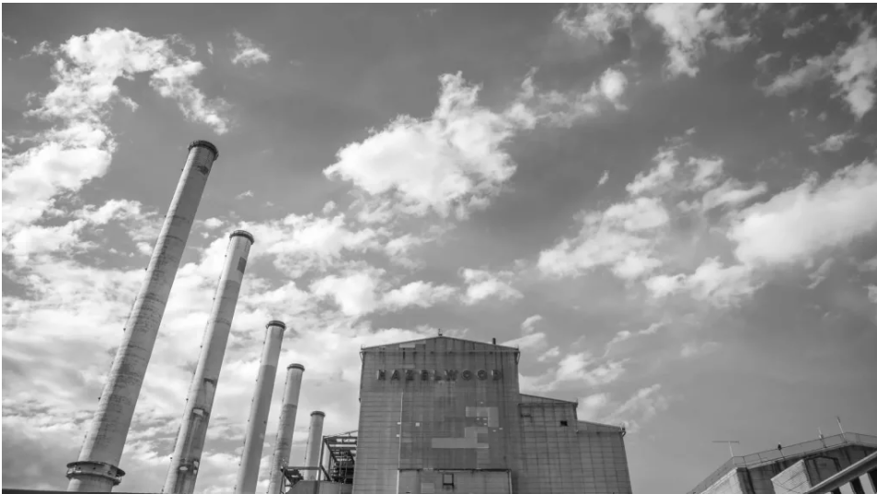
Figure 10 – Credit Hazelwood Stacks (year – unknown) ENGIE Australia.

The Morwell River Diversion (Hazelwood)
The Morwell River was approved for diversion in 2005, and diverted shortly after, to facilitate coal mining operations at the Hazelwood mine, as the original course of the river intersected areas designated for mining activities. To enable these mining operations to proceed, it was necessary to divert the river to avoid interference with mining infrastructure and to manage water flow in the area.

The Hazelwood Mine Fire
The Hazelwood mine fire began on 9 February 2014, during a period of severe hot weather, and lasted for 45 days. It began when nearby grassfires, started deliberately, spread into the mine site in several locations.
The mine fire was particularly difficult to control due to the burning coal seam. Fire fighters from the CFA, interstate agencies and the mine operators were deployed over the duration. The fire continued burning for more than six weeks, with the CFA declaring it safe on 25th March 2014.

The Hazelwood Mine Fire Inquiry
In 2014 and 2015 the Victorian Government held the Hazelwood Mine Fire Inquiry (HMFI). The inquiry was conducted in response to the Hazelwood Mine Fire and lasted several years.
The HMFI found gaps in the adequacy of the then-current regulatory framework, noting that it was “ill-suited to contemporary needs”, and identified the need for more work to be done to improve the regulatory framework to ensure that rehabilitation is done successfully. In addition to issues surrounding the regulatory framework, the HMFI also identified issues relating to the communication between the key parties involved in mining operations and rehabilitation, often working in isolation, highlighting the need for coordination and collaboration to improve rehabilitation outcomes for the Latrobe Valley Mines.
The Victorian Government committed to all 246 recommendations resulting from the inquiry, which have been tracked and reported on over a number of years.

The Morwell Main Drain Sink Hole and the Movement of the Princes Highway
In February 2011, a large sinkhole opened at the main drain at Hazelwood mine, which transferred surface water drainage from Morwell township to the wetlands north of Hazelwood Mine. The sinkhole was likely caused by ingress of water and ground movement of due to historical mining activities.
The sinkhole caused cracking in the Princes Freeway (formerly known as the Princes Highway) a major arterial road in the region, which prompted the temporary closure of a section due to concerns about its stability and the potential risk to public safety. The closure disrupted traffic and necessitated detours for commuters traveling through the area. Engineers and geologists were deployed to assess the sinkhole and the cracking, to determine the extent of the risk posed.
The incident underscored the ongoing challenges associated with the legacy of coal mining in the Latrobe Valley, including the need to manage land subsidence and rehabilitate former mine sites effectively. It also highlighted the importance of ongoing monitoring and maintenance efforts to ensure the safety of infrastructure built on or near areas affected by historical mining activities.

Ceased Mining and Rehabilitation
The cessation of mining operations in March 2017 at the Hazelwood mine, owned by ENGIE, highlighted the rapidly changing economic environment for brown coal mining and the need for mine rehabilitation preparedness.
Since its closure ENGIE has completed ‘no regrets’ rehabilitation works agreed to by the Earth Resources Regulator (ERR). These works have included buttressing and placing surcharges (earthen counterweights) on selected batters and lowering the gradient of batters above the proposed final pit lake’s water line to 1V:3H and covering these slopes with clay and topsoil. These works were deemed necessary to manage potential instabilities within the mine that arise following large scale coal extraction.
ENGIE has demolished the 8 Hazelwood power station chimneys, boiler/ turbine houses and mining dredgers in 2020/21, and continues to decommission mining infrastructure at the site. In 2020 ENGIE submitted a work plan variation that included a Rehabilitation and Closure Plan proposing a full pit lake (45m AHD) as the final rehabilitation concept.
ENGIE is currently in the process of undertaking an Environmental Effects Statement, which considers a final lake level of RL +45m and constructing its Declared Mine Rehabilitation Plan (DMRP).
The mining license at Hazelwood is due to expire in September 2026

The Morwell River Diversion (Flood Protection)
In 2021/22, following a severe flood event in mid-2021, the Morwell River Diversion nearly failed at Yallourn Mine. In order to repair it, water had to be diverted. Part of the diversion plans included taking flood and some high flow waters into the Hazelwood Mine pit.
Hazelwood, ENGIE, in conjunction with Yallourn and at the request of the State Government, received approval to construct a flood diversion channel and weir on the Morwell River upstream of the mine. The weir was employed during high rainfall in 2022 to divert some flood waters into the Hazelwood pit and reduce risk downstream at Yallourn (see previous). It was agreed that although the water could remain in the Hazelwood mine pit to cover exposed coal and help reduce the risk of fire over the summer, these actions have no bearing on the final rehabilitation outcome for the Hazelwood mine.

Loy Yang
Located to the south of Traralgon in the Latrobe Valley, Loy Yang is Victoria’s largest open cut brown coal mine and is owned by AGL Energy. Coal is mined to depth of more than 200m with an annual output exceeding 30 million tonnes of coal and three-four million cubic metres of overburden.
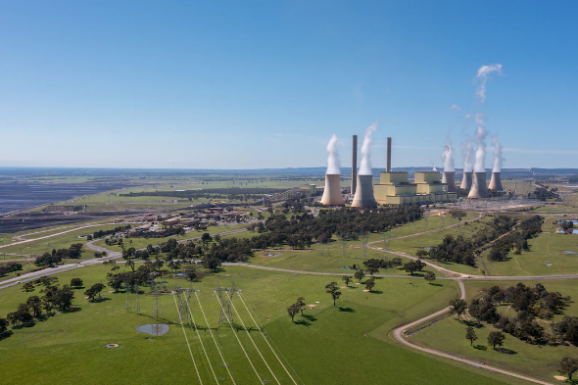
Figure 12 – Credit Loy Yang Aerial Photo AGL Energy Ltd (date unknown)
The Loy Yang mine supplies coal to two power stations: Loy Yang A and Loy Yang B. The Loy Yang A has 4 power generating units, with an approximate capacity of 2,210MW and generates approximately 30% of Victoria’s power requirements, producing enough power to supply over 2 million average Australian homes every year. Loy Yang B has 2 units, with an approximate capacity of 1,070MW
The mine along with the Loy Yang A and B power stations, employs approximately 750 full time personnel and up to 340 contractors.
Loy Yang was announced as a Declared Mine under the Mineral Resources (Sustainable Development) Act 1990 (MRSDA) by the Minister on 30 Jun 2005.

The History of Loy Yang
In 1976, the Victorian Parliament authorised the Loy Yang Project and construction commenced in 1977. In 1982, the first dredger at the mine was commissioned and commercial operations commenced with the removal of overburden on 1 October 1982. The first coal deliveries occurred in July 1983, with commercial operation of the first 500 MW power unit officially started on 30th June 1984.
The Loy Yang facility was originally constructed by International Combustion Australia, who were contracted by the government owned SECV. The development consisted of two separate power stations, Loy Yang A and Loy Yang B. Loy Yang A was commissioned between 1984 and 1988, and Loy Yang B was added between 1993 and 1996.
AGL Energy Limited acquired Loy Yang A in 2012. Loy Yang B was acquired by Alinta in 2018 from the previous joint owners GDF SUEZ Australian Energy and Mitsui and Co Ltd. Some key events in Loy Yang Mines’ history are described below:
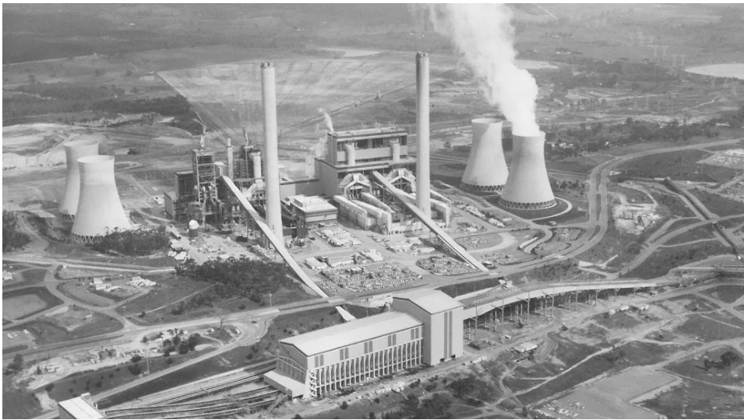
Figure 13 – Credit: Loy Yang Aerial Photograph, (ca:1980’s) – supplied by AGL

Community Opposition
On September 3, 2007, activists from Real Action on Climate Change chained themselves to the coal conveyor belt from the Loy Yang Mine which supplies coal to the brown-coal-fired Loy Yang A and Loy Yang B power stations. The action took place several days before an Asia-Pacific Economic Cooperation summit in Sydney and was intended to draw attention to Prime Minister John Howard's failure to limit Australian carbon emissions. Four people were arrested.

Environment Victoria Legal Action against AGL
On 23rd September 2021 Environment Victoria took legal action against the Environmental Protection Authority (EPA) and the operators of the three Latrobe Valley power stations, including AGL Energy (owner of Loy Yang A), for failure to manage climate pollution. The case challenged the EPA’s decision to not prescribe a direct restriction on the power stations’ greenhouse gas emissions. This was the first case to test the Victorian government’s climate change law. In December 2022, the Supreme Court of Victoria dismissed the case, concluding that the EPA did not fail to act unlawfully and that climate change considerations were satisfactorily regarded as part of the EPA’s decision-making process.

Loy Yang A Shutdown
On 13th February 2024 all four units at Loy Yang A shut down after two transmission lines collapsed in a severe storm event. Thousands were without power due to a combination of extreme temperatures, strong winds and extensive lightning strikes, which damaged electrical infrastructure across parts of Victoria. By 14th February 2024, two of the four units had returned to service with the other two units progressively brought back online after.

Cease Mining and Rehabilitation
AGL is scheduled to cease mining operations at Loy Yang in June of 2035 and enter its rehabilitation and closure phase. AGL is licensed to extract coal until 2048 in partnership with the owner of Loy Yang B, Alinta Energy, which has yet to announce any plans.
AGL is currently undertaking closure planning work to meet this date, maturing their preferred option of a “full” pit lake (45 m RL) and preparing to submit regulatory documents in 2025.
AGL will continue to manage the risks at the site until rehabilitation is complete, to achieve a safe, stable, and non-polluting landform and meet their prescribed closure criteria.
Loy Yang mine has had its mining licences extended to 2065, to provide for a period of rehabilitation works.
As part of AGL’s planning for the future of the Loy Yang site, it has committed to a Structured Transition Agreement (STA) with the Victorian Government to support the respectful and constructive retirement of the Loy Yang A Power Station. Loy Yang A power station is scheduled to close in 2035.
Currently, Alinta Energy’s Loy Yang B has a scheduled closure date of 2047.

References
Geology of the Gippsland Basin was created with reference to:
Cupper, M. L., White, S., & Neilson, J. L. (2003). Quaternary: ice ages-environments of change. In W. D. Birch (Ed.), Geology of Victoria (pp. 337–360). Special Publication, Geological Society of Australia (Victoria Division).
Holdgate, G. R. (2003). Coal. World-class energy reserves without limits. In W. D. Birch (Ed.), Geology of Victoria (23rd ed., pp. 489–891). Special Publication, Geological Society of Australia.
Holdgate, G. R., & Gallagher, S. J. (2003). Tertiary. A period of transition to marine basin environments. In Geology of Victoria (23rd ed., pp. 289–819). Special Publication, Geological Society of Australia (Victoria Division).
Leonard J. G. (2003). Groundwater. A vital, renewable resource. In W. D. Birch (Ed.), Geology of Victoria (23rd ed., pp. 519–741). Special Publication, Geological Society of Australia (Victoria Division).
Vocabulary | Mine Land Rehabilitation Authority
Heritage Victoria 2008, Coal-mining-heritage-study-in-Victoria-Vines-2008.pdf.

OFFICIAL
The Mine Land Rehabilitation Authority
65 Church St, Morwell VIC 3840

