Consultation report:

Mine Rehabilitation: The Future Together

On 25 June 2025, the Mine Land Rehabilitation Authority (MLRA) hosted a community open house event titled *Mine Rehabilitation: The Future Together*.

Held at the Latrobe Valley GovHub in Morwell, the event brought together community members, industry representatives, researchers, and government stakeholders. Attendees had the opportunity to speak directly with mine licensees about closure planning and the development of Declared Mine Rehabilitation Plans (DMRPs.) In addition, they gained insights into the regulatory processes involved and connected with both government representatives and researchers. The event also provided material on the *Collaborative Planning for Post-Mining Development in the Latrobe Valley* project, along with guidance on what’s coming next, how to get involved in each process, and where to find further information.

# What We Did

The MLRA established an open house format, allowing attendees to explore various information stations at their own pace. Exhibitors included Energy Australia Yallourn, ENGIE Hazelwood, AGL Loy Yang, Federation University Australia, Resources Victoria, and the MLRA.

Exhibitors were available throughout the day to answer questions and listen to community feedback. The event ran from 11:30am to 5:00pm and was attended by a broad cross-section of the community. Visitors were provided with a broad range of information and materials. To ensure accessibility, key materials were also made available online, and feedback opportunities were provided both in person and via follow-up channels.

# What We Heard

As part of the event, visitors were invited to take part in an interactive *Insights Wall* activity. Visitors were encouraged to write down a word, question, or short comment reflecting something they learned, felt, or were curious about during their visit.

This feedback helped us understand the topics and themes that resonated most strongly with community members.

## Water

One of the most recurring themes was water, its availability, use, management, and restoration. Several notes reflected a desire for clearer information about water use in mine rehabilitation, including concerns about groundwater, the Morwell River Diversion, and calls for better pricing mechanisms to support river restoration. Attendees expressed an interest in more transparent communication about water risks, especially in relation to declared mines and the broader Latrobe River system.

## Timeframes and processes

There was also strong interest in gaining a better understanding of timeframes and regulatory processes, with some visitors questioning the robustness of current regulation and the level of coordination between government and industry.

## Future use and repurposing

Another key area of reflection was the future use and repurposing of mine land. Attendees noted the importance of diversity in repurposing, including both industry and recreation, and expressed a desire to see plans that deliver lasting value for the region.

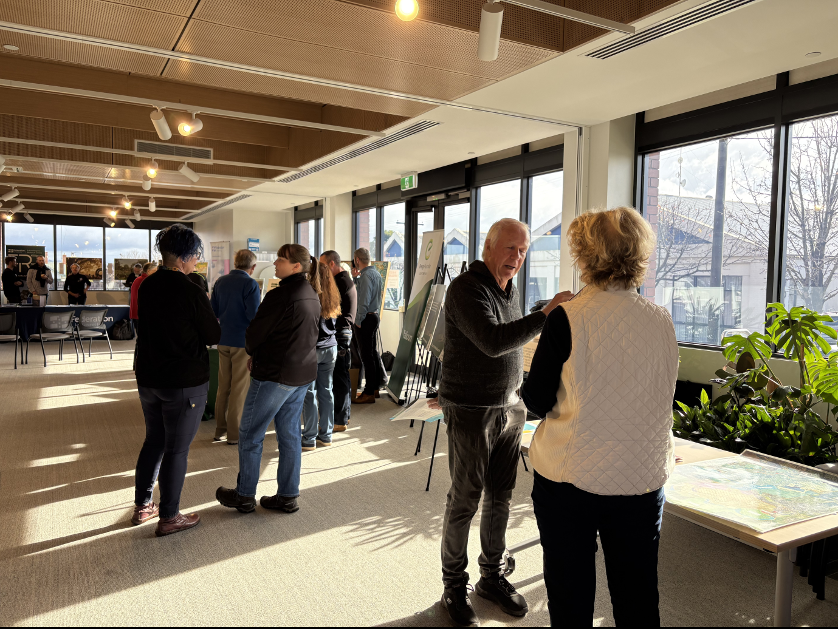

Attendees at the Mine Rehabilitation The Future Together event in discussion

## Engagement

Community engagement itself emerged as a topic of discussion. Some visitors asked whether there is enough inclusion of communities beyond the Latrobe Valley. Others called for ongoing dialogue and deep listening, with several people specifically asking for the event to be held again in future.

Together, this feedback highlights a community that is curious, thoughtful, and invested in the long-term outcomes of mine rehabilitation. It underscores the importance of continuing to create open, accessible opportunities for the public to ask questions, build understanding, and help shape what happens next.

What We Will Do Next

Feedback gathered during the event, including from the Insights Wall and direct conversations, will inform the MLRA’s ongoing community engagement and planning activities. We will:

* Share key themes on our website, in future updates, and with participating stakeholders
* Use the feedback to refine our materials and messaging, particularly around technical content
* Continue working with industry and government to keep community voices central to planning
* Continue to educate and inform the community in relation to mine rehabilitation

We thank all who attended and contributed to the conversation.

# Want to know more?

# If you have any questions or comments, you can contact us by calling 1800 571 966, emailing [contactus@mineland.vic.gov.au](mailto:contactus@mineland.vic.gov.au), following us on social media, or subscribing to our mailing list at [www.mineland.vic.gov.au](http://www.mineland.vic.gov.au).