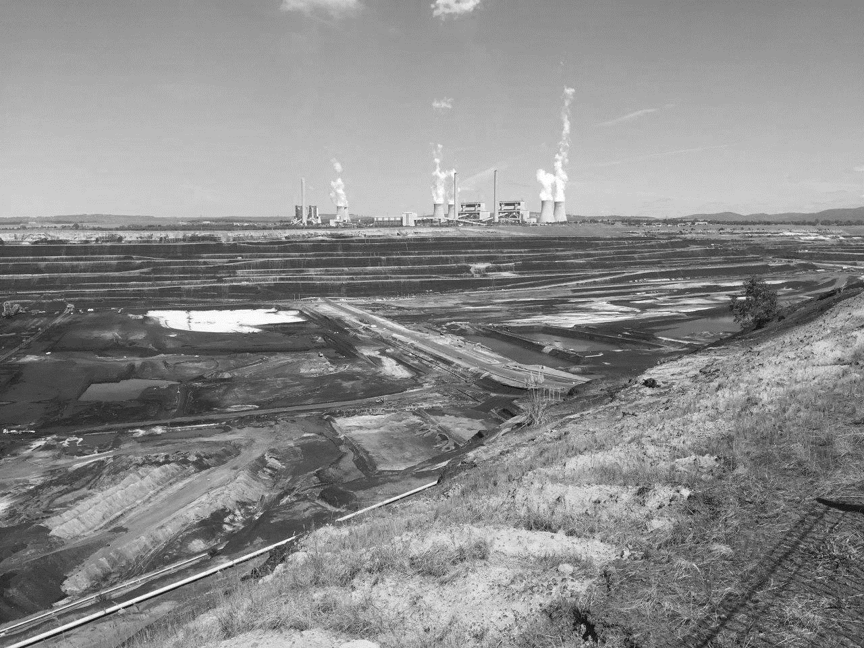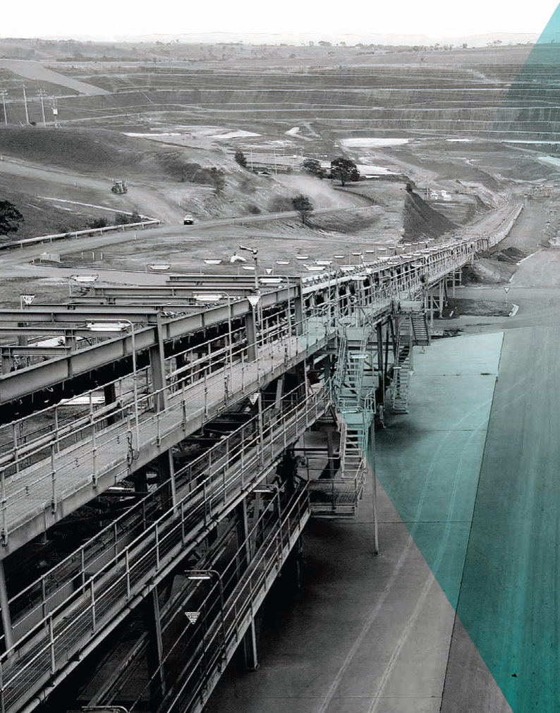

**1**

MINE LAND

REHABILITATION

AUTHORITY

The Mine Land Rehabilitation Authority

**Book 1**

Background information and useful reference regarding the

Mine Land Rehabilitation Authority

*- intentionally blank -*

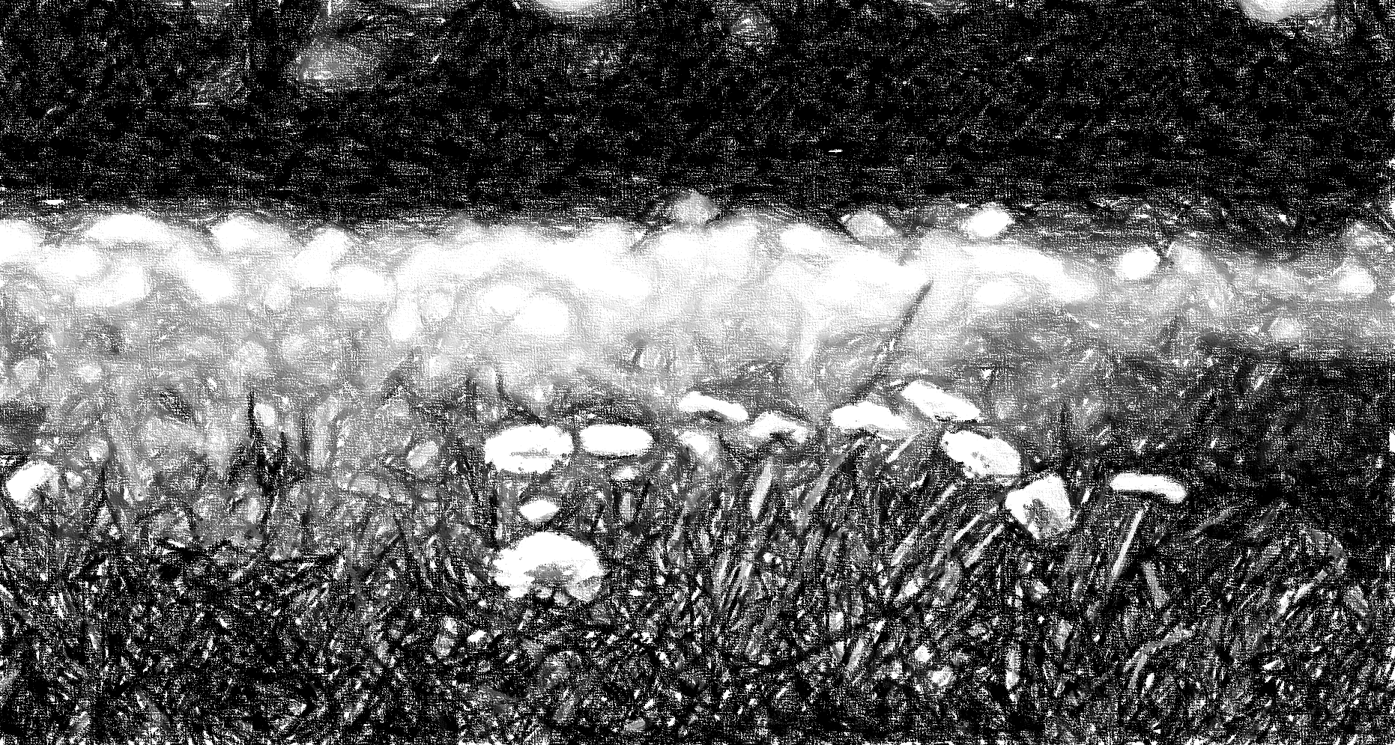The Mine Land Rehabilitation Authority acknowledges Aboriginal and Torres Strait Islander people as the Traditional Custodians of the land and acknowledges and pays respect to their Elders, past, present, and emerging.

Approval for Use

|  |  |  |  |  |  |
| --- | --- | --- | --- | --- | --- |
| Doc Title / Version | |  | | | |
| Classification | | For External Use | | | |
| Version | Date | | Prepared By | Reviewed By | Approved For Use |
|  | 16 September 2024 | | Simon Warren  External | Antonia Scrase Technical Director | Jenny Brereton  Chief Executive Officer |

Contents

1. Introduction 6

1.1. Purpose 6

2. Definitions 7

3. The Evolution of the MLRA 8

3.1. The Hazelwood Mine Fire Inquiry 8

4. The Latrobe Valley Mine Rehabilitation Commissioner 10

5. The Mine Land Rehabilitation Authority 10

5.1. Establishment of the MLRA 10

5.2. Objectives 10

5.3. MLRA’s Phases of Activity 11

# Introduction

Coal mining in the Latrobe Valley has continued for over 100 years. The mines are regulated by the Earth Resource Regulator (ERR) which sits within Resources Victoria (a Department within the Department of Energy, Environment and Climate Action – DEECA). The Mine Land Rehabilitation Authority (MLRA) is a relatively new addition to government, an independent Authority, with the core objective of facilitating good rehabilitation outcomes for the Latrobe Valley.

In February 2014, a fire burned at Victoria’s Latrobe Valley Hazelwood coal mine for 45 days. The fire had a significant impact on the valley and its community.

The Victorian government responded with the 2015/16 Hazelwood Mine Fire Inquiry (HMFI), making recommendations which included the establishment of an independent body to oversee and coordinate the rehabilitation planning and implementation for the Latrobe Valley mines.

In June 2017 the legislation governing mines and mine land in Victoria, the Mineral Resources (Sustainable Development) Act 1990 (MRSDA), was updated. The amended legislation established the Latrobe Valley Rehabilitation Commissioner, an independent appointment, in place until in June 2020, when the Commissioner position transitioned to become the Mine Land Rehabilitation Authority (MLRA).

HAZELWOOD MINE FIRE

*Feb* **2014**

HAZELWOOD MINE FIRE INQUIRY

**2015/2016 February**

*June* **2017**

LATROBE VALLEY COMMISSIONER

*June* **2020**

MINE LAND REHABILITATION AUTHORITY

Fig 1 Timeline of key milestone relevant to the MLRA and its evolution.

## Purpose

The purpose of this document is to provide background information regarding the MLRA and its role in mine land rehabilitation in Victoria. The document is intended to benefit and inform the MLRA’s Stakeholders, the Victorian community, and other interested parties. The document will explain the reasons for the introduction of the MLRA and its evolution to current day, providing an overview of its objectives and its activities in mine land rehabilitation.

# Definitions and Acronyms

Definitions considered useful for the improved creation, use and understanding of this document have been identified.

|  |  |
| --- | --- |
| Reference | Definition |
| DEECA | Department of Energy, Environment and Climate Action |
| DMLR | Declared Mine Land Register |
| DMRP | Declared Mine Rehabilitation Plan |
| LVRRS | Latrobe Valley Regional Rehabilitation Strategy |
| ERR | Earth Resource Regulator |
| EES | Environmental effects Statement |
| HMFI | Hazelwood Mine Fire Inquiry - The inquiry requested by the Victorian Government in response to the 2014 Hazelwood Mine fire. |
| MLRA | Mine Land Rehabilitation Authority |
| The Commissioner | The Latrobe Valley Rehabilitation Commissioner established under the MRSDA as a result of recommendations by the HMFI. |
| Regulatory Framework | The provisions of the MRSDA that apply to the rehabilitation of, and the activities carried out on declared mine; and an approval, authority or permission given, granted or issued under another Act relating to activities, (i) carried out on declared mine land; and (ii) to which a rehabilitation plan applies. |

Refer to the [MLRA Vocabulary](https://www.mineland.vic.gov.au/learn/vocabulary/) for all other definitions and reference.

# The Evolution of the MLRA

The establishment of the MLRA was a recommendation arising from the Hazelwood Mine Fire Inquiry, which highlighted significant issues with both the complexity of the Victorian legislation and the Mine Licensees progress and understanding of the requirements for rehabilitation planning and implementation.

## The Hazelwood Mine Fire Inquiry

The Hazelwood Mine Fire Inquiry (HMFI) found gaps in the adequacy of the then-current regulatory framework, with the *2015/2016 Hazelwood Mine Fire Inquiry Report (Vol IV)* noting that it was *“ill-suited to contemporary needs”,* and identified the need for more work to be done to improve the regulatory framework to ensure that rehabilitation is done successfully (*HMFI Report Vol IV, Part 10, p.180*). In response to these findings, a series of recommendations were included within the *HMFI Report (Vol IV),* to address some of these issues. In particular, ‘*Recommendation 17’*, was raised regarding the need to improve the regulatory framework.

***Recommendation 17***

*Amend the Mineral Resources (Sustainable Development) Act 1990 (Vic) and the Mineral Resources Sustainable Development (Mineral Industries) Regulations 2013 (Vic) to address the issues that have been raised throughout the Inquiry, such as the need for:*

* *a dedicated part of the mineral resources act that exclusively regulates the Latrobe valley mines*
* *definitions and criteria for progressive and final rehabilitation*
* *definitions and criteria for closure*
* *transparent processes for the referral of work plans and work plan variations to relevant State agencies and referral authorities, which compel the Mining Regulator to act on the advice received*
* *strengthened criteria for community consultation an engagement under S.39A of the Mineral Resources Act and/or in community engagement plans*
* *clarity about the roles of the mine operators and the State in ongoing post closure monitoring and maintenance*
* *clarity about the role and required skills and expertise of auditors of rehabilitation liability assessments and the auditor accreditation process (see Recommendation 6).*

Ref: HMFI REPORT 2015/2016 VOLUME IV – MINE REHABILITATION - Recommendation 17

In addition to issues surrounding the regulatory framework, the HMFI also identified issues relating to the communication between the key parties involved in mining operations and rehabilitation. The HMFI found “*that the Mining Regulator has at times acted in isolation from other relevant state agencies, to the detriment of the mining industry and ultimately the broader community”,* *(HMFI Report Vol IV, Part 10, p177)*, noting that there was also evidence which suggested “*a degree of passivity on the part of the mine operators in relation to seeking out answers to important questions such as sourcing water”,* *(HMFI Report Vol IV, Part 10, p.180)*.

The HMFI highlighted the need for coordination and collaboration to improve rehabilitation outcomes for the Latrobe Valley Mines;

***Recommendation 14***

*By 30 June 2017, establish an independent Latrobe Valley Mine Rehabilitation Commissioner, until the statutory authority is established under Recommendation 15. It should be a statutory appointment by amendment to the Mineral Resources (Sustainable Development) Act 1990 (Vic) with the following core functions relevant to mine rehabilitation:*

* *Advising the Minister, State an industry on a range of matters, including policy, legislation and regulation.*
* *Monitoring the implementation and effectiveness of strategies.*
* *Undertaking strategic audits of State departments and mine operators.*
* *Conducting investigations into significant issues with power to obtain information.*
* *Coordinating parties to resolve outstanding issues.*
* *Promoting and coordinating research to address knowledge gaps, as contained in Recommendation 18.*
* *Sharing and publishing information including research findings.*
* *Undertaking public education and community engagement.*
* *Publishing an annual report.*

Ref: HMFI REPORT 2015/2016 VOLUME IV – MINE REHABILITATION - Recommendation 17

***Recommendation 15***

*Establish an independent Latrobe Valley Mine Rehabilitation Authority, as a statutory body by amendment to the Mineral Resources (Sustainable Development) Act 1990 (Vic), to commence no later than 2026, or earlier in the event of premature closure of one of the Latrobe Valley mines. The Statutory Authority’s responsibilities should include those of the Commissioner, with increased or additional focus on the following:*

* *Planning for post closure monitoring and maintenance, including clarifying roles and financial obligations.*
* *Identifying processes for community and key stakeholder input into the assessment of rehabilitation against closure criteria.*
* *Addressing key issues that arise as a result of final rehabilitation.*
* *Monitoring water availability and conducting regional water modelling that more accurately estimates pit lake fill times.*

Ref: HMFI REPORT 2015/2016 VOLUME IV – MINE REHABILITATION - Recommendation 17

In light of the recommendations, the HMFI Board recommended that an independent body was established to oversee and coordinate the rehabilitation planning and implementation for the Latrobe Valley mines, this involved 2 steps:

* in 2017 the introduction of the Latrobe Valley Rehabilitation Commissioner, which then became,
* the MLRA in 2020, by amendment to the MRSDA.

# The Latrobe Valley Mine Rehabilitation Commissioner

Delivering on a key recommendation from the 2015-16 Hazelwood Mine Fire Inquiry, the amendments to the MRSDA in June 2017, introduced the Latrobe Valley Mine Rehabilitation Commissioner.

The Commissioner was appointed by the Governor in Council, with the key objective to monitor and audit mine rehabilitation and consult local communities.

The Commissioner was required to provide independent advice on mine rehabilitation directly to the Government, work in partnership with the Latrobe Valley Mine Rehabilitation Advisory Committee and help develop the Latrobe Valley Regional Rehabilitation Strategy.

Working closely with the community, stakeholders, and the Latrobe Valley mine operators, the Commissioner would oversee individual mine licensees' rehabilitation planning for each of the coal mines in the Latrobe Valley.

# The Mine Land Rehabilitation Authority

## Establishment of the MLRA

The MLRA is an independent authority established on 30th June 2020 pursuant to *S.84AD* of the MRSDA, under amendments made by the Victorian government in response to a recommendation from the 2015/16 Hazelwood Mine Fire Inquiry;

***84AD Mine Land Rehabilitation Authority***

1. *The Mine Land Rehabilitation Authority is established.*
2. *The Rehabilitation Authority—* 
   1. *is a body corporate with perpetual succession; and*
   2. *may sue and be sued; and*
   3. *may acquire, hold and dispose of real and personal property; and*
   4. *subject to this Act, may do and suffer all acts and things that a body corporate may by law do and suffer.*
3. *The official seal of the Rehabilitation Authority must be kept as directed by the Rehabilitation Authority and must not be used except as authorised by the Rehabilitation Authority*

The MLRA replaced the Latrobe Valley Mine Rehabilitation Commissioner and is tasked with delivering rigorous, clear, and independent advice within a framework of collaboration, education, and engagement.

## Objectives

The MLRA holds three primary objectives:

* Conduct meaningful engagement – communicate, listen, collaborate, inform
* Evaluate, facilitate, and advise – on plans and information, sharing between stakeholders and provide timely, relevant advice and recommendations
* Provide technical expertise – expert resources, knowledge acquisition, facilitate research where required and provide robust and forthright advice

The MLRA facilitates equitable, informed mine rehabilitation outcomes for all, working with community, industry, and government to oversee the rehabilitation of declared mine land and work collaboratively towards its transition to safe, stable, and sustainable post-mining landforms.

## MLRA’s Phases of Activity

While the MLRA’s activities are directly related to declared mines and their progression towards a completely rehabilitated site, the MLRA’s remit is wider than that. Its remit lasts for longer than the mine licensees and has the potential to include rehabilitation activities. As such, the MLRA’s activities do not easily follow the life cycle of a mine.

To structure the MLRA’s activities, considering the legislative requirements and limitations, two distinct phases have been identified, based on the level of control and direct input the MLRA has on the rehabilitation work being undertaken. It is likely that there will be overlap between phases. These phases are:

* The Engagement Phase.
* The Registered Declared Mine Land Phase.

### Engagement Phase

The MLRA fulfills dual roles of facilitation and advice prior to a mine licensee’s application to assess whether they have met their closure criteria and may relinquish their license. There is a range of activities that the MLRA conducts which include (but are not limited to):

* Consultation and facilitation of rehabilitation planning,
* Advice and review of DMRPs,
* Review of Closure Criteria and Post-Closure Plans,
* Participation in the EES process,
* Periodic reviews of the LVRRS and
* Support of research relevant to rehabilitation to grow knowledge and understanding in the Victorian community.
* Conduct a range of education and engagement activities

**POLICY & PLANNING**

**PUBLIC SECTOR BODIES**

**REGULATORS**

**Engagement Phase**

**LVRRS**

Develop relationships to formally consult and discuss opportunities for improvement and change to improve rehabilitation outcomes.

**EDUCATION**

**DECLARED MINE LICENSEES**

**COMMUNITY**

Refine Current Plan - engage, facilitate, influence.

**MINISTERIAL**

**STRATEGIC AUDITS**

MEF

**NEW DECLARED MINES**

*Figure 1: Engagement Phase*

The MLRA has a legislated role to provide advice to the Minister for Resources and Department Head during rehabilitation planning, in particular during the development of the Declared Mine Rehabilitation Plan (DMRP), which includes but is not limited to Stakeholder engagement, Closure Criteria and the Post-Closure Plan. At the point where a Licensee applies for assessment that closure criteria have been met, the Minister must request advice from the MLRA, and will direct the MLRA to register the Declared Mine Land and Post-Closure Plan should the Minister consent to surrender of the license.

The MLRA has a legislated role to provide engagement and education activities to inform communities and stakeholders about mine rehabilitation, to enable community to have informed discussion on rehabilitation of declared mines.

### Registered Declared Mine Land Phase

Once the licensee has surrendered the mine licence, the MLRA is responsible for registering declared mine land on the Declared Mine Land Register (DMLR). The MLRA is responsible for the maintenance of the DMLR, including removal of land from the register at the Minister’s direction. Following the surrender of a license and registration of Declared Mine Land, the MLRA’s role depends on who the landowner is. The landowner is responsible for undertaking monitoring and maintenance of the land.

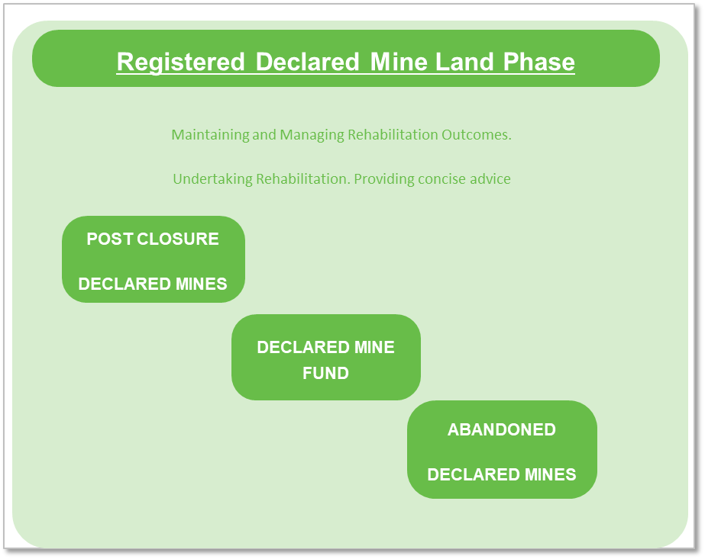

*Figure 2: Registered Declared Mine Land Phase*

The MLRA may be the landowner if the title is transferred to it under Section 84AZZF of the MRSDA.

Should the landowner not be the MLRA, the MLRA must ensure that the Post-Closure Plan is being implemented and all appropriate monitoring and maintenance is being undertaken.

*- intentionally blank -*



**OFFICIAL**

The Mine Land Rehabilitation Authority

65 Church St, Morwell VIC 3840