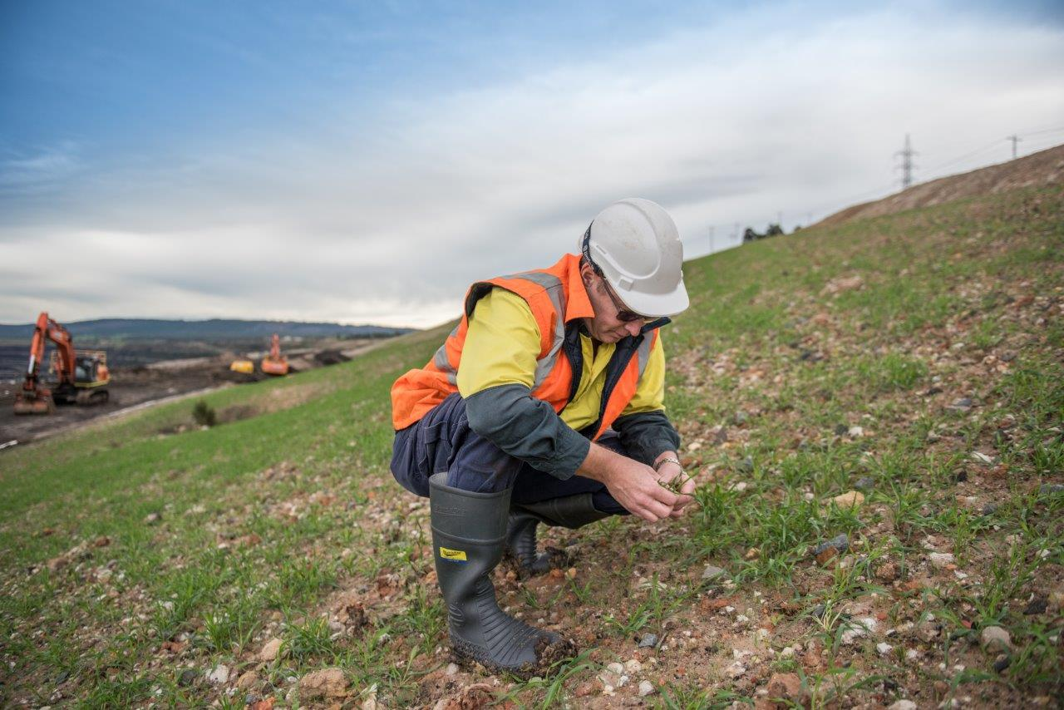

**2**

MINE LAND

REHABILITATION

AUTHORITY

Mine Rehabilitation

**Book 2**

Background information and useful reference regarding the Mine Rehabilitation in Victoria

**OFFICIAL**

The Mine Land Rehabilitation Authority

September 2024

*- intentionally blank -*

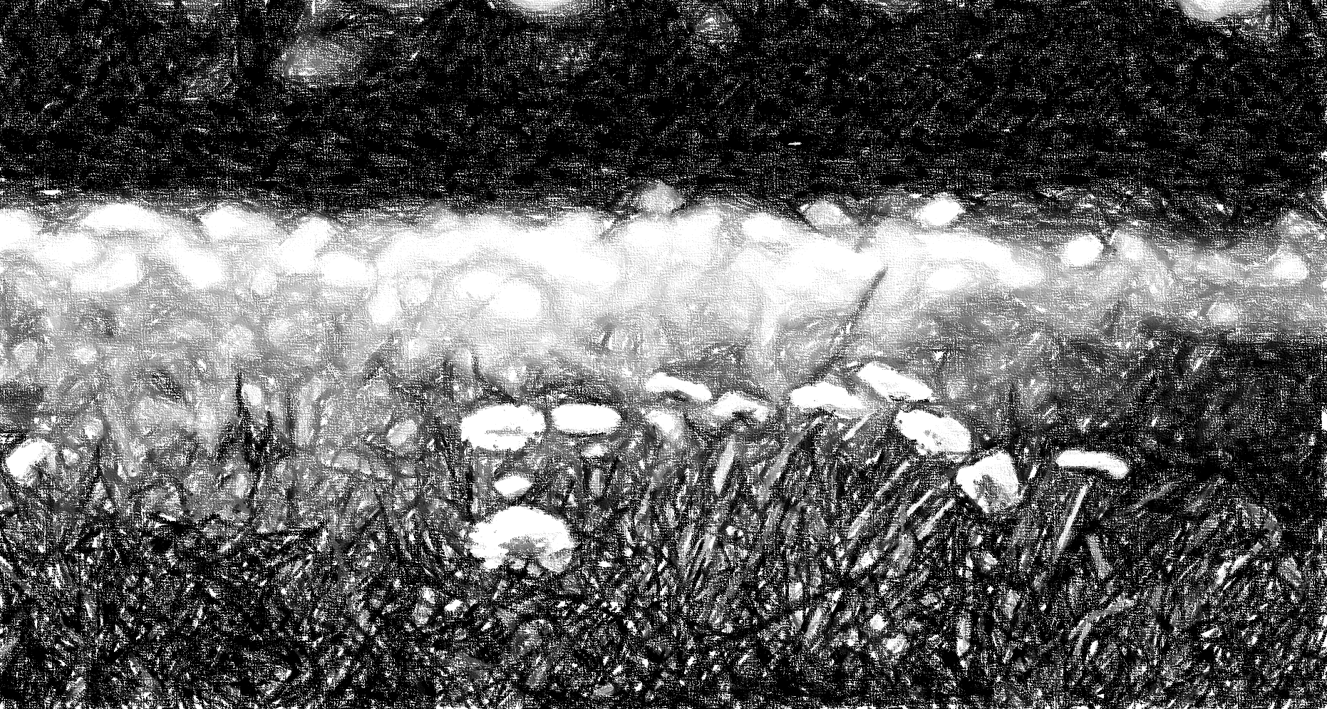The Mine Land Rehabilitation Authority acknowledges Aboriginal and Torres Strait Islander people as the Traditional Custodians of the land and acknowledges and pays respect to their Elders, past, present, and emerging.

Approval for Use

|  |  |  |  |  |  |
| --- | --- | --- | --- | --- | --- |
| Doc Title / Version | | 202501 | | | |
| Classification | | For external use | | | |
| Version | Date | | Prepared By | Reviewed By | Approved For Use |
|  | 10 September 2024 | | Tanya Mok | Antonia Scrase Technical Director | Jenny Brereton  Chief Executive Officer |

*-*

Contents

1. Introduction 6

1.1. Purpose………………………………………………………………………………………………………….6

2. Definitions 7

3. Mine Rehabilitation (Mine Closure) 8

3.1. Planning for Closure/ Rehabilitation………………………………………………………………………….8

3.2. Best Practice Mine Lifecycle…………………………………………………………………………………11

4. Mine Rehabilitation Legislation in Victoria 15

4.1. Mineral Resources (Sustainable Development) Act 1990………………………………………………..15

4.2. Regulators and Agencies Involved in Mine Rehabiliation in Victoria……………………………………16

# Introduction

Mine rehabilitation in Victoria means returning land disturbed by mining to a safe, stable and sustainable condition that enables beneficial uses of the site and surrounding land (2023, MLRA Vocabulary). Mine rehabilitation is an integral part of the planning, operational, closure and post-closure phases of a declared mine’s lifecycle. Mine closure is considered a process involving a sequence of events and activities that achieves mine rehabilitation.

The Mineral Resources (Sustainable Development) Act (MRSDA) is the key piece of legislation for mine rehabilitation in Victoria. The MRSDA legislates that mine rehabilitation is the responsibility of the Declared Mine Licensee, the organisation or body holding the extractive/ mineral mining licence.

## Purpose

The purpose of this document is to explain mine rehabilitation at a high level for the Victorian community and other interested parties.

## Limitations

This document has been developed using the publicly available information and guidance and in house MLRA experience.

The MLRA has made every attempt to ensure the information within this report is factual, however does not take responsibility for the use of this information elsewhere.

The information within in this document is generic, but largely focused on Victoria Australia, Every mine site is different, each mining company, jurisdiction and country has different terminology and differing approaches.

# Definitions

Definitions considered useful for the improved creation, use and understanding of this document have been identified.

|  |  |
| --- | --- |
| Reference | Definition |
| Beneficial Uses | A use to the environment, or a segment of the environment, that leads to public benefit, welfare, safety, health, or aesthetic enjoyment and which requires protection from the effects of waste discharges, emissions, or deposits. A beneficial use may be an existing or potential use. A resource may have more than one beneficial use. |
| Declared Mine | A mine or quarry in Victoria declared by the Minister to have geotechnical or hydrogeological factors within that pose a significant risk to public safety, the environment or infrastructure. |
| Declared Mine Licensee | The holder or the former holder of a licence that covers declared mine land. |
| Closure (mine) | The process of planning and managing the decommissioning of a mine, mitigating mining impacts, undertaking environmental rehabilitation, and relinquishing the mining license/lease(s). For recent and new mines this is envisioned as a 'whole of mine life' process. |
| Closure Criteria | Criteria developed during mine closure planning against which mine closure is evaluated. |
| Closure Plan/DMRP | Documentation that details mine closure strategies, design, planning and implementation activities, and performance evaluation to meet approved closure criteria. |
| Bond | A financial instrument, a bank guarantee or levy, imposed on the mine licensee. It is held by Government and used in the event that the licensee fails to perform required mine closure activities. |
| Overburden | Near surface materials lying above the ore body that are removed for the mining process. |
| Perpetuity | An agreement or bond that has no fixed maturity or expiry date. |
| Post Closure Plan | A document produced by the declared mine licensee and submitted for approval with the DMRP. Per the Mineral Resources (Sustainable Development) Act 1990 section 84AZU(3)(c), the PCP sets out the monitoring and maintenance to be carried out post-closure. |
| Declared Mine Fund (DMF) | An account established under the legislation as part of the Public Account trust fund.  The Declared Mine Fund is used to pay for the post-closure monitoring, maintenance, and rehabilitation of land in the declared mine land register, including costs incurred by unforeseen events. |

Refer to the [MLRA Vocabulary](https://www.mineland.vic.gov.au/learn/vocabulary/) for all other definitions and reference.

# Mine Rehabilitation (Mine Closure)

## Overview

Mine closure is the process to achieve mine rehabilitation. Ideally, this process commences before mining starts, continues over the operational life of the mine and through into rehabilitation.

The process of mine closure is undertaken by the mine licensees and operators throughout the mines’ lifecycle of *planning*, *operations* and *rehabilitation* phases leading to a point in time when the mine is “rehabilitated’ and the mine license can be surrendered. At this point the land is no longer considered a mine and subsequent land uses can commence.

Vital to successful mine rehabilitation is a strong, clear, and informed regulatory environment that is adaptable to changing circumstances, a committed, knowledgeable mining industry and strong transparent stakeholder engagement. Where one or more of these is missing from the process it makes achieving a successful outcome more difficult and potentially more costly. Building trust and collaboration between stakeholders is key to ensuring the mine land can transform to support new sustainable land uses.

Current best practice is for mine closure planning to start at the mine planning phases, allowing for a growing understanding of the site requirements over time and reduction of knowledge gaps as the mine progresses through its operational phase and into closure and rehabilitation. All mines’ life cycles have similar phases, but the timeframes for each phase are different and frequently fluctuate significantly during the mine’s life. Therefore, closure planning is always site specific.

In Victoria, as in other states and territories, the mine rehabilitation legislation is evolving and mine licensees have to adapt and update closure plans, bonds etc in line with changing expectations and changes in the legislative parameters. In some cases, this can be difficult, and a highly consultative, collaborative approach must be encouraged and implemented by all parties for the duration of the rehabilitation activity.

Key aspects of closure / rehabilitation planning include:

* Development of Rehabilitation Vision, Principles and Objectives – set the goals for rehabilitation.
* Closure criteria – measurable criteria that determine the success of the rehabilitation.
* Closure risk assessments – identifying the long-term risks and appropriate mitigations associated with the proposed landform. Construction risks also need to be considered.
* Stakeholder Engagement – engagement is key to successful rehabilitation, community, traditional owners, government.
* Final landform design – considers potential end land uses and designs to support them accordingly.

These are discussed in further detail in Section 3.2 Planning for Closure/ Rehabilitation.

## Planning for Closure/ Rehabilitation

Mine closure is a dynamic and iterative process that takes into account environmental, social, and economic considerations from the earliest phases of mine development. Fundamental to this process is the need to consider closure as an integral part of the mine operations’ core business.

Some key aspects of good practice mine closure and rehabilitation planning are as follows, taken from relevant sections of the *ICMM Integrated Mine Closure – Good Practice Guide 2nd Edition, 2019*.

* ***Integration Into Life of Mine Planning*** – When closure is fully embedded in life of mine planning, there are better results as expectations, risks and opportunities can be proactively managed and achieved for the mining company and stakeholders. This is not always possible depending on the phases of the mine life.
* ***Knowledge Base*** – The licensee collects information throughout the life of mine, with regular updates as data is collected and reviewed. This is the information that will inform site-specific closure planning, such as the environmental and socioeconomic setting, environmental baseline data, operational data (such as volumes and types of waste currently and planned to be deposited, waste characterisation), commitments and compliance requirements.
* ***Closure Vision, Principles and Objectives*** - The vision will typically incorporate an overview of the post-closure land use and will evolve as more information becomes available. Closure principles are the common precepts that guide the basis of a closure plan, such as promoting physical and chemical stability, meeting regulatory obligations, and facilitating social transition. The closure objectives indicate in concrete terms what is to be achieved through implementation of the closure activities.
* ***Post-Closure Land Use*** - Where the use of the land after mining can be defined, this greatly aids closure planning & will inform all aspects of the closure plan, particularly the definition of both the closure vision and objectives.
* ***Stakeholder Engagement*** – The licensee undertakes stakeholder engagement throughout the closure planning process, with insight from that engagement used to shape key elements of the closure plan.
* ***Identifying and Assessing Risks and Opportunities*** - A wide range of risks and opportunities are associated with closure, covering physical, social, economic, and ecological considerations. Formal identification and evaluation of risks and opportunities helps to set priorities and shape many aspects of the closure plan, including the selection of closure activities.
* ***Closure Activities*** - Specific closure actions or works are executed in the implementation of the closure plan, both at final closure and progressively.
* ***Closure Criteria*** – These are developed by the licensees and are quantitative indicators of successful rehabilitation. Meeting success criteria can mark the end of the post-closure period for a mine or part of a mine.
* ***Progressive Rehabilitation / Closure*** - implementation of closure activities during the operational phase of the mine.
* ***Social Transition*** – The licensee should plan for transitioning of community, including its workforce, towards closure of an operation.
* ***Closure Costs*** – The licensees need to understand their closure costs, so undertake estimations of all aspects of closure, and updating those estimates as plans evolve, and more information becomes available.
* ***An Execution Plan*** – Execution plans should be developed and regularly updated through the closure planning process.
* ***Monitoring, Maintenance and Management*** – During and following the completion of closure activities, monitoring should be carried out to provide evidence of effectiveness of the closure activities at meeting agreed closure objectives, achievement of the closure criteria, or on a pathway to be met.
* ***Relinquishment or Surrender of the Mining License*** – This is a process which involves the licensees providing evidence of achievement of the closure criteria, along with engagement with ERR and potentially other agencies.
* ***Temporary or Sudden Closure*** - Various factors can result in the temporary or unplanned closure of an operating mine. At each phase of the mine life, the mine licensees should understand how temporary or sudden closure could affect the closure planning.
* ***Closure Governance*** – The mine licensees need to have an overarching approach to closure governance, this will ensure the effective allocation of resources to closure planning from many disciplines across the mining company, including both site resources and, where available, corporate support. Effective closure governance will affect every aspect of closure planning at an operation.”

## Best Practice Mine Lifecycle

While variations can occur, mines typically follow a life cycle which includes distinct phases of activity and recognisable milestones, as shown in Fig 1.

**Mine Lifecycle**

*(Typical)*

**PLANNING FOR CLOSURE**

**Closure**

**(Fulfilment of Closure Criteria)**

**Relinquishment**

(Licence Surrender)

**PLANNING & PROGRESSIVE REHABILITATION**

**CLOSURE IMPLEMENTATION & MONITOR AND MAINTAIN**

**MONITORING, MAINTENANCE & REHABILITATION**

**Mining Licence Approval**

**End of Mining**

**Mine Licensee Responsibility**

**Landowner**

**Responsibility**

**PLANNING PHASE**

Pre-Feasibility, Feasibility

**OPERATIONAL PHASE**

**CLOSURE PHASE**

**POST CLOSURE PHASE**

Fig 1 The typical lifecycle of a declared mine, illustrating the primary phases and key milestones relevant to Mine Rehabilitation.

### Planning Phase, Pre-feasibility, Feasibility and Planning for Closure

This phase of a mine’s life is driven by the mining company & tenement holder (who may become the mine licensee, once a license application has been submitted to, and approved by government) and involves the conceptual development of the mining project. This development progresses through pre-feasibility and feasibility assessments, before culminating in a submission to government, and an application for a mining license. Some of the key aspects considered during this phase are, but not limited to:

* An understanding of the scope and scale of the project – ore, grade, waste rock/ tailings/ ash, overburden, mining method.
* An understanding and identification of regulatory requirements and licence applications made.
* The potential social and environmental impacts are defined, and controls determined to mitigate impacts.
* The design of the operational mine is developed.
* The operational requirements are understood.
* Conceptual closure plans are developed.
* The project is costed.

### Operational Phase & Progressive Rehabilitation

Once the mining license is issued, usually with conditions attached, and all other relevant licenses and approvals obtained, the mine company and now mine licensee can commence mining.

The mine licensee is responsible for the operation, closure planning and progressive rehabilitation of the mine site. During the operational phase of a mine, the mine operators are focused on removal of the ore from the ground, as fast and as efficiently as possible. The mining process is dynamic with lots of different aspects feeding into decision making. As a result, mine plans evolve and change over time. To manage this ever-changing environment, the licensees usually develop short-, medium- and long-term plans. Good practice mine closure planning requires closure designs to be incorporated into this process, reducing the cost, and increasing the likelihood of achieving good rehabilitation outcomes that are well informed as the mine site changes over time.

Throughout this phase, the closure process is ongoing, and evolving, with any changes to the operational plans understood in terms of changing closure risks and residual liabilities. Adaptations to the final landform design may be required or completely rethought and fed back into the operational mine plans.

The closure plan for declared mines in Victoria are called the Declared Mine Rehabilitation Plan (DMRP). Ideally, it is developed in the planning phases and further developed over the operational life of mine. However, the three declared mines in Vicotria have all been operating for some considerable time, which means the mine licensees are developing DMRPs in different stages of their life cycles. The impact of this is likely reduced options and additional costs for the licensees in fulfilling their regulatory requirements.

The closure plan (DMRP) is a live document that requires updates based on several factors including:

* changes to the operational mine plans,
* development in understanding of the surrounding environment,
* technical studies,
* new information and changes in approaches,
* stakeholder engagement,
* business decisions,
* changes in legislation,
* changes in risk profile or appetite,
* development of closure designs, closure criteria etc.

Progressive rehabilitation is work that is undertaken, during operations, to progress towards the final rehabilitated landform and closure designs. The intent of progressive rehabilitation is to ensure at the end of the mine’s operational life there is a reduction in uncertainty in the final rehabilitation designs achieving the desired outcomes, and a lesser amount of physical, construction work to be undertaken. An additional and important benefit of progressive rehabilitation is that it reduces the liability should a mine cease operation sooner than expected, and the operators are no longer present to undertake the work.

Progressive rehabilitation includes, but is not limited to, technical studies into any relevant area, landform designs, stakeholder engagement, end land use planning, trials on aspects of the landform design, project management and workforce planning, contracting, legal set up for the rehabilitation phase and undertaking physical construction of the closure designs.

Importantly in this phase, the mine licensees must develop closure criterion, these can be updated throughout the operational and closure phases, and they should be measurements of the closure objectives and consider the following:

* Proposed post mining land uses,
* Key risks to those post mining land uses, for example, water quality, soil contamination, economic
* Key controls, for example water diversion structures, loss of soil for erosion, vegetation cover
* Legislated requirements, for example Contaminated site audits, landfill closure processes
* Stakeholder inputs,

The operational phase of a mine can end for several reasons including: the ore has been diminished to the point it is uneconomic, the mine has mined its allowable licence area, or for social and environmental reasons. Ultimately this is usually a business decision and the choice of the mining company/ mine licensee. When the operational phase is completed, the mine immediately moves into the closure phase.

In some circumstances, a mine may also temporarily cease operations, this is called “Care and Maintenance”. The temporary cessation of mining operations is usually due to the project becoming uneconomic, or the mining company facing financial hardship. During this period the operators are expected to maintain the mine site and continue a certain amount of legislated reporting. These cessations of operations have the potential to impact closure planning and designs in several ways, and always should be considered in planning for a mine and mine closure.

### Closure Phase: Closure Implementation

The mine licensee is responsible for the closure implementation phase. This is when the closure plan/ DMRP, is implemented. There are still likely to be significant uncertainties, for example, material properties and volumes, unforeseen environmental and geotechnical considerations and events, and further model development to incorporate additional information. In this phase it is likely that closure designs and potentially closure criteria will need to be altered and amended as the work evolves. The closure planning process and the closure plan needs to be iterative including have updating of risk assessments with changes from the original plan.

During this closure phase there are two distinct areas of activity:

* The first area of activity is an initial period of high activity during the demolition of infrastructure and construction of the landform designs. Activities during demolition and construction could include but are not limited to:
  + Stakeholder engagement.
  + Contract and project management.
  + Workforce plans implemented.
  + Demolition of the mine’s operational structures & waste management.
  + Construction of landform designs and closure designs.
  + Legislated activities undertaken, such as contaminated site investigations and audit process.
  + Monitoring during construction.
  + Legislated reporting.
  + Security of the site.
* The second area of activity is the monitoring and maintenance phase which continues until the closure criteria (determination of success of rehabilitation) are achieved. The activities undertaken during this phase might include:
  + Monitoring (movement, water quality, vegetation etc) to demonstrate the achievement of closure criteria.
  + Maintenance of the constructed landforms.
  + Project and contract management.
  + Legislated reporting.
  + Ongoing Stakeholder engagement.
  + Security of the site.

To complete this phase of the mine’s life, the mine licensee must surrender/ relinquish their mining licence. In order to be able to surrender their licences they must demonstrate they have successfully rehabilitated their mine site. This is done through the demonstration of achieving of their closure criteria, and in Victoria, paying into a post closure fund (administered by government) for post closure (post license surrender) ongoing monitoring and maintenance.

In Victoria, and most other locations, mine licensees cannot surrender their license until have they have demonstrated they have achieved their closure criteria, and this has been accepted by government.

### Post Closure: After Mining

Every country, state and territory works through the post closure phase of a mine’s life differently. But ultimately it is the period where there is no mining licence present, when the mine operators/ licence holders are no longer responsible for the site (unless they are landowners) and have no further obligations under the relevant mining legislation or mine licence. The site is no longer a mine.

New landowners, or the Crown, often take on the area and make new use of the land (e.g. agriculture, grazing, alternative energy, manufacturing etc). This phase continues in perpetuity, with ongoing sequential land uses, being implemented.

However, Victoria has started to approach this phase in a more structured manner for declared mines; Post closure in Victoria is the phase where the mine has been rehabilitated, the license has been surrendered, and sequential land uses are implemented.

Victoria takes the view that, regardless of how “safe, stable and sustainable” the final rehabilitated site is, parts of the license area have been “engineered” and some residual liability and risk will remain, resulting in the likelihood that site specific monitoring and maintenance will be required in perpetuity. In some cases, this may be incorporated into land management associated with the future land uses, but for some aspects within the previously licensed area there will be monitoring and maintenance over and above the next land use requirements. Some likely monitoring and maintenance that may be required are, but not limited to:

* Water quality monitoring
* Ground movements
* Cover management – maintaining the grasses on covers, soil cover repairs.
* Management of closed landfills
* Fencing / security

Victoria has tried to address this ongoing liability through legislating the requirement for mine licensees to develop a post closure plan, as part of their DMRP development. The post closure plan sets out the required maintenance and monitoring, and future large-scale replacements (if required) of infrastructure. The post closure plan is costed and at license surrender the mine licensees pay an appropriate sum into the Declared Mine Fund (DMF), which is to be administered by the Mine Land Rehabilitation Authority (MLRA).

# Mine Rehabilitation Legislation in Victoria

Resources Victoria (within DEECA (Department of Energy, Environment and Climate Action)) is the lead agency responsible for regulating mining activities in Victoria, with the Minister for Energy and Resources administering the relevant Act and Regulation.

The primary legislation for mining and mine rehabilitation is the Mineral Resources (Sustainable Development) Act (MRSDA). Other Acts, such as the Environmental Protection Act and Planning and Environment Act are also relevant to mining. Federal Acts may also apply to the rehabilitation of declared mines, e.g. the Environmental Protection, Biodiversity and Conservation Act (EPBC).

## Mineral Resources (Sustainable Development) Act 1990

The MRSDA is the legislation governing the identification, treatment, and process for declared mines and declared mine lands in Victoria. Its purpose is to encourage mineral exploration, economically viable mining and extractive industries which extracts value from, resources in a way that is compatible with the economic, social, and environmental objectives of the State, while ensuring mines are rehabilitated to a suitable standard. The Act establishes the *Mine Land Rehabilitation Authority.* It determines its powers, legislated requirements, and its stakeholders.

The Regulations supporting this Act provide additional detail on the requirements for mine licensees on rehabilitation and operational planning.

### Declared Mines and Declared Mine Land

The determination of a mine as *declared* is legislated in the MRSDA.. A Declared Mine is a mine deemed to pose significant risk to public safety, infrastructure, and/or the environment due to complex geotechnical, hydrogeological, hydrological or water quality issues. Declaration is made by the Minister for Energy and Resources. Once declared the mine is known as a *declared mine.*

Mining in Victoria is granted under licence, an approval under strict guidelines providing the holder the sole rights to mine for specified minerals. Declaration of a minemeans that the land covered by a mining licence that includes a declared mine, becomes *declared mine land* and the holder of the licence becomes the *declared mine licensee*.

Currently, the only declared mines in Victoria are the Latrobe Valley’s three brown coal mines:

* Yallourn: owned by EnergyAustralia (mining licence Nos 5003, 5216, 5304).
* Hazelwood: owned by ENGIE (mining licence No. 5004).
* Loy Yang: owned by AGL (mining licence No. 5189).

## Regulators and Agencies Involved in Mine Rehabiliation in Victoria

Mine Rehabilitation is affected and influenced by many regulators and agencies to ensure a whole-of-government approach. The key regulatory and policy agencies are:

* Earth Resources Regulator (ERR) (DEECA).
* Environment Protection Authority Victoria (EPA).
* Planning (Department of Transport and Planning & Federal Department of Environment).
* Earth Resources Policy and Planning (ERPP) (includes the LVRRS) (DEECA).
* Water and Catchments (DEECA).
* Mine Land Rehabilitation Authority (Independent Authority attached to DEECA).

The following are agencies that are an important, but less involved with the policy and regulation of mine rehabilitation:

* Catchment management and water authorities (CMA & WA).
* WorkSafe Victoria.
* Country Fire Authority (CFA).
* Emergency Management Victoria.
* Parks Victoria.
* Local councils across Victoria (LGA).

### Earth Resources Regulator (ERR)

The role of ERR is to regulate exploration, mining, quarrying, petroleum, recreational prospecting, and other earth resource activities and to ensure earth resources activities are conducted safely to protect people, property, infrastructure, and the environment. ERR administers the MRSDA.

There are two main departments within ERR, (1) Assessments and (2) Compliance.

1. **The Assessment Team** assesses and authorises mining projects, they assess any changes to the mine plan throughout the life of the mine. They will review and request that other Government Departments (referral authorities) comment on Work Plans, Work Plan Variations and DMRPs.
2. **The Compliance Team** in ERR enforce laws, and the approved Work Plans and Work Plan Variations through reviewing annual compliance reporting, and auditing key aspects of the mine operations against their regulatory documents, such as, ground controls, rehabilitation planning, and fire risk management. They undertake monitoring of mining and rehabilitation activities to ensure that mine, quarry, and petroleum operators fulfil their obligations to safeguard the community and environment.

### Environment Protection Authority Victoria (EPA)

The Environment Protection Authority Victoria (EPA) is Victoria’s environmental regulator. The EPA work to prevent and reduce the harmful effects of pollution and waste on Victorians and their environment and work with community, industry, and business to achieve this. The EPA is overseen by the Minister for Energy, Environment and Climate Change. There are a number of parts of the EP Act that apply to mine licensees, General Environmental Duty (GED), Licensed Activities and Site Contamination.

The GED is at the core of the legislation and applies to all Victorians. The GED requires businesses to understand the risks to human health and the environment of activities that they conduct and take reasonably practicable steps to eliminate or minimise them.

In addition to the GED, mine licensees often have EPA licensed activities, such as on-site landfill sites, and surface water discharges. The licensees must comply with license conditions and report regularly to the EPA. The EPA has requirements to close out these licensed activities, the mine licensees will need to comply with the closure requirements, in addition to the DMRP closure criteria.

The EPA also requires a contaminated sites assessment process for any land which is changing to a more different land use. The declared mine licensees will likely have to undertake a site contamination process, which is likely to include an Audit process prior to application of the mining licence surrender.

### Planning (Department of Transport and Planning and Federal Department of Environment)

The Department of Transport and Planning administer the Environmental Effects Statement (EES) process which is an accredited process for the federal EPBC. The declared mines may be required to undertake an EES as part of the assessment of their final proposed landforms.

### The development of the LVRRS

Those responsible for the development of the Latrobe Regional Rehabilitation Strategy (LVRRS) are located within Resources Victoria (DEECA).

The LVRRS comprises key guiding principles that provide the foundation for the policy position for the Latrobe Valley mines to be able to rehabilitate the declared mines. The policy and principles must be addressed / incorporated within their DMRPs. The LVRRS emphasises three key components for the licensees to consider.

* *Stability* - looking at the stability of the three mines at a high level to determine most appropriate ways of stabilising the mines and regional impacts.
* *Water* - looking at water availability for mine rehabilitation in the Latrobe Valley.
* *Planning* – Looked at potential planning to support the transition away from mining economies.

The strategy is subjected to a legislated, three yearly review process although it can be revised at any time.

#### **Background**

The closure of the Hazelwood Mine and Power Station in 2017 and the scheduled closure of Yallourn and Loy Yang in 2028 and 2035, respectively, has highlighted a fundamental shift in the region’s economy and the demand for electricity produced from brown coal. As this has occurred and the mining cycles come to an end, the focus has turned to mine rehabilitation and finding positive and practical solutions for an area where some of the largest, open cut coal mines in the country are located, all in close proximity to communities and infrastructure.

The Hazelwood Mine Fire in 2014 and subsequent inquiries highlighted that mine rehabilitation was an area needing a greater focus from all parties. The Hazelwood Mine Fire Inquiry found that there were a number of knowledge gaps associated with mine rehabilitation including with the proposed use of water to fill mine voids, the preferred option of each of the Latrobe Valley licensees.

The Victorian Government committed to developing a regional rehabilitation strategy to help address these knowledge gaps. The Latrobe Valley Regional Rehabilitation Strategy is the culmination of several years of work that sought to deliver a program of technical studies. The strategy was prepared by the Department of Jobs, Precincts and Regions (now DEECA), in collaboration with the Department of Environment, Land, Water and Planning, (now split between DTP and DEECA), and has had input from other departments and stakeholders as it evolved.

The technical studies considered the stability and fire risks associated with the mines once they cease operating and how these might be managed, as well as water availability and water quality considerations to deliver the various rehabilitation options. Regional planning was also a consideration.

#### **Regional Context**

The LVRRS supports integrated planning and decision‑making for the rehabilitation of the Latrobe Valley coal mines – Hazelwood, Yallourn, and Loy Yang – within a regional context through providing guidance to the community, mine licensees, public sector bodies and other stakeholders on matters that need to be considered in planning for, and undertaking, rehabilitation of the three coal mines.

This strategy has been developed on the basis that:

* All three Latrobe Valley coal mines are on privately owned land, and the rights and obligations of landholders apply.
* The MRSD Act places responsibility for rehabilitation of individual mine sites on mine licensees, including planning, rehabilitation works and associated costs.
* Government’s role is to provide policy and guidance, and to facilitate or support investment by industry where there is a clear community benefit. Its role should not constrain the ability of industry to find new and innovative solutions to mine rehabilitation.
* There are social, cultural, environmental, and economic factors that may change the feasibility of rehabilitation options available at future points in time, including significant uncertainties associated with climate change and water availability.
* Rehabilitation is likely to take decades after the cessation of mining at each site, and the community should have the opportunity to be involved over this time.

#### **Regional Rehabilitation Outcomes**

The vision of the LVRRS is that the Latrobe Valley coal mines and adjacent land are transformed to safe, stable and sustainable landforms which support the next land use.

This vision will be delivered by achieving six outcomes for the rehabilitation of the mines, and the monitoring and evaluation of that land after rehabilitation is complete:

* People, land, environment, and infrastructure are protected.
* Land is returned to a safe, stable, and sustainable landform.
* Aboriginal values are protected.
* Community is engaged, and their aspirations inform the transformation.
* Long term benefits and future opportunities to the community are optimised.
* An integrated approach to rehabilitation and regional resource management is adopted.

To support the realisation of this vision and outcomes, the LVRRS sets out principles to guide planning for the rehabilitation of Latrobe Valley coal mines and adjacent land within a regional context.

#### **LVRRS Implementation Principles**

* The fire risk of the rehabilitated land should be no greater than that of the surrounding environment.
* Ground instability and ground movement risks and impacts during rehabilitation and in the long-term, and requirements for ongoing management to sustain a safe and stable landform, should be minimised as far as practicable.
* Mine rehabilitation should plan for a drying climate. Rehabilitation activities and final landforms should be climate resilient.
* Any water used for mine rehabilitation should not negatively impact on traditional owners’ values, environmental values in the Latrobe River system, or the rights of other existing water users.
* Traditional owners should be involved in rehabilitation planning, assessment and decision-making.
* The community should be consulted on rehabilitation proposals, the potential impacts, and have the opportunity to express their views.
* Mine rehabilitation and regional land use planning should be integrated, and the rehabilitated sites should be suitable for their intended uses.

### Water and Catchments (DEECA)

Water and access to water is an intrinsic part of the rehabilitation story for Victoria’s declared mines. The Water and Catchments team is responsible for ensuring that Victoria’s water resources are managed responsibly and equitably under the Water Act. They develop policy around the use of water for mine rehabilitation and advise the Minister for Water about water applications.

### Mine Land Rehabilitation Authority

The MLRA sits within government but is an independent authority. The MLRA is a formal referral agency for Declared Mine Plans. For more information on the MLRA please see Mine Land Rehabilitation Authority.

*- intentionally blank -*



**OFFICIAL**

The Mine Land Rehabilitation Authority

65 Church St, Morwell VIC 3840