# The Latrobe Valley Regional Rehabilitation Strategy

The Latrobe Valley’s three declared mines must be rehabilitated to a state which is safe, stable, sustainable and suitable for proposed post-mining land uses. Rehabilitation is a complex, long-term process that presents both risks and opportunities.

This fact sheet explains the purpose of the Latrobe Valley Regional Rehabilitation Strategy (or the LVRRS) and its role in guiding rehabilitation planning across the region. The LVRRS provides policy direction and practical guidance for mine rehabilitation, which is expected to span several decades.

It sets out a collaborative pathway for stakeholders to explore key issues with a clear view to ensuring the best possible outcomes for the region.

## The requirement for the LVRRS

In response to the Hazelwood Mine Fire Inquiry (HMFI) findings, the Government released a detailed implementation plan that included a commitment to develop a regional rehabilitation strategy for the Latrobe Valley’s three brown coal mines. The goal was to develop a strategy that would guide rehabilitation planning at a regional level, considering the interconnectivity between the Latrobe Valley mines (Figure 1).

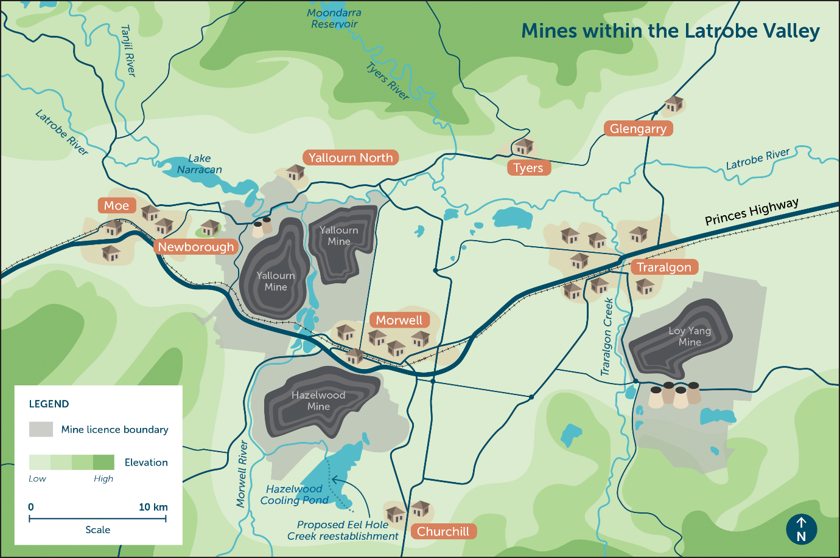

*Figure 1 the three Latrobe Valley mines are in close proximity to communities, waterways, infrastructure and each other. Mine licenses (grey) indicate the large areas mine owners are responsible to rehabilitate*

## The scope of the LVRRS

The LVRRS provides foundational policy, principles and actions to guide rehabilitation planning for the Latrobe Valley coal mines over many decades. The LVRRS provides a framework for regulatory oversight, water access planning and long-term monitoring, and is underpinned by regional geotechnical and water studies.

## Release of a regional strategy

The [LVRRS](https://resources.vic.gov.au/projects/lvrrs) was published in June 2020 and addresses three key aspects outlined in the ​*Mineral Resources (Sustainable Development) Act*​:

* the safety, stability and sustainability of coal mine land and any adjacent land
* the planning for the Latrobe Valley region in relation to the rehabilitation of coal mine land and any adjacent land, and the relationships between each mine void
* the development of a plan for the monitoring and evaluation of coal mine land after rehabilitation of that land is complete.

The LVRRS provides a Vision to guide the mine licensees in rehabilitation planning, with six Rehabilitation Outcomes to support delivery of the Vision (Figure 2).

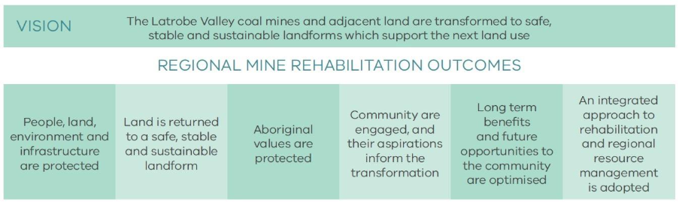

*Figure 2 the LVRRS Vision is supported by six Regional Mine Rehabilitation Outcomes*

The Outcomes are supported by eight Implementation Principles (Figure 3), to guide planning for the rehabilitation of the Latrobe Valley coal mines and adjacent land within a regional context. The [LVRRS website](https://resources.vic.gov.au/projects/lvrrs) provides resources, including studies that help assure these Principles.

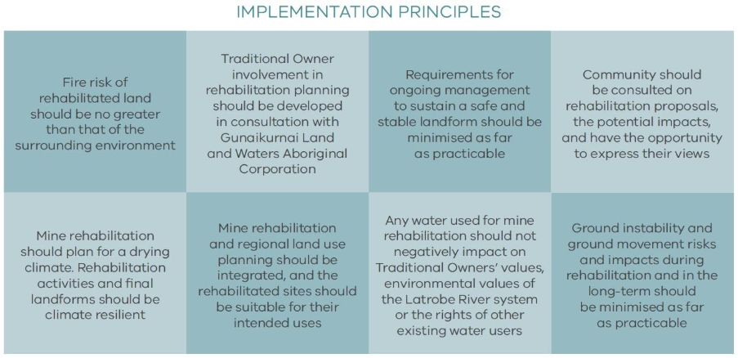

*Figure 3 The eight Implementation Principles support the Rehabilitation Outcomes and provide principles for regional rehabilitation planning*

The LVRRS Amendment (2023)

In October 2023 the [LVRRS Amendment](https://resources.vic.gov.au/__data/assets/pdf_file/0004/984082/Latrobe-Valley-Regional-Rehabilitation-Strategy-Amendment.pdf) was released and reflects significant changes since 2020, including announced early closures at the Yallourn and Loy Yang mines, and the commencement of an Environmental Effects Statement (EES) at the Hazelwood mine.

Importantly, the Amendment provides conditions that could be placed on water access for mine rehabilitation to protect other uses and values of the Latrobe River system. It includes [studies undertaken](https://www.water.vic.gov.au/our-programs/long-term-water-resource-assessments-and-strategies/latrobe-valley-regional-rehabilitation-strategy) on the use of manufactured water for mine rehabilitation, and [alternative options](https://resources.vic.gov.au/__data/assets/pdf_file/0004/1113637/A-study-into-potential-alternative-and-contingency-rehabilitation-options-for-Latrobe-Valley-coal-mines.pdf) for rehabilitation, and outlines upcoming opportunities for community and stakeholder engagement in mine rehabilitation planning.

## The future of the LVRRS

The Mineral Resources (Sustainable Development) Act 1990 (Vic) states: “the Minister must review the regional rehabilitation strategy at least once every 3 years after it is published.”

## Implementation of the LVRRS

Latrobe Valley mine licensees and public sector bodies are responsible for implementing the LVRRS. The MLRA has a legislated role to monitor the implementation and effectiveness of the LVRRS and reports on this annually through the MLRA Annual Reports.

If you’re reading a printed copy, you can find all hyperlinks by visiting www.mineland.vic.gov.au and searching for the relevant topic.

MLRA Content Disclaimer:

This content provides the MLRA's high-level overview of aspects of mine rehabilitation in the Latrobe Valley. It does not reflect the opinions, pre-empt decisions or policies of Resources Victoria, mine licensees or any other government department. The information was accurate to the best of the MLRA's knowledge at the time of publication and is intended to inform the community, stakeholders and Traditional Owners.

Contact the MLRA for more information on 1800 571 966 or [contactus@mineland.vic.gov.au](mailto:contactus@mineland.vic.gov.au)

 @MLRAuthority  Facebook.com/MLRAVictoria  MLRAuthority