Consultation report:
Imagining the Future of Mine Land
October 2025

In October 2025, the Mine Land Rehabilitation Authority (MLRA) hosted a community tour at the Yallourn North Extension site. The event brought together community groups, local government representatives, and Traditional Owner representatives to explore and discuss the future of mine rehabilitation in the Latrobe Valley.

What We Did
The Yallourn North Extension site showcases the rehabilitation of the former Yallourn North Extension open-cut mine, located between Yallourn North and Tyers, adjacent to the Yallourn Monocline. Today, the site is leased for agricultural use and serves as a practical learning environment where the MLRA explores the principles and practices of mine rehabilitation.
A guided tour was held on 9 October 2025, with representatives from several community and stakeholder groups in attendance. Participants walked the site, observed its rehabilitation progress, and took part in both facilitated discussions and informal conversations about the site’s future potential. The visit concluded with a group discussion and Q&A session, providing participants the opportunity to share their insights, ideas, and aspirations for mine land in transition.

What We Heard
At the end of the tour, attendees took part in a questions and answers and a group conversation. This was a highlight of the day.

The conversation brought up four main themes. They were Repurposing in Addition to Rehabilitation, Opportunity, Access and Collaboration.

Repurposing in Addition to Rehabilitation
Participants emphasised that while rehabilitation of the mine voids is important, the future use of the surrounding land is equally significant. Community members are eager to see repurposed mine land contribute to broader social, environmental, and economic outcomes; not simply restored but reimagined for community benefit.

Opportunity
There is a strong appetite for revitalisation and renewal across the Latrobe Valley. Participants spoke about the potential for repurposed mine land to serve as a catalyst for regional regeneration; creating spaces that attract visitors, support local industries, and highlight the Valley’s unique landscape. Examples such as Burra (South Australia) and Mount Gambier’s crater lakes and limestone sinkholes were raised as inspiration for how natural and post-industrial features can become assets for tourism, education, and community connection.

Access
Many participants noted that the Yallourn North Extension site provides a tangible example of successful rehabilitation. However, the restricted access to the site, currently fenced and locked; can unintentionally send a message that rehabilitated mine sites remain unsafe or off-limits. Participants expressed a desire for greater public access, suggesting that allowing the community to visit and experience the site could help build trust and understanding about rehabilitation outcomes. This sentiment reflects the community’s ongoing interest in seeing progress at the declared mine sites and being part of the rehabilitation journey.

Collaboration
Attendees expressed enthusiasm for collaborative opportunities at the site. There was strong interest in involving the Gunaikurnai Land and Waters Aboriginal Corporation (GLaWAC) and other community groups in ongoing stewardship, as well as exploring potential for citizen science initiatives or educational partnerships.
Participants viewed collaboration as essential to ensuring that future uses of the land reflect shared values and deliver inclusive benefits for the community.

Feedback
Feedback on the day was overwhelmingly positive. Participants described the tour as “great” and “outstanding”, expressing appreciation for the opportunity to visit the site and engage with the MLRA team. Comments such as “great work as always, MLRA” and “thank you for inviting us, it was great” reflected a strong sense of enthusiasm and support for the event.

As the MLRA is strengthening its program of hosting groups at the Yallourn North Extension site, all attendees were encouraged to contact the MLRA directly with feedback about how such tours might be improved.

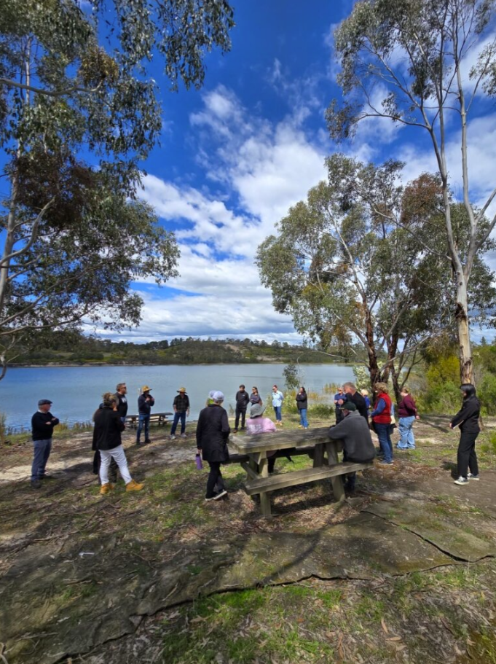
Attendees at the Yallourn North extension site on 9 October 2025

What We Will Do Next
Feedback gathered during the questions and answers and a group conversation, will inform the MLRA’s ongoing community engagement and planning activities. We will:
- Work with the Department of Transport and Planning (DTP) to confirm site constraints, approvals and gauge appetite for site works and identify funding pathways, while continuing to run tours.
- Share key themes on our website, in future updates, and with participating stakeholders
- Use the feedback to refine our materials and messaging
- Continue working with industry and government to keep community voices central to planning
- Continue to educate and inform the community in relation to mine rehabilitation
- Share these views and insights in briefings with the Minister for Resources.

We thank all who attended and contributed to the conversation.

Want to know more?

If you have any questions or comments, you can contact us by calling 1800 571 966, emailing contactus@mineland.vic.gov.au, following us on social media, or subscribing to our mailing list at www.mineland.vic.gov.au.

