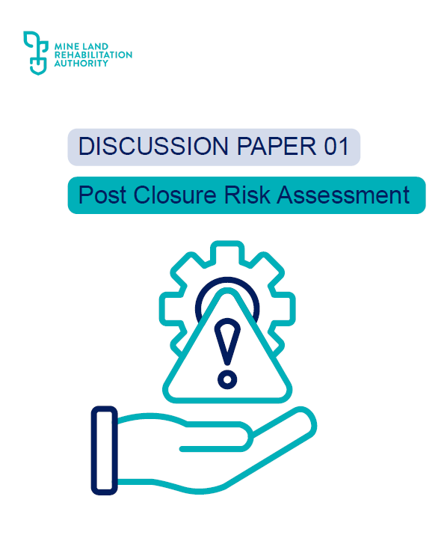

Approval for Use
Title & ID |  | MLRA Discussion Paper 01: Post Closure Risk Assessment
Classification |  | External Use
Rev | Date |  | Approved For Use
00 | 11th December 2025 |  | Antonia Scrase, Technical Director

The MLRA would like to thank the following government reviewers:
DEECA Resources Victoria, including:
Resources Victoria Approvals Coordination
Earth Resources Policy and Programs
Regulatory Operations, Technical Services
DEECA Water and Catchments Group

Table of Contents
Table of Contents ii
1. Purpose 1
2. Introduction 1
2.1. Background 2
2.2. Disclaimer 3
3. Defining the post closure phase 3
4. What are residual risks and liabilities? 4
5. Key considerations in declared mine residual risk assessments 5
5.1. Defining the risk appetite 5
5.2. Risk Methodology 5
5.2.1. Risk matrices 7
5.3. Understanding the starting point 7
5.3.1. Developing a Conceptual Site Model 8
5.3.2. Understanding post closure timeframes 9
5.4. Risk identification 9
5.4.1. Final landform – new and existing sources/ hazards 9
5.4.2. Pathway changes over time 9
5.4.3. Changing Sensitive receptors 9
5.4.4. Changes to the landform over time 10
5.4.5. Climate change and exceedance events 11
5.5. Risk analysis and evaluation 11
5.6. Controls, mitigations and management 11
5.7. Uncertainty and assumptions 12
6. Risk Tools 13
6.1. SPR 14
6.2. Failure Modes Effect Analysis 14
6.3. Fault Trees 15
6.4. Bowties 15
7. Post closure plan 15
8. Summary 18
8.1. Key considerations 18
9. References 20
Appendix A: Example Risk Register 22

Discussion Paper 01: Post Closure Risk Assessment

Purpose
The Mine Land Rehabilitation Authority (MLRA) has prepared this discussion and guidance paper to outline key considerations and potential methodologies to assist in undertaking post closure risk assessments to support the development of the Declared Mine Rehabilitation Plan (DMRP), including the post closure plan and subsequent post closure risk management plans.
The paper is deliberately structured in a manner to lead the reader through a logical sequence and to allow them to understand each step in the process and the key points that are being made along the way.
The document has been prepared to help bridge the risk assessment process for operations to post closure so that a discrete post closure risk assessment can be developed. Post closure risk assessment forms an intrinsic part of the development of a structured post closure plan that can be operationalised following closure determination by future land managers.
A robust post closure risk assessment process can be informed by tiers of more detailed assessments focussing on elevated risk areas, key subject matters, remaining engineering structures and critical controls.
In line with AS/NZS ISO 31000:2009, the risk assessment process should be iterative. Risks should be systematically analysed and evaluated, with additional control measures introduced and implemented until residual risks are either eliminated or reduced as far as reasonably practicable. This iterative approach also provides key input into risk-based landform design, where the design progressively evolves in response to identified risks and associated controls.
By adopting a tiered approach, and explicitly considering the potential failure modes of the landform, the closure process will help ensure that for post closure:
- designs are fit for purpose and can support proposed future post closure land uses, and
- a robust process is in place to identify all ongoing monitoring and maintenance controls, ensuring that any potential residual risks remaining on the declared mine land can be appropriately managed.
In accordance with sections S84AL(1)(kb), S84AL(1)(kh) and S84AZU(3)(c) of the Mineral Resources (Sustainable Development) Act 1990 (MRSDA), the MLRA will have a key role in the post-closure management of declared mine land. The Authority will be responsible for either implementing or providing oversight on the implementation of relevant registered post closure plans. As such, the MLRA has a vested interest in the development and undertaking of each declared mine’s DMRP including the post closure plan, post closure risk assessments and risk management plans.

Introduction
Post closure is defined as the period after the mine is rehabilitated, closure criteria have been achieved, and the mining licence is surrendered. Under the MRSDA, declared mine licensees are required to undertake a post closure risk assessment and provide post closure risk management plans which must be included as part of a post closure plan for the declared mine land. The post closure plan defines any ongoing risk management, monitoring and maintenance works which will be required after (post) closure,,; who is responsible for these activities, their timing, and the value of the future costs associated with these obligations.
The provisions relating to post closure management are contained in the MRSDA and associated Mineral Resources (Sustainable Development) (Mineral Industries) Regulations 2019 (the Regulations). These provisions acknowledge that risks and liabilities may remain after closure, even once declared mine land has been rehabilitated, closure criteria have been met, the mining licence has been surrendered and declared mine land has been registered,. The post closure plan sets out how these remaining risks (termed residual or post closure risks) will be managed through monitoring and maintenance. This is supported by other legislative mechanisms such as the registration process and the Declared Mine Fund, (which will be established to support the surrender of the mining licence), the transfer of prescribed records and information and long-term management of the land.
Understanding the residual risk profile and the residual liabilities (i.e. risks and liabilities remaining after the surrender of the mining licence) is key to the development of a robust post closure plan and to enable the successful surrender of a mining licence. Mine licensees, government and stakeholders must come to an agreement that the level of residual risk is acceptable and will be appropriately managed for licence surrender to be a reality,. Mine licensees need to provide clear, robust and transparent risk assessments and mitigation measures (implemented and / or proposed with clear responsibilities) if government and stakeholders are to understand and agree upon what is an acceptable level of residual risk.

Background
Post closure assessment and provisioning, meaning the work that occurs after a licence is surrendered to ensure the right equipment, resources, and funding are available, is still a relatively novel idea in mine rehabilitation both nationally and internationally. Only a few mining jurisdictions currently have robust and implementable frameworks in place to support this.
The Institutional Control Program, set up by the Province of Saskatchewan in Canada in 2007, is one of the few programs with a formal framework for managing post closure risks and liabilities. It is considered one of the best-developed and implemented models for long-term site stewardship. It reflects the long-term planning and management focus necessary for former uranium mines with long lived low level radioactive wastes. It has widened its remit to include other commodities and currently manages approximately 50 closed mine sites.
Post closure assessment is becoming recognised as important in Australia as more mines approach closure and where many mines may close in a single region as is particularly noticeable in the coal sector. Two States in Australia (Victoria and Queensland) have made recent amendments to legislation that capture post closure residual risk and liabilities. However, the new model has yet to be fully implemented in either State. Interim guidelines on residual risk assessment have been published by the Queensland Government, with further work underway to develop the final guidelines. Whilst this is increasingly becoming an area of interest in the mining community, there is currently little information or guidance available.

Disclaimer
The information outlined in this discussion paper has been drafted by the MLRA in good faith and intends to provide some interim information for consideration by:
- mine licensees, during the preparation of their Declared Mine Rehabilitation Plans (DMRPs), which includes a post closure plan, and
- Government, during the assessment of the DMRPs.
This paper does not replace, preclude or overwrite any legislation or guidance material published by Resources Victoria relating to the Declared Mine Post Closure Plan or post closure risk assessments and is only intended as supportive guidance if and where it is deemed helpful. The use of this material is at the discretion of the mine licensees.

Defining the post closure phase
As presented in yellow in Figure 1 below, the post closure period referred to in Victoria’s legislation is defined as the period following the completion of all the following activities by the declared mine licensee:
- mining operations
- rehabilitation (active and passive rehabilitation) activities
- achievement of closure criteria (also referred to as closure determination)
- surrender of the mining licence
- return of the bond
- provision to the MLRA of prescribed records and information
- registration of the declared mine land and the post closure plan with the MLRA and adding them to the declared mine land register, and
- receipt of payment into the Declared Mine Fund.
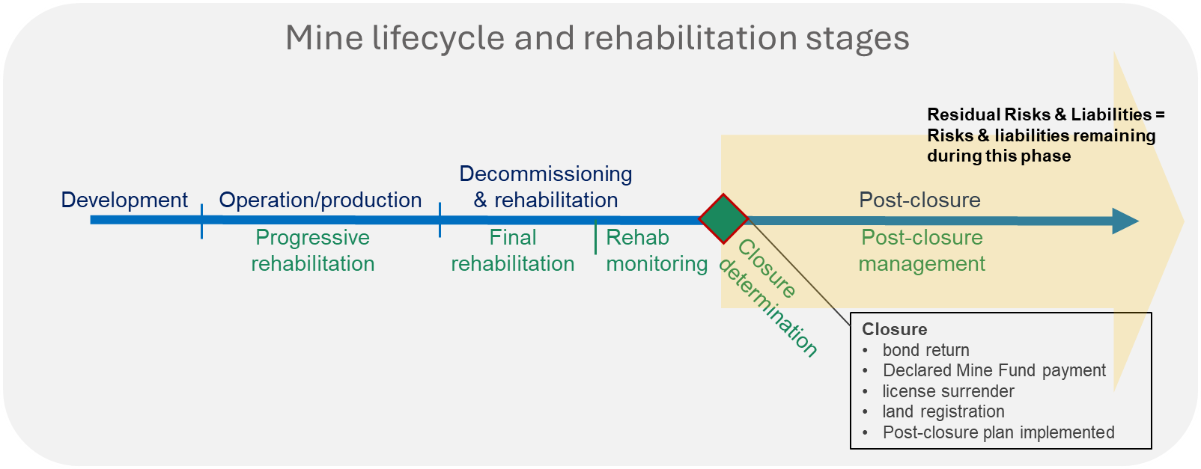
Figure 1 Mining Lifecycle, adapted from DEECA (2025)
During operations and rehabilitation, risks are managed by trained and experienced personnel through active monitoring, with site access restricted. The mine licensee is responsible for the mine site and all activities within the licence boundary. However, as a mine site transitions away from the operational and rehabilitation phases, and into the post closure phase, the following key changes occur:
- the mine licensee is no longer responsible for the site in accordance with regulated operational mining requirements
- ongoing liabilities and risks are now managed by the landowner(s) or the MLRA
- changes to land use such as agricultural, recreational, or others may have been implemented or may be in progress, and site access may no longer be restricted.

What are residual risks and liabilities?
Residual risks and liabilities are defined as those that remain after all mine closure activities have been completed. Specifically in Victoria, they are defined as “any liability that exists after the determination by the Minister that closure criteria have been met and the mining licence surrendered”. These specifically apply to the post closure phase of the mining lifecycle (highlighted by the yellow arrow in Figure 1).
The Queensland Government (2024) Residual Risk Assessment Guideline – Interim identifies two components to residual risks:
- remedial action risk – the possibility that, although land has been rehabilitated and appropriately managed, further remedial action may be required in the foreseeable future.
- ongoing management risk – the possibility that continuing activities will be required, such as:
- monitoring the condition of the land or site features
- taking action to prevent or minimise environmental harm caused by the land or its features.

The Queensland Government (2018) notes residual risk as inclusive of ongoing monitoring and management of engineered structures to ensure they continue to perform as designed. They also note that rehabilitation works and engineered structures may fail, necessitating corrective action..
They further acknowledged that most land uses (including land where mining disturbance activities have not occurred) require some level of ongoing management, defined as ‘normal’ levels of management to maintain sustainable land utilisation and stability. This may include activities such as pest and weed management, fire prevention and maintenance of livestock fences. Many of these activities will also apply to rehabilitated mine land or post-mining land uses. However additional management is generally anticipated such as geotechnical monitoring for stability.
The declared mine licensees’ residual risk assessment and post closure land management should therefore focus on these additional requirements; those that go beyond ‘normal’ levels of land management, based on the proposed end land uses, and are not considered residual risks or liabilities associated with historic mining activities.
The declared mine post closure plan should be supported by a post closure risk assessment particularly to address credible, but unexpected future failure events.

Key considerations in declared mine residual risk assessments
Key considerations and expected steps for mine licensees’ conducting risk assessments and developing risk management plans to inform each of the DMRPs include the following aspects which are considered essential for defining and conducting a post closure risk assessment, and are discussed in further detail within the following sub sections:
- risk assessment methodology
- providing a clear starting point for the post closure risk assessment: the final landform at licence surrender
- key inputs for risk identification, including the
  - final landform design, and credible failure modes,
  - proposed end land use and sensitive receptors, and
  - the changing environment over time (including climate change)
- risk analysis (potential consequence and likelihood)
- development of controls, mitigations and management
- uncertainty and assumptions

Defining the risk appetite
As discussed in Section 1, mine licensees and government must agree that the level of residual risk is acceptable for a licence to be surrendered - reduced or eliminated as far as reasonably practicable, with low requirements for maintenance and with funding provision - to enable the surrender of the mining licence.
Accordingly, to allow for a transparent risk assessment, mine licensees should clearly define and state their risk appetite and the basis for determining what they consider an ‘acceptable’ risk, i.e. Explaining how the decision on “as far as reasonably practicable” has been reached may assist in demonstrating this position. This level of acceptable risk should also be linked to the relevant closure criteria and the associated post closure monitoring and maintenance plans. It is expected that, once these parameters are defined, engagement with government and the MLRA will finalise the acceptable level of risk for post closure. Note: As outlined in the DEECA (2025) Ministerial Guidelines for preparation of Declared Mine Rehabilitation Plans, the demonstration of whether risks have been eliminated or reduced as far as reasonably practicable should be consistent with the harm reduction principle outlined in the Environment Protection Act 2017.

Risk Methodology
The residual risk assessment process should align with the broadly applied and accepted Australian and New Zealand risk management principles (AS/NZ 31000:2018); risk identification, analysis, evaluation and treatment (see Figure 2).

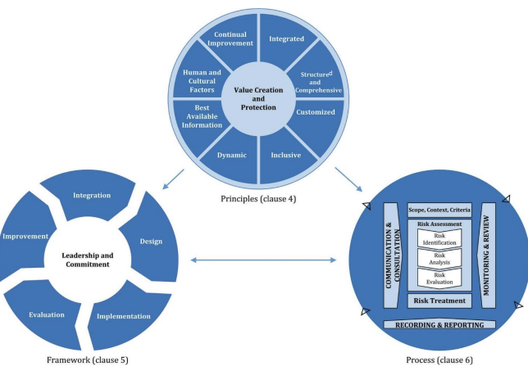
Figure 2 Risk management process based on AS/NZS ISO 31000:2018
The DEECA (2025) Ministerial Guidelines for preparation of Declared Mine Rehabilitation Plans, emphasises the importance of adopting a structured approach to risk assessments. Most mining risk assessments begin with a qualitative approach. This is a useful screening tool for early-stage closure assessment, with more rigorous assessments (such as quantitative risk assessments) undertaken on aspects where elevated risks may be identified. A tiered approach is considered robust for post closure risk assessments, with the risk framework clearly articulating the process and circumstances where more detailed risk assessments are undertaken. More detailed risk assessments should be considered for the following: 6
- elevated risk aspects (as identified by an initial screening of risk)
- specific controls for the purpose of maintaining the safety, stability and sustainability of the land (e.g., flood control structures)
- potentially individual landforms within the licence area (e.g. flood levees, overburden dumps) and
- engineered structures which will remain on the land post closure
Some risk tools which can be used to support these more detailed assessments are described in Section 6.
The risk framework should provide clear linkages between the post closure risk assessments, control measures and their integration into risk management plans (e.g., Ground Control Management Plan, Fire Risk Management Plan, Environmental Management Plan) and associated monitoring plans.

Risk matrices
A risk matrix is a tool used to rank and analyse risk based on the likelihood and potential consequence of an event occurring.
The ICMM guidelines provide information on closure risk matrices, however when using this guidance, it is important to be aware that the post closure period discussed, is different to the legislated post closure period in Victoria,
The Victorian regulatory framework provides an operational risk matrix tool, DJPR (2020) Preparation of Work Plans and Work Plan Variations,which would not be appropriate for the post closure period. Companies frequently use their own internal approved risk matrices, however for the same reason the DJPR (2002) risk matrix is not appropriate, usually the company risk matrix will need amending, due to the following considerations:
- the post closure period will extend, in theory, into perpetuity, a much longer time frame than originally considered as part of operations, therefore the likelihood section of the risk matrix needs to be amended to reflect these longer time frames. The likelihood descriptors should also take into consideration limitations of technical models noting that the predictive accuracy of models reduce over longer time horizons, up to a certain point in time, where predictions become too uncertain and are no longer meaningful.
- consequence categories and descriptors may need to be updated to address not only the longer time frames, but also the change from a company owned, secured site to a government/ individual / or community owned, potentially unsecure site. For example, some categories may not be required as they are not relevant to post closure period e.g. FTE (full time equivalent) time lost.

Understanding the starting point
Providing a clear starting point, (what landform is being assessed at what point in time) for the post closure risk assessment is a key step to ensuring that a robust and structured risk assessment is undertaken. The final (rehabilitated) landform, covering all land within the licence area, represents the starting point for the post closure risk assessment, and it includes the physical and environmental conditions within which potential risks are identified. The final landform should be described for the whole site. The conceptual site model (CSM) approach can assist with this (as described in Section 5.3.1), to visualise the post closure landform and the surrounding environment.
The starting point (post closure landform at time of licence surrender) should then be further described by domain as per guidance and for more complex domains, a domain-based CSM may be appropriate. This description should include:
- an inventory (by domain) of remaining rehabilitated post-surrender features and facilities within the licence area,
- an inventory of controls (by domain) that are inherently integrated into the final landform design,
- the corresponding proposed post-mining land uses (by domain),
- off licence area land uses and potential sensitive receptors that maybe impacted by the rehabilitation.
The final post closure landform with the corresponding post-mining land uses provides the starting / reference point of the post closure risk assessment. By adopting this starting point, no additional management controls are assumed to be in place (i.e., only the landform design itself). Identifying the starting point then allows for clear identification of the post closure controls required to manage and maintain the final landform.

Developing a Conceptual Site Model
A CSM helps to identify environmental, human health and other risks posed by a repurposed site by outlining potential source, pathway and receptor (SPR) relationships. Taking the time to develop a site-wide CSM (and potentially multiple CSMs based on domain and / or discipline) for the post closure period, prior to commencing a risk assessment, assists in visualising and understanding potential future outcomes. The post closure CSM should be constructed on the assumption that final landforms are in place, rehabilitation has been completed and proposed post closure land uses are implemented.
The SPR model is widely applied in environmental assessments. The Environment Protection Authority Victoria (EPA) provides guidance on the development of CSMs and identifying potential sources, pathways and receptors at sites. The CSM can be extended to non-environmental aspects of risk assessments. The CSM and SPR model provides a structured approach to understanding the site and the potential risks arising from its conditions. The CSM should not be static but be developed as more information comes to light. The Independent Expert Scientific Committee (IESC) also provides guidance on the conceptualisation of ecohydrological impact pathway diagrams, the methodology can be applied to domains and to other potential sources, pathways & receptors.
The CSM seeks to identify:
- sources – site activities and hazards,
- pathways – the routes the hazard can take to reach the receptor,
- receptors – environmental, cultural, infrastructure and human receptors that can be harmed / damaged.
Risks are realised when SPR linkages are complete. A CSM may be presented in a pictorial/ graphical (which is one of the most effective ways to understand and communicate a complex site), text or tabular format. For more information and examples of CSMs see IESC guidance document.
The level of complexity of the level of conceptual model development that is appropriate will depend on the nature of the issue being addressed and the scale of the systems to be considered. For complex systems and issues, several conceptual models that vary in scope, detail, spatial extent, relevant time frame and focus may be necessary to fully reflect the complexity of the system, and to maximise usability. For very simple systems or issues, for example, potential impacts of one point source waste discharge, a simple box and arrow model or even a text description alone may be sufficient. Further information on how to develop a CSM can be found in the Australian & New Zealand Guidelines for Fresh & Marine Water Quality Conceptual models section.

Understanding post closure timeframes
Timescales for the post closure period are often discussed as “in perpetuity”, There are practical implications in applying this concept to closure planning that need to be addressed (e.g., to engineering design considerations, changing risk profiles, climate change, evolving land uses, expected maintenance and monitoring, potential failures and associated costs).
It is therefore important, that as part of defining the starting point of the post closure risk assessment, the timeframes adopted in the assessment and in the associated monitoring and maintenance plan are expressly stated, with justification provided to demonstrate their appropriateness (e.g., linking to confidence in climate modelling, or engineering design life). The risk assessment methodology should also state how timeframes, particularly in relation to the likelihood of risk events, have been considered.

Risk identification
The risk identification process should begin with an inventory (by domain) as described in Section 5.2, and the development of a comprehensive list of potential hazards which could have an impact on the rehabilitated landform not continuing to achieve rehabilitation objectives and the legislated safe, stable and sustainable requirements, during the post closure period.
Examples of key aspects which are important to consider when identifying post closure risks follow.

Final landform – new and existing sources/ hazards
As the landform is transformed from operational to rehabilitation and then to the final landform post licence surrender, new hazards may be introduced and / or existing hazards altered. Examples of features posing potential post closure hazards/ sources are outlined below.
- pit lake waterbody
- pit lake water quality
- fluctuations in pit lake levels due to evaporation or release of water due to wall instability events
- river interconnection including diversion, inlet and outlet structures
- surface water control structures (e.g., permanent surface water drains)
- landfills/ ash dumps
- overburden dumps
- high walls and exposed steep slopes / batters.
- exposed coal
It is important to identify all sources / hazards with due consideration of the final landform, across the entire mine licence area. See discussion on the CSM model in Section 5.3.1.

Pathway changes over time
The pathways for sources/ hazards to reach the receptors may also change over time, particularly with the long-time frames involved in post closure. When identifying risks, potential changes to pathways need to be considered individually. A non-exhaustive list of examples is presented below;
- groundwater flow direction once pit lake levels stabilise
- subsidence from groundwater extraction, reversing to rebound
- old “dry” bores that become productive again
- hydrology and flooding levels/paths

Changing Sensitive receptors
In addition to changing the physical attributes of the land, land use will also change in the post closure phase. It is possible for the final landform to support multiple end land uses. New land uses both on and off licence can result in an alteration to the proximity, type and number of receptors that could be impacted by the final landform. With the introduction of new or changing receptors, there may be changes in exposure likelihood and / or the introduction of new exposure pathways and therefore risks, both on and off licence. For example:
- if the mine void is transformed into a pit lake it becomes a new source / hazard, with proposed public access a recreational end land use becomes a new receptor introducing new risks such as the potential for drowning, and
- whilst during the operational phase the site may have limited impact on downstream water quality, the introduction of a full and interconnected pit lake as the rehabilitated landform poses a new hazard and is likely to create new exposure pathways. These could affect downstream water quality, positively or negatively interacting with new / changed receptors that had not previously been identified. These include downstream users as new receptors such as aquatic ecology.
As a result of changing land uses, both on and off licence, new risks or different consequences to sources/ hazards, may be introduced during the post closure phase. Risks once considered low or moderate during operations and rehabilitation, due to active controls by the mine operator, may become high in a post closure context.
It is therefore important, that the first post closure risk assessment considers the range of potential land uses within different parts of the licence area, and the current adjacent land uses as well as current off licence sensitive receptors and assess the risks in the context of the new landforms and new receptors.
It is key that, as knowledge develops for the rehabilitation of the mine licence, and the surrounding land uses and sensitive receptors change, post closure risk assessments are updated and re-assessed.
Undertaking a standalone risk assessment for the post closure phase ensures that the assessment is tailored to the specific post-mining land uses and changing receptors.

Changes to the landform over time
While landforms are designed to achieve certain closure objectives and criteria, there may also be ongoing requirements to monitor aspects of the site and manage engineered structures to ensure they continue to meet their design function and design life. There may also be a need to rectify any subsequent failures of rehabilitation that occur after the surrender was approved, noting where it is difficult, and in some cases impossible, to eliminate the risk of rehabilitation failure.
The final landform should be designed using a risk-based approach. The risk-based approach may require a detailed / focused risk assessment to understand the key aspects of the design. The design life, design loads and events should be aligned with the level of risks identified. This includes the structures and controls required to ensure the continued functionality of the landform. Decisions made on the design life serviceability, design events and loads of the final landform should be provided and justified within the DMRP and relevant design reports.
Post closure risk assessment should consider and assess the changes and failure of rehabilitated landforms over time. Landforms may be affected by both foreseen and unforeseen events arising from several factors, including but not limited to:
- major floods
- erosion
- fire
- earthquakes
- increasing concentrations of contaminants in water bodies
- loss of vegetation and failure of cover systems
- instability events
- other natural or human processes
Risks remaining at the point of licence surrender may not necessarily reflect all the risks relevant throughout the post closure period. For example:
- building on the pit lake example in Section 5.4.2, it is likely that water quality will change over time. While it may be acceptable at the point of licence surrender, ongoing evapo-concentration, bio-geochemical reactions, pit lake dynamics, variations in input water quality etc. may cause degradation in the long-term. Although not a risk at the point of licence surrender, additional mitigations may be needed to manage this over time. Examples of mitigation measures may include provision of funds, resources and specific infrastructure.

Climate change and exceedance events
While closure designs typically account for a defined level of risk and / or design intent (e.g., 1% Annual Exceedance Probability (EAP)), given the long timescales of mine closure, it is not unexpected that events may exceed the original design criteria. Furthermore, with climate change, conditions are projected to become drier than historically observed and subject to more extreme storm events.
As such, the post closure risk assessment should consider and account for a changing climate, including the potential for events larger than those originally used in the operational designs. This should be incorporated into the risk assessment as identified hazards, supported by climate and other relevant modelling to inform the final landform design as well as the type and frequency of management, maintenance and repair works that may be required post closure.

Risk analysis and evaluation
The risk analysis process assesses the potential consequence and likelihood of each risk event, with the combination of these two factors determining the overall level of risk. This allows risks to be ranked and prioritised. Some that may be used to support this process are presented in Section 6.
To provide a reference point for the post closure risk assessment, an inherent risk analysis should be undertaken based on the ‘starting point’ described in Section 5.3. This should be followed by a risk evaluation to determine whether the inherent risk level is acceptable, in line with the risk appetite and tolerances described in Section 5.1. Where the inherent risk level is deemed unacceptable, treatments (such as controls, mitigations and management measures – see Section 5.6) should be developed and implemented during the closure phase, prior to licence surrender.
The residual risk level (post closure risk) after the implementation of these measures should be analysed and evaluated again against the defined risk appetite and tolerances. Additional controls should be applied until the risk is either eliminated or it can be demonstrated that the risk has been reduced as far as reasonably practicable. As further discussed in Section 5.7, it is important that confidence and certainty in the risk assessment are considered as part of the analysis and evaluation process, to avoid over- or under- estimating the level of risk.

Controls, mitigations and management
As outlined in the DEECA (2025) Ministerial Guidelines for preparation of Declared Mine Rehabilitation Plans, appropriate risk treatments and controls should be identified using the hierarchy of control, with any critical controls also identified.
When identifying controls and mitigations in a risk assessment, specific measures related to each risk should be described, rather than referring only to overarching management plans. This provides transparency in the risk management, as well as clarity, accountability, and effective implementation for the next responsible party. controls and mitigations identified within the risk assessment should also inform the post closure plan, prescribed records/information and supporting management documents.
The post closure risk treatment process also plays a key role in the final landform design. Returning to the pit lake example in Section 5.4.2, the creation of a publicly accessible, recreational pit lake could introduce the risk of drowning. Potential controls to mitigate this risk could include, but are not limited to, incorporating fencing, egress points around the lake, installing signage and ensuring that there are no steep drop-offs below the water line in publicly accessible areas. The introduction of these controls would result in explicit changes to the final landform design and may require additional post closure management.
Individual risk events and their treatments cannot be considered in isolation. For example, CSIRO (2025) notes that re-profiling a slope may improve stability (increasing the factor of safety), but could also result in increased disturbance, closer proximity to sensitive sites at the crest, or impacts to surface water flows. Accordingly, it is important to consider the broader implications of controls to ensure that new measures do not exacerbate existing risks or introduce new ones, and that if they do, the new risk will need to be assessed separately.

Uncertainty and assumptions
As noted in Section 5.3.1, the timescales for post closure are long, and assessing risks, particularly during early planning stages, can be challenging due to uncertainties, limited data, evolving environmental conditions, pending technical studies, and the potential unpredictability of future land use and / or stakeholder expectations.
There may be various uncertainties and assumptions associated with the post closure phase, and it is crucial that they are expressly stated, justified and documented as part of the risk assessment process. This should include, but not be limited to, engineering design life, factor of safety, probability of failure, and any modelling predictive uncertainty analysis. These should be clearly described and justified, with a clear road map in place to verify them prior to licence surrender (e.g., a milestone planning/ schedule of technical studies).
For transparency, and to provide stakeholders with confidence that post closure risks are well understood, the level of confidence associated with each risk item and its corresponding controls should also be reported. One way to achieve this is through the inclusion of “confidence level” columns within a risk register (see Appendix A: Example Risk Register). The aim is to communicate the degree of certainty in both the understanding of each risk and the effectiveness of the controls in mitigate it. Examples of confidence levels are presented in Table 1.
Table 1 Risk confidence rating
Confidence level | Confidence description*
Confidence level | Risk understanding | Control effectiveness
Low | The risk is understood at a conceptual level only. Additional technical studies are required to further understand the source, pathway, receptor, consequence and / or likelihood of this risk. | The control has not been applied at the site or more broadly within the mining industry. This a new control with little evidence to demonstrate its effectiveness.  The site-specific procedures / management plans / conceptual designs etc. have not been developed. No trials (with supporting data) have been undertaken at the site.
Medium | One or more aspects of the SPR are well understood and is backed by supporting data. | The control has not been applied at the site before but has been applied more broadly within the mining industry or is an industry accepted control. There is some evidence which demonstrates the effectiveness of this control (e.g., case studies at other sites, calibrated modelling, tested specifications).  Site specific procedures / management plans / conceptual designs etc. have been developed, but further work is required to finalise.
High | All aspects of this risk are well understood.  There is data supporting the understanding of the risk.  Risks of this type have been identified and managed during operations. | The control has been previously applied to the site with evidence which demonstrates that this control is effective (e.g., through site-specific trials and calibrated/validated modelling and predictive uncertainty analysis).  Site specific procedures / management plans / detailed designs etc. have been developed & trials undertaken, data collected.
* The supporting evidence to demonstrate the certainty rating should also be provided.
It is acknowledged that the detail of the post closure risk assessment (and number of assumptions), will be proportional to the level of uncertainty and information available, and the agreed risk appetite. Confidence levels will vary depending on the mine’s position within its lifecycle i.e., for a mine which is still operational, the post closure risk assessment is expected to be at a lower level of confidence, compared to a mine which is within a couple of years of cessation of operations or has already commenced the rehabilitation phase, where more finalised designs, technical studies and data would be expected to be available.

Risk Tools
To support the risk assessment process, a series of risk assessment tools and methods are available. The selection of risk assessment methods depends on factors such as:
- the reason why the risk assessment is being undertaken
- the quantity and quality of supporting data, and
- the required rigour warranted to assess the consequences of risk,.
Some common risk assessment tools include:
- risk matrices
- source-pathway-receptor (SPR)
- decision trees
- failure modes and effects analysis (FMEA) and
- bowtie models.
Some of these methods / tools are discussed further below, with Figure 3 presenting how these tools vary based on the rigour of analysis.
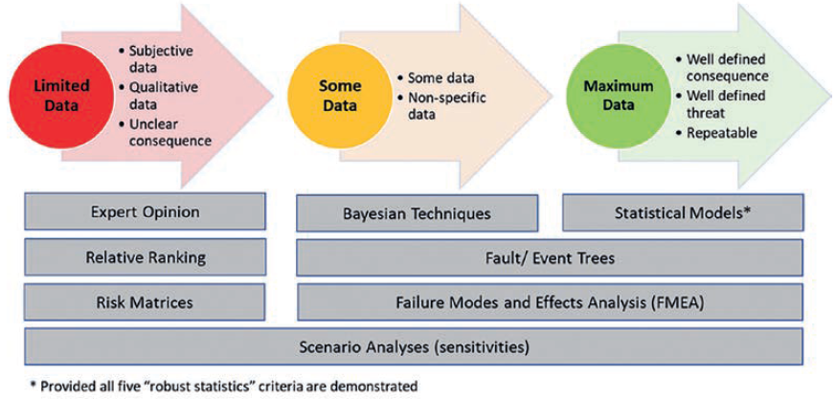
Figure 3 Spectrum of risk analysis with increasing analysis rigour with increasing quality of data and understanding from left to right (adapted from NRC 2010, sourced from CSIRO 2025).

SPR
The SPR linkages, developed through the CSM process in Section 5.3.1, can be used to form the basis of the risk assessment. An example of a risk register, utilising the SPR model, is presented in Appendix A: Example Risk Register.

Failure Modes Effect Analysis
Failure Modes Effects Analysis (FMEA) is a structured risk assessment tool used to assess potential failure modes of a system. It evaluates the likelihood of failures in structures, equipment and processes as well as the effects of those failures on larger systems and the surrounding environment.
There are several benefits to utilising FMEA to assess the failure modes of the final landform and associated structures, including:
- providing a robust method of testing landforms and controls against worst-case events, which may be overlooked in other forms of risk assessment,
- offering a feedback loop to improve closure design, controls and mitigations
- testing landform designs to failure, which builds confidence in both the final landform and the effectiveness of controls.
Failure modes maybe triggered by natural events (e.g. an earthquake, a rainfall event greater than the design standard, or fire), by the failure of engineered structures (e.g. instability of a dam), or by operational issues associated with new land uses (e.g. failing to exclude heavy-hooved animals from sensitive soil and vegetation cover areas).
An example risk register can be found in Appendix A: Example Risk Register. Further information on FMEA can be found at Dr A. Robertson & S. Shaw (n.d.), Infomine E-Book: Mine Closure.

Fault Trees
Similar to the FMEA approach, Fault Tree Analysis (FTA) is a top-down systematic risk assessment methodology that focuses on the potential failure of an event. It aims to identify, quantify and represent, in diagrammatic form, the faults or failures, and the combination of fault of failures, that can lead to a major hazard or event.

Bowties
A bow tie analysis is a common tool used to visualise and assess significant risks. Each bowtie focuses on a single risk event (the “knot” in the bowtie) and visually depicts the pathways from the cause of an event / emerging risk to its consequences using a simple qualitative cause-consequence diagram. It also allows for the identification of both preventative and mitigative controls. See Appendix A: Example Risk Register.
The bowtie tool is particularly useful in the following scenarios:
- where more detail is needed about the causes and consequence of a risk than is contained in a risk register
- when additional focus is required on identifying controls, control effectiveness and control gaps and ensuring that each pathway has appropriate and adequate controls
- when differentiating between preventative and mitigative controls (e.g., those that may need to be incorporated into the landform design vs monitoring, maintenance and management requirements)
- when assessing the potential failure of the landform
- when the overall control strategy needs to be confirmed, and
- where a visual tool may be much clearer than text, or a simple diagram is required to communicate the range of causes and consequences and the associated controls.

Post closure plan
The post closure plan has been included in this paper, as an initial prompt regarding what may be required in the post closure plan and how it links to the outputs of the post closure risk assessment. This is an initial high-level identification, and further information is likely to be added as understanding is developed. The inclusions in this section should not be considered as all that would be required/ recommended within the post closure plans.
The MLRA considers the post closure plan to be a document that will be used to manage the land long after the licence has been surrendered, when current site-based personnel are no longer present to advise. The Plan therefore needs to provide the clear, concise information needed to understand the landforms some tens / hundreds of years into the future. The post closure plan should be:
- a standalone document, that will be required “in perpetuity” to manage the ongoing residual risks and liabilities
- the primary source of information for future landowners and/ or those responsible for the ongoing management and potential repair of the declared mine land
- the tool for the transfer of knowledge and understanding of the declared mine land to enable new land managers to understand what is required and why it is required at the site
- a plan that draws together all management, monitoring and legal requirements associated with declared mine land, at the point of licence surrender and into the future, and refers out to where detail is held
- a document that enables future potential landowners to do due diligence and understand their liabilities
- enables costing for declared mine funding, identification of resources and new infrastructure applied to manage post closure risks
The post closure plan outlines the ongoing monitoring and maintenance works required after the surrender of the mining licence. It must be supported by a post closure risk assessment, with the identified risk treatments and controls forming key components of both the plan and its associated management documents. Following licence surrender, two primary forms of activity will be undertaken:
- “normal’ land management activities required for the new post-closure land uses, and
- the additional land management requirements associated with the historic mining activities to maintain stability, safety and sustainability of the declared mine land, identified in the post closure risk assessment and outlined within the registered post closure plan.
As presented in Figure 4, whilst the post closure plan primarily aims to capture land management requirements beyond ‘normal’ land management requirements (refer to Section 4), it is acknowledged that some grey areas may exist. For example, if the final land use is designated as grazing, stock fences may typically be required to contain and protect livestock. However, fencing may also be necessary to restrict public access to landforms resulting from historic mining activities like remediated contaminated land (e.g., asbestos landfill areas). In this case, the fencing would be considered part of the post closure requirements and therefore included in the post closure plan.
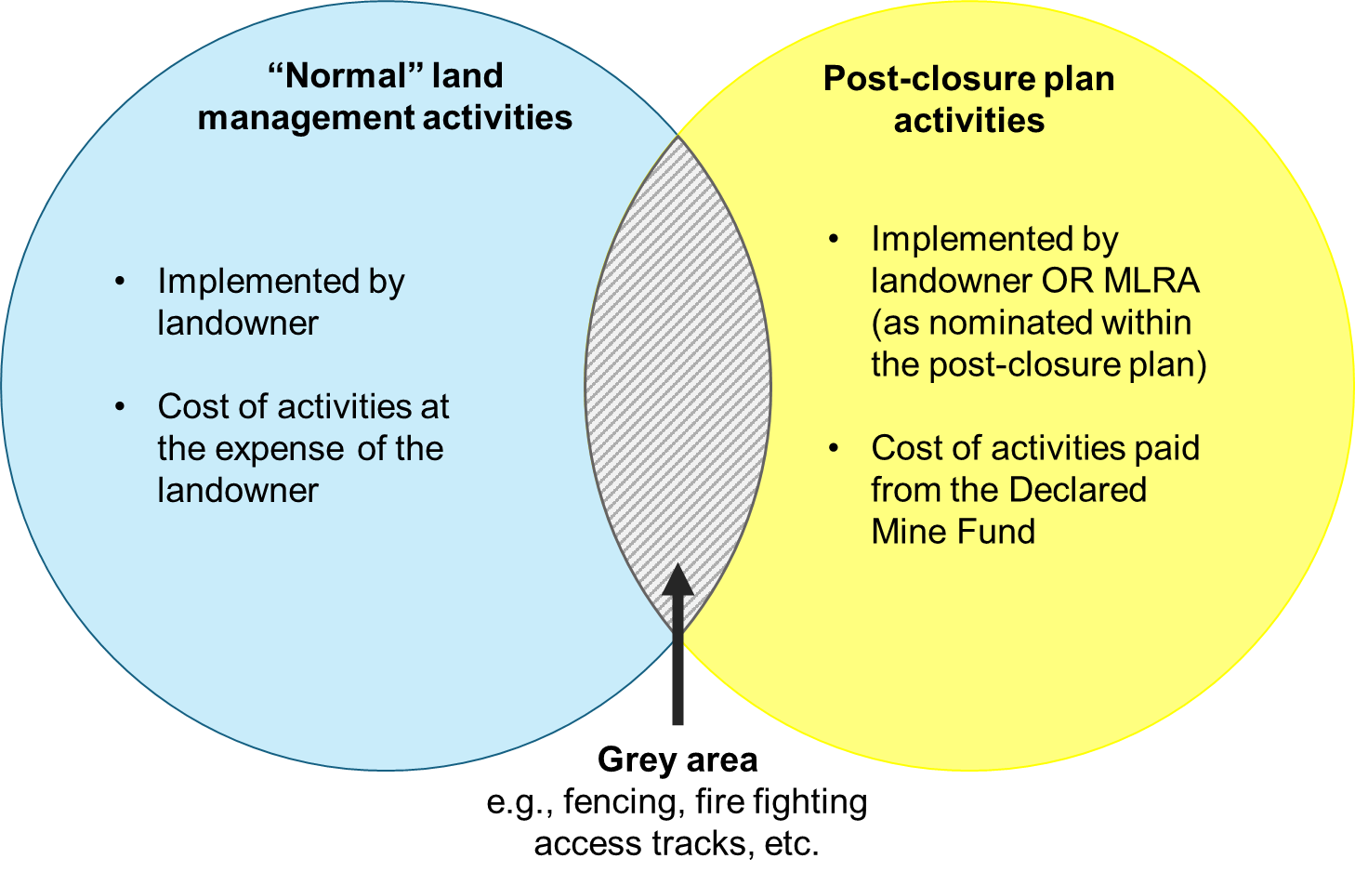
Figure 4 Diagram conceptually depicting the scope of post closure plan with respect to ‘normal’ land management and funding arrangements for the associated management work
The post closure plan should reference, and have appended, more detailed monitoring and management plans, which could be domain, or discipline based and should be attached. In developing the post closure plan, consideration should be given to potential future land ownership arrangements. For example, the land may be sold in smaller parcels, with different owners or managers across a given area or identify clear accountabilities detailed management plans may be structured around domains and sub-domains.
For transparency and long-term understanding of activities required in the post closure plan, all monitoring and management activities should explicitly cross-reference the risk assessment to show which individual risks they are managing and also briefly summarise why these activities are key to the ongoing functioning of the rehabilitation. In addition to requirements outlined in S84AZU(c) and Regulation 64D, the following elements (among others) should be considered for inclusion:
- description of the final landform with the inclusion of relevant maps and plans (at the overall site, domain and feature basis & ideally including CSMs for the rehabilitated site, and domains). The description of the final landform should also include the inventory of controls (by domain) which are implicitly integrated into the final landform design (see Section 5.35.1)
- A summary of remaining residual risks that require ongoing monitoring and management
- Standalone post closure risk assessment, including description of the framework, methodology and process and proposed review period
- Details of the post closure monitoring (by domain and/ or sub-domain and discipline) required, including but not limited to:
  - reference number for each monitoring requirement
  - the objective
  - the purpose of the monitoring & reference to relevant risk IDs
  - description of monitoring
  - compliance levels/ triggers that are relevant to the monitoring
  - reference all ongoing regulatory requirements & reporting relevant to monitoring
  - reference to landform designs/ structure designs/ compliance requirements or other relevant information
  - references to relevant monitoring plans/procedures and management plans where further details are provided on (but not limited to); locations (x,y ref & figures) / frequency / analytes / method / compliance levels / triggers / Trigger Action Response Plans (TARPs) etc
- Outline of all land maintenance requirements, by domain and sub-domain, including but not limited to:
  - reference number for each maintenance activity
  - the objective
  - the purpose of the maintenance & reference to relevant risk IDs & monitoring ID reference
  - type of maintenance
  - frequency and/ or trigger for maintenance
  - references to the management plans where further details are provided
- what is considered “normal” land management per domain and sub-domain and therefore excluded from residual liabilities
- inclusion of contingency planning summary, taking into consideration potential for catastrophic failures of the landform and unforeseen events, caused by natural or human processes. Reference to where a contingency management plan provides additional background and management information
- inclusion of all monitoring plans and management plans identified as part of risk assessment process
- relevant drawings, figures, final detailed designs, risk mapping, that support the post closure risk assessment and ongoing management.
All prescribed records and information, such as relevant maps, plans, design documentation, survey information, and other supporting materials required for the effective understanding and implementation of the post closure plan should be included. All maps and plans provided should be to scale and legible. The plan should be provided in digital formats (e.g., .docx and .pdf) format, with associated data provided in a format that can be imported into a GIS database (such as ArcGIS).
Due to the likely size and complexity of the post closure plan, it is recommended it is treated as a standalone document within the DMRP.

Summary
The document has been prepared to help bridge the risk assessment process for operations to post closure so that the discrete post closure risk assessment can be developed. The post closure risk assessment forms an intrinsic part of the development of a structured post closure plan that can be operationalised following closure determination by future land managers.
A robust post closure risk assessment process can be informed by tiers of more detailed assessments focussing on elevated risk areas, key subject matters, remaining engineering structures and critical controls.
In line with AS/NZS ISO 31000:2009, the risk assessment process should be iterative. Risks should be systematically analysed and evaluated, with additional control measures introduced and implemented until residual risks are either eliminated or reduced as far as reasonably practicable. This iterative approach also provides a key input into risk-based landform design, where the design progressively evolves in response to identified risks and associated controls.
By adopting a tiered approach, and explicitly considering the potential failure modes of the landform, the closure process will help ensure that for post closure:
- designs are fit for purpose and can support proposed future post closure land uses, and
- a robust process is in place to identify all ongoing monitoring and maintenance controls, ensuring that any potential residual risks remaining on the declared mine land are appropriately managed.
In accordance with S84AL(1)(kb), S84AL(1)(kh) and S84AZU(3)(c) of the MRSDA, the MLRA will have a key role in the post closure management of declared mine land. The Authority will be responsible for either implementing or providing oversight on the implementation of the relevant registered post closure plans. As such, the MLRA has a vested interest in the development and undertaking of each declared mine’s post closure risk assessments and management plans.
The Mine Land Rehabilitation Authority (MLRA) prepared this discussion paper to outline key considerations and potential methodologies to assist in undertaking post closure risk assessments and providing provision for post closure, while prompting thought and feedback for consideration by government and the mine licensees.

Key considerations
The following key aspects should be considered as part of the post closure risk assessment:
- describe a risk framework that links all risk assessments and risk management plans together and sets out the requirement for more detailed assessment on key remaining structures / controls
- a dedicated / standalone post closure risk assessment, which is distinct from the operational risk assessment
- prior to commencing the risk assessment, have a clearly defined starting point including a clear understanding of the controls which are implicitly incorporated into the final landform design
- the post closure risk assessment should have explicit consideration for the following after licence surrender:
  - final rehabilitated landform
  - proposed end land uses and landholders (if known)
  - climate change
  - existing, new and changing receptors
  - potential failure modes
  - existing, new and changing exposure pathways
  - post closure timeframes and its influence on the assessment of the likelihood of a risk event
  - consequence of a risk event
  - mitigations, monitoring, maintenance activities require to mitigate risk events, and
  - confidence in understanding the risk and effectiveness of risk controls.
- include detailed risk assessment to assess the potential failure mechanisms of the rehabilitated landform, and
- consider the long-term impacts of climate change and other hazards/ sources that are likely to impact the resilience of the landform design.
Understanding the residual risk profile (i.e., risks remaining after the surrender of the mining licence) is key to developing robust final landform designs that support end land uses, underpin the content and structure of the post closure plan and to enable the successful relinquishment of a mining licence. The outcomes from the risk assessment feed into the post closure plan where it should be used to:
- identify ongoing monitoring and maintenance requirements of the landform, post-licence surrender
- identify triggers for rectification and further rehabilitation of the land
- provide transparent and robust documentation to help stakeholders understand potential residual risks and liabilities
- ensure that landform designs developed during the rehabilitation and closure planning phase incorporate the key mitigation measures required by the proposed end land uses.
- Identify who is responsible for the post closure activities, their timing, and the value of the future costs associated with them.

References
A. Robertson & S. Shaw (n.d.), Infomine E-Book: Mine Closure
Australian Government Department of Finance (2016) An Overview of the Risk Management Process. https://www.finance.gov.au/sites/default/files/2019-11/Risk-Management-Process.pdf
Australian Government Department of Finance (2023) Element 7: Emerging Risks. https://www.finance.gov.au/government/comcover/risk-services/management/risk-management-toolkit/element-7-emerging-risks
Australian & New Zealand Guidelines for Fresh & Marine Water Quality, Conceptual models
Commissioner for Resources Safety & Health (2023) Risk assessment education resource, Mining Safety and Health Advisory Committee https://www.publications.qld.gov.au/ckan-publications-attachments-prod/resources/f7f107ce-52d4-427e-837b-5a81984bbb40/20232003-risk-assessment-educational-resource.pdf?ETag=d353c0ea3e90ed671fee9803b4d9ae91
CSIRO (2025) Guidelines to Open Pit and Waste Dump Closure, Guidelines for Open Pit and Waste Dump Closure | CSIRO Publishing
DEECA (2025) Ministerial Guidelines for preparation of Declared Mine Rehabilitation Plans
DJPR (2020) Preparation of Work Plans and Work Plan Variations (version 1.3), https://resources.vic.gov.au/legislation-and-regulations/guidelines-and-codes-of-practice/work-plan-guidelines-for-mining-licences/Preparation-of-work-plans-and-work-plan-variations-mining-projects.pdf
DJPR (2022) Regulatory Impact Statement — Mineral Resources (Sustainable Development) (Mineral Industries) Regulations 2022, https://earthresources.vic.gov.au/__data/assets/pdf_file/0004/895693/Regulatory-Impact-Statement-Proposed-Mineral-Resources-Sustainable-Development-Mineral-Industries-Amendment-Regulations-2022.pdf
EPA Victoria (2025) Consultation guideline: Preparing a risk management and monitoring program. https://engage.vic.gov.au/download/document/42474
Government of Victoria (1990) Mineral Resources (Sustainable Development) Act 1990, Australia
ICMM (2015) Health and Safety Critical Control Management: Good Practice Guide. https://www.icmm.com/en-gb/guidance/health-safety/2015/ccm-good-practice-guide
ICMM (2025) Integrated Mine Closure Good Practice Guide, ICMM - Integrated Mine Closure: Good Practice Guide
IESC, Summary guide – Using impact pathway diagrams based on ecohydrological conceptualisation in environmental impact assessment
IGF (2023) Relinquishment of Closed Mine Sites: Policy steps for governments, https://www.iisd.org/system/files/2023-09/relinquishment-closed-mines-policy-steps-for-governments-en.pdf
Mine Land Rehabilitation Authority (2025) Vocabulary https://www.mineland.vic.gov.au/learn/vocabulary/
Queensland Government (2018) Managing residual risks in Queensland Discussion Paper. https://environment.desi.qld.gov.au/__data/assets/pdf_file/0036/88857/managing-residual-risks-discussion-paper.pdf
Queensland Government (2024) Residual Risk Assessment Guideline – Interim (ESR/2020/5433, Version 1.02) Residual Risk Assessment Guideline - Interim
Tiemann, C., MacDonald, V., Young, R. and Dixon, K. (2022), Rehabilitation and mine closure policies creating a pathway to relinquishment: an Australian perspective. Restor Ecol, 30:e13785.https://doi.org/10.1111/rec.13785

Appendix A: Example Risk Register

Table 2 Example SPR Risk Register
Risk ID | Risk Description |  |  |  |  | Inherent controls (implicit in landform design) | Consequence category | Inherent risk |  |  |  | Post closure controls |  |  | Residual Risk |  |  |  | Further work required to improve confidence | Estimated timeframe / milestone delivery date
Risk ID | Domain | Source  / Hazard | Pathway | Receptor | Potential consequence | Inherent controls (implicit in landform design) | Consequence category | Likelihood | Consequence | Risk Rating | Confidence | Controls | Relevant control plan or procedure | Confidence | Likelihood | Consequence | Risk rating | Confidence | Further work required to improve confidence | Estimated timeframe / milestone delivery date

Risk ID | Risk Description |  |  | Inherent controls (implicit in landform design) | Inherent risk |  |  |  |  |  |  |  |  |  | Post closure controls |  |  | Residual risk |  |  |  |  |  |  |  |  |  | Further work required to improve confidence | Estimated timeframe / milestone delivery date
Risk ID |  |  |  | Inherent controls (implicit in landform design) | Likelihood | Consequence categories |  |  |  |  |  |  |  | Confidence Level |  |  |  | Likelihood | Consequence categories |  |  |  |  |  |  |  | Confidence Level | Further work required to improve confidence | Estimated timeframe / milestone delivery date
Risk ID | Domain | Failure mode description | Effects and pathway | Inherent controls (implicit in landform design) | Likelihood | CC 1 | Ranking 1 | CC 2 | Ranking 2 | CC 3 | Ranking 3 | CC 4 | Ranking 4 | Confidence Level | Controls | Relevant control plan or procedure | Confidence | Likelihood | CC 1 | Ranking 1 | CC 2 | Ranking 2 | CC 3 | Ranking 3 | CC 4 | Ranking 4 | Confidence Level | Further work required to improve confidence | Estimated timeframe / milestone delivery date
*CC – Consequence category
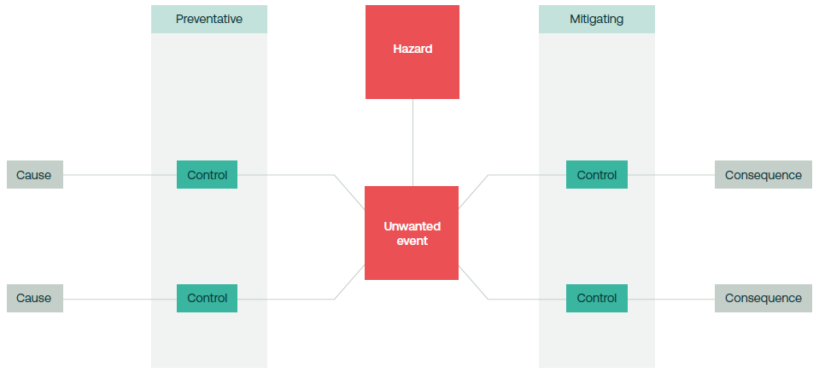
Figure 5 Example of bowtie format

Intentionally Blank

MRSDA, S84AZU(3)(e)
MRSDA, S84AZU(3)(c)
MRSD Regulations 64D
DEECA (2025) Ministerial Guidelines for preparation of Declared Mine Rehabilitation Plans (not publicly available at the time of this papers release)
DJPR (2022) Regulatory Impact Statement — Mineral Resources (Sustainable Development) (Mineral Industries) Regulations 2022, https://earthresources.vic.gov.au/__data/assets/pdf_file/0004/895693/Regulatory-Impact-Statement-Proposed-Mineral-Resources-Sustainable-Development-Mineral-Industries-Amendment-Regulations-2022.pdf
IGF (2023) Relinquishment of Closed Mine Sites: Policy steps for governments, https://www.iisd.org/system/files/2023-09/relinquishment-closed-mines-policy-steps-for-governments-en.pdf
Tiemann, C., MacDonald, V., Young, R. and Dixon, K. (2022), Rehabilitation and mine closure policies creating a pathway to relinquishment: an Australian perspective. Restor Ecol, 30:e13785.https://doi.org/10.1111/rec.13785
IGF (2023) Relinquishment of Closed Mine Sites: Policy steps for governments, https://www.iisd.org/system/files/2023-09/relinquishment-closed-mines-policy-steps-for-governments-en.pdf
Tiemann, C., MacDonald, V., Young, R. and Dixon, K. (2022), Rehabilitation and mine closure policies creating a pathway to relinquishment: an Australian perspective. Restor Ecol, 30:e13785.https://doi.org/10.1111/rec.13785
MRSDA, S84AZZB
DEECA (2025) Ministerial Guidelines for preparation of Declared Mine Rehabilitation Plans (not publicly available)
IGF (2023) Relinquishment of Closed Mine Sites: Policy steps for governments, https://www.iisd.org/system/files/2023-09/relinquishment-closed-mines-policy-steps-for-governments-en.pdf
Mine Land Rehabilitation Authority (2025) Vocabulary
Queensland Government (2024) Residual Risk Assessment Guideline – Interim (ESR/2020/5433, Version 1.02) https://www.des.qld.gov.au/policies?a=272936:policy_registry/era-gl-residual-risk-assessment.pdf https://www.des.qld.gov.au/policies?a=272936:policy_registry/era-gl-residual-risk-assessment.pdf
Queensland Government (2024) Residual Risk Assessment Guideline – Interim (ESR/2020/5433, Version 1.02) https://www.des.qld.gov.au/policies?a=272936:policy_registry/era-gl-residual-risk-assessment.pdf
Queensland Government (2024) Residual Risk Assessment Guideline – Interim (ESR/2020/5433, Version 1.02) https://www.des.qld.gov.au/policies?a=272936:policy_registry/era-gl-residual-risk-assessment.pdf
IGF (2023) Relinquishment of Closed Mine Sites: Policy steps for governments, https://www.iisd.org/system/files/2023-09/relinquishment-closed-mines-policy-steps-for-governments-en.pdf
DEECA (2025) Ministerial Guidelines for preparation of Declared Mine Rehabilitation Plans
Queensland Government (2018) Managing residual risks in Queensland Discussion Paper
Queensland Government (2024) Residual Risk Assessment Guideline – Interim (ESR/2020/5433, Version 1.02) https://www.des.qld.gov.au/policies?a=272936:policy_registry/era-gl-residual-risk-assessment.pdf
Australian Government Department of Finance (2016) An Overview of the Risk Management Process. https://www.finance.gov.au/sites/default/files/2019-11/Risk-Management-Process.pdf
DEECA (2025) Ministerial Guidelines for preparation of Declared Mine Rehabilitation Plans
CSIRO (2025) Guidelines to Open Pit and Waste Dump Closure, https://ebooks.publish.csiro.au/content/guidelines-open-pit-and-waste-dump-closure
ICMM (2025) Integrated Mine Closure: Good Practice Guide. https://www.icmm.com/integrated-mine-closure
DJPR (2020) Preparation of Work Plans and Work Plan Variations (version 1.3), https://resources.vic.gov.au/legislation-and-regulations/guidelines-and-codes-of-practice/work-plan-guidelines-for-mining-licences/Preparation-of-work-plans-and-work-plan-variations-mining-projects.pdf
DEECA (2025) Ministerial Guidelines for preparation of Declared Mine Rehabilitation Plans
ICMM (2025) Integrated Mine Closure: Good Practice Guide. https://www.icmm.com/integrated-mine-closure
EPA Victoria (2025) Consultation guideline: Preparing a risk management and monitoring program. https://engage.vic.gov.au/download/document/42474
EPA Victoria (2025) Consultation guideline: Preparing a risk management and monitoring program. https://engage.vic.gov.au/download/document/42474
IESC, Summary guide – Using impact pathway diagrams based on ecohydrological conceptualisation in environmental impact assessment
Conceptual models
Queensland Government (2018) Managing residual risks in Queensland Discussion Paper. https://environment.desi.qld.gov.au/__data/assets/pdf_file/0036/88857/managing-residual-risks-discussion-paper.pdf
ICMM (2025) Integrated Mine Closure Good Practice Guide, https://www.icmm.com/integrated-mine-closure
CSIRO (2025) Guidelines to Open Pit and Waste Dump Closure, https://ebooks.publish.csiro.au/content/guidelines-open-pit-and-waste-dump-closure
Commissioner for Resources Safety & Health (2023) Risk assessment education resource, Mining Safety and Health Advisory Committee https://www.publications.qld.gov.au/ckan-publications-attachments-prod/resources/f7f107ce-52d4-427e-837b-5a81984bbb40/20232003-risk-assessment-educational-resource.pdf?ETag=d353c0ea3e90ed671fee9803b4d9ae91
CSIRO (2025) Guidelines to Open Pit and Waste Dump Closure, https://ebooks.publish.csiro.au/content/guidelines-open-pit-and-waste-dump-closure
CSIRO (2025) Guidelines to Open Pit and Waste Dump Closure, https://ebooks.publish.csiro.au/content/guidelines-open-pit-and-waste-dump-closure
Dr A. Robertson & S. Shaw (n.d.), Infomine E-Book: Mine Closure
CSIRO (2025) Guidelines to Open Pit and Waste Dump Closure, https://ebooks.publish.csiro.au/content/guidelines-open-pit-and-waste-dump-closure
Australian Government Department of Finance (2023) Element 7: Emerging Risks. https://www.finance.gov.au/government/comcover/risk-services/management/risk-management-toolkit/element-7-emerging-risks
Commissioner for Resources Safety & Health (2023) Risk assessment education resource, Mining Safety and Health Advisory Committee https://www.publications.qld.gov.au/ckan-publications-attachments-prod/resources/f7f107ce-52d4-427e-837b-5a81984bbb40/20232003-risk-assessment-educational-resource.pdf?ETag=d353c0ea3e90ed671fee9803b4d9ae91
The detail around the content and volume of the prescribed records and information are currently being developed.
ICMM (2015) Health and Safety Critical Control Management: Good Practice Guide. https://www.icmm.com/en-gb/guidance/health-safety/2015/ccm-good-practice-guide

