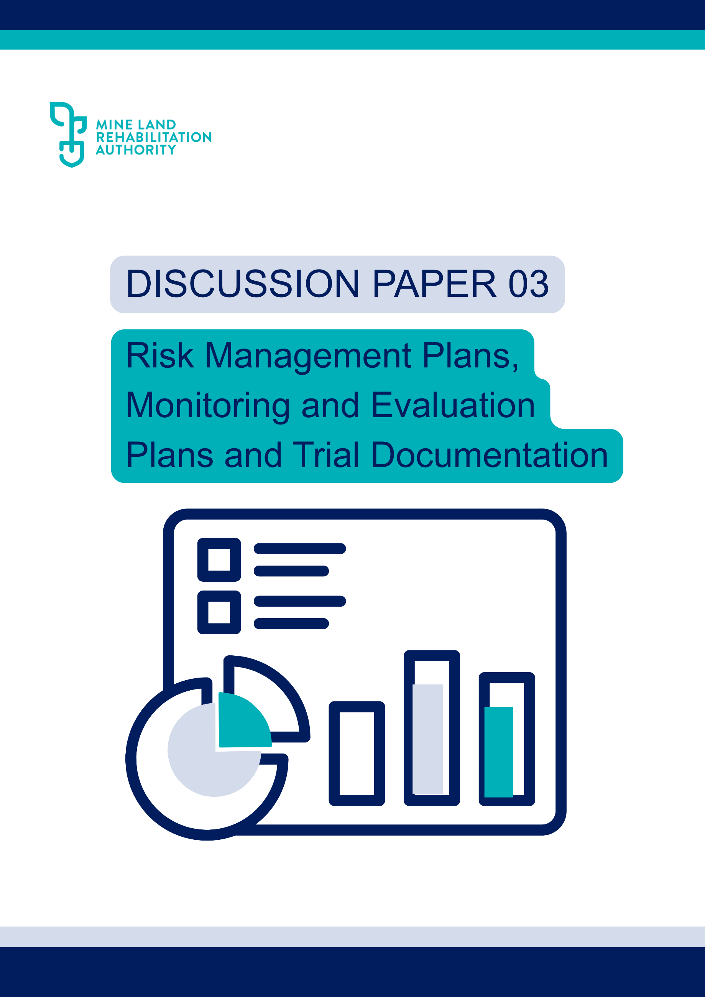

MLRA Discussion Paper 03: Risk Management Plans, Monitoring & Evaluation Plans and Trial Documentation

Approval for Use
Title & ID |  | MLRA Discussion Paper 03: Risk Management Plans, Monitoring & Evaluation Plans and Trial Documentation
Classification |  | External Use
Rev | Date |  | Approved For Use
00 | 12th March 2026 |  | Antonia Scrase, Technical Director

Executive summary
This document has been developed to provide guidance on the essential information that should be included in key documents supporting Declared Mine Rehabilitation Plans (DMRPs) such as:
- Risk Management Plans
- Monitoring and Evaluation Plans, and
- Trial documentation
Its purpose is to assist in the creation of traceable and auditable records that form a robust foundation for technical studies, environmental understanding, risk management, control performance assessment, and the supporting evidence required for closure criteria determination.

Contents
Executive summary 2
1. Purpose 4
2. Introduction 4
2.1. Background 4
2.2. Disclaimer 5
3. Risk Management Plans 5
4. Monitoring and Evaluation Plans 6
5. Trials 7
6. References 9

Purpose
The Mine Land Rehabilitation Authority (MLRA) has prepared this discussion paper to outline key considerations and potential methodologies to assist in the drafting of risk management plans, monitoring and evaluation plans and trial documentation.

Introduction

Background
Risk assessment management plans are a key regulatory requirement of managing operational and rehabilitating mines. As part of the Work Plan Variation (WPV) declared mine licensees are required to prepare and maintain a Risk Assessment Management Plan (RAMP), a Ground Control Management Plan (GCMP) and a Fire Risk Management Plan (FRMP). Resources Victoria provides guidance on these documents.
Monitoring is a systematic and ongoing process for tracking activities (for example on a, daily, weekly, monthly, quarterly, or annual basis) and for observing and assessing environmental or other changes through the systematic collection and analysis of data. Clear objectives and targets must be defined along with how performance against those objectives and targets will be measured. Monitoring involves collecting data over time, analysing trends and patterns, and using this information to inform decision-making and management responses.
Monitoring and evaluation plans are key aspects of understanding a project and its environment, understanding current and background conditions, managing risk, building models, undertaking designs, demonstrating achievement of closure criteria as well as tracking project progression. A structured defensible monitoring plan is key to providing stakeholders with confidence that input data supporting key aspects of the Declared Mine Rehabilitation Plan (DMRP) has been appropriately understood and defined.
There are numerous guidance documents available for the development of monitoring plans, depending on the aspect being monitored. While these vary in subject matter, their underlying approach is broadly consistent. This paper provides a high-level summary of that approach and links to some relevant guidance.
Monitoring and evaluation plans should be reviewed and updated at regular intervals and be provided with the DMRP as a supporting document. Monitoring and evaluation plans are key to providing understanding that the data is relevant and sufficient for the purpose and provides opportunity for stakeholders to provide feedback to enable rectification within time frames that fit the project program.
Trials are intrinsically tied to mine closure risk management. Trials can be scaled, starting at laboratory level through to large field trials, at a size that can limit the “edge’ effects of smaller trials in the actual environment. Trials are useful tools for determining, in the field, whether a proposed design will achieve its purpose, before committing the whole project to a course of action. Trial data can be used to support and reduce the length of monitoring time required to demonstrate the achievement of closure criteria. It is therefore critical that a trial is carefully designed, clearly scoped and supported by defined objectives and success measures prior to commencing.
Risk management plans and monitoring plans should be adaptive and regularly reviewed documents and should be provided as an appendix to the DMRP. Trial documents should also be provided with DMRP and be reported on through the updates of the DMRP and annual reporting.
While risk management plans have historically formed part of the Work Plans and Work Plan Variations, they need to be regularly updated to reflect the distinct risk profiles associated with the rehabilitation phase, the post-active rehabilitation monitoring phase, and the post-closure phase. Forward planning for these specific time periods is required.

Disclaimer
The information outlined in this discussion paper has been drafted by the MLRA in good faith and intends to provide some interim information for consideration by:
- mine licensees, during the preparation of their Declared Mine Rehabilitation Plans (DMRPs), which includes a post-closure plan
This paper does not replace, preclude or overwrite any legislation or guidance material published by Resources Victoria relating to the Declared Mine Rehabilitation Plans and is only intended as supportive guidance if and where it is deemed helpful. The use of this material is at the discretion of the mine licensees.

Risk Management Plans
The purpose of risk management plans is to assist organisations to identify, assess, and control risks before they cause harm. The risk plans should include:
- Regulatory requirements for risk management
- Key / critical risks and associated controls identified during rehabilitation risk assessments
- Describe monitoring programs and refer out to the detailed monitoring plans
- Risk treatment processes including Trigger Action Response Plans (TARPs) for critical and/ or key risks
- Provide traceable, auditable evidence that regulatory and other requirements are being met.
- Risk registers
- Outline regulatory reporting requirements
Key principles for risk management plans are:
- Site-specific, tailored to the location and characteristics
- Stage-specific, recognising that risks change as rehabilitation progresses
- Integrated with other project plans and documents (e.g., risk registers, construction plans, health and safety plans).
- Adaptive, allowing for updates as new information or monitoring data become available.
- Aligned with relevant legislation, regulatory standards, and industry guidelines.
The risk management plans should deal with all the specific stages associated with mine rehabilitation. Forward planning for the different stages of rehabilitation is required, to ensure risk management is understood before risks are realised and opportunities to alter controls are lost. For Victoria’s declared mines the following stages require risk management plans:
- Operations
- Rehabilitation – both active stage and monitoring and maintenance stages
- Post closure period (after licence surrender)
Risk management plans should address all components of mine rehabilitation that present identifiable risks. They should comprehensively cover each risk area to ensure thorough and effective management. They are live documents, that should be provided as part of DMRP submissions.
Currently, declared mines include the following risk management plans as part of their operational documentation. RV provide guidance on risk management plans:
- Risk assessment management plan
- Ground control management plan
- Fire risk management plans
The current risk assessment management plans largely focuses on operations, with minimal emphasis on rehabilitation, environmental and social risks. Integration and documentation of social and environmental risk management and controls with all other risks is key for supporting the rehabilitation of mine sites

Monitoring and Evaluation Plans
A clearly defined purpose for a monitoring and evaluation plan, with specific goals and criteria, including the desired end point, is essential for developing robust monitoring and evaluation plans. Regardless of the subject being monitored and evaluated, every monitoring plan includes a consistent set of core elements to ensure effective implementation:
- Purpose and objective of the monitoring
- Define the issue, what is being monitored and when / if monitoring can be ceased
- Description of the surrounding environment
- Identify relevant risks and controls
  - cross reference to risk assessment and risk management plans
- Number of monitoring points
  - describe why this number of points is relevant and why they were identified as appropriate
- What exactly is being monitored:
  - identify analytes/ determinants etc
  - describe why they have been identified, describe changes and why
- Frequency of the monitoring:
  - Describe why the frequency was chosen and
  - if the frequency will alter, when and why.
- Location of the data points
  - Describe why the locations were identified,
  - Provide a figure of locations and x,y,z references supplied.
- Identify criteria and reporting requirements
  - Any relevant criteria should be identified and a table provided that forms the basis for ongoing compliance reporting and closure criteria reporting
  - Clearly identify when the monitoring can cease and why, either through the achievement of a criteria, and/ or time period etc.
- Methodology for collection and analysis
  - How the data will be collected and what procedures apply
  - The laboratories or where the samples will be analysed
  - Forms / instructions / processes used for the laboratories
  - Describe the data management
  - Refer out to procedures/ Standard operating procedures/ performance standards
  - How the data will be analysed
  - Feedback loop for results
- QA/QC
  - Describe the internal QA/QC processes, cross reference to processes
  - Note the laboratories or third-party QA/QC
  - Reporting on QA/QC
It is recommended that the monitoring plans are supplied with the DMRP, and as supporting information with the ongoing reporting requirements, this provides stakeholders the transparency for (if relevant):
- The basis of the rehabilitated landform designs
- Understanding of the environment / baseline conditions
- The management of risks and performance of controls
- Closure criteria progression

Trials
A mine closure field trial aims to address key knowledge gaps and uncertainties by testing specific closure designs such as cover design and revegetation, construction methods, assessing material performance, and identifying issues through monitoring to refine the design. Trials also provide valuable opportunities to build stakeholder confidence, demonstrate that the design can meet its intended objectives before sitewide implementation, shorten long-term monitoring requirements, and reduce the risk of costly rework if design issues emerge later.
Undertaking a rehabilitation trial requires a knowledge gap or uncertainty requiring further testing, rigorous planning, and clarity about the outcomes sought. Trials provide the evidence base that underpins landform design, construction practices, and long-term rehabilitation performance. For trial results to be meaningful, they must be structured and documented so that methods, observations, and outcomes can be reliably replicated. Without this, even well-intentioned trials risk generating data that cannot be trusted or applied at scale.
The following section explains why replicability is fundamental to trial success and highlights the importance of deliberate, well-documented approaches to ensure trial outcomes genuinely support broader rehabilitation objectives.
A trial loses much of its value if it cannot be reproduced due to inadequate documentation. If a trial is poorly planned, documented, monitored, or controlled, the resulting data will have limited relevance for informing broader rehabilitation decisions. Time spent thoroughly understanding and planning all trial components is therefore essential.
As with all rehabilitation activities, a trial must have a clearly defined purpose. Where possible, it should be designed to gather comprehensive information about site conditions, design assumptions, materials, construction processes, material changes, chemistry, any errors or failures identified during the trial and performance monitoring. Understanding the trial’s purpose and objectives is a critical first step in the design process.
Examples of potential trial purposes include, but not limited to:
- Testing and comparing alternative construction methodologies
- Supplying data for model calibration
- Generating site-specific information
- Validating or refining a design
- Providing monitoring data to inform closure criteria
- Building confidence in the rehabilitation design or its key components
It is advisable to engage specialists with expertise relevant to the trial’s design and implementation. Where trials are developed and constructed internally, external review by qualified subject matter experts should be considered prior to implementation to ensure robustness in documentation and technical rigour.
A trial design report should be developed to pull together all the relevant information for the trial, which includes but is not limited to:
- The purpose of the trial
- The scope of the trial
- The location, size and timeframe for the trial
- Detailed reason and references for the reason for the trial
- The risk/ controls IDs / criteria/ designs etc that the trial is testing
- Environmental information that may include, if relevant to the trial:
  - Climate information
  - Ground conditions
  - A Conceptual Site Model (CSM) for the trial
  - Material characterisation & identification
  - A contaminated site assessment (if required) or waste reuse requirements for movement or importing material
  - Relevant previous studies and designs – briefly summarise these reports and cross reference
- Trial development, which should include the following studies/ designs/ reports, if relevant for the trial. Include in the trial report summaries and references, and supply the reports as appendices:
  - Options analysis for the trial
  - Conceptual design and supporting technical information
  - Basis for Design Report – all key aspects and assumptions of any modelling, that form the basis for design
  - Modelling of design
  - Small scale testing
  - Field scale trial detailed design: which may include but not limited to;
    - technical specifications:
      - Material standards: materials to be used, and grade or
      - Workmanship and procedures: detailed instructions on how to construct
      - QA/ Testing: e.g. soil density, compaction, mixing ratio, ITPs
    - detailed drawings,
    - engineering calculations
      - Models
      - Technical reports e.g. geotechnical, site contamination
      - Design calculations
    - cost estimates – if required
- Trial monitoring plan (see monitoring plans described in the previous section)
Once the trial is constructed additional documentation is likely to be needed:
- As-construct report: brings together the construction and QA testing
- Monitoring and Analysis Reporting
- Updates to models and design based on trial outcomes.
Reporting requirements
- Trial design report
- Construct to design report
- Monitoring reporting
- Final report of the trial / conclusions / recommendations

References

IERE What is Environmental Monitoring? - The Institute for Environmental Research and Education

Indepth Research Institute What is Monitoring and Evaluation? Definition, Process, Objectives, Differences - Indepth Research Institute

Resources Victoria: Guidance on Work Plan Variations https://djsir-search.funnelback.squiz.cloud/s/redirect?collection=djsir~sp-resources&url=https%3A%2F%2Fresources.vic.gov.au%2Flegislation-and-regulations%2Fguidelines-and-codes-of-practice%2Fextractive-industry-work-plan-guideline%2FPreparation-of-Work-Plans-and-Work-Plan-Variations-Guideline-for-Extractive-Industry-Projects.docx&auth=rzaTteg%2B9xt7uJje2RhS%2BQ&profile=_default&rank=1&query=risk+management+plans

https://djsir-search.funnelback.squiz.cloud/s/redirect?collection=djsir~sp-resources&url=https%3A%2F%2Fresources.vic.gov.au%2Flegislation-and-regulations%2Fguidelines-and-codes-of-practice%2Fextractive-industry-work-plan-guideline%2FPreparation-of-Work-Plans-and-Work-Plan-Variations-Guideline-for-Extractive-Industry-Projects.docx&auth=rzaTteg%2B9xt7uJje2RhS%2BQ&profile=_default&rank=1&query=risk+management+plans
What is Monitoring and Evaluation? Definition, Process, Objectives, Differences - Indepth Research Institute
What is Environmental Monitoring? - The Institute for Environmental Research and Education
https://djsir-search.funnelback.squiz.cloud/s/redirect?collection=djsir~sp-resources&url=https%3A%2F%2Fresources.vic.gov.au%2Flegislation-and-regulations%2Fguidelines-and-codes-of-practice%2Fextractive-industry-work-plan-guideline%2FPreparation-of-Work-Plans-and-Work-Plan-Variations-Guideline-for-Extractive-Industry-Projects.docx&auth=rzaTteg%2B9xt7uJje2RhS%2BQ&profile=_default&rank=1&query=risk+management+plans

